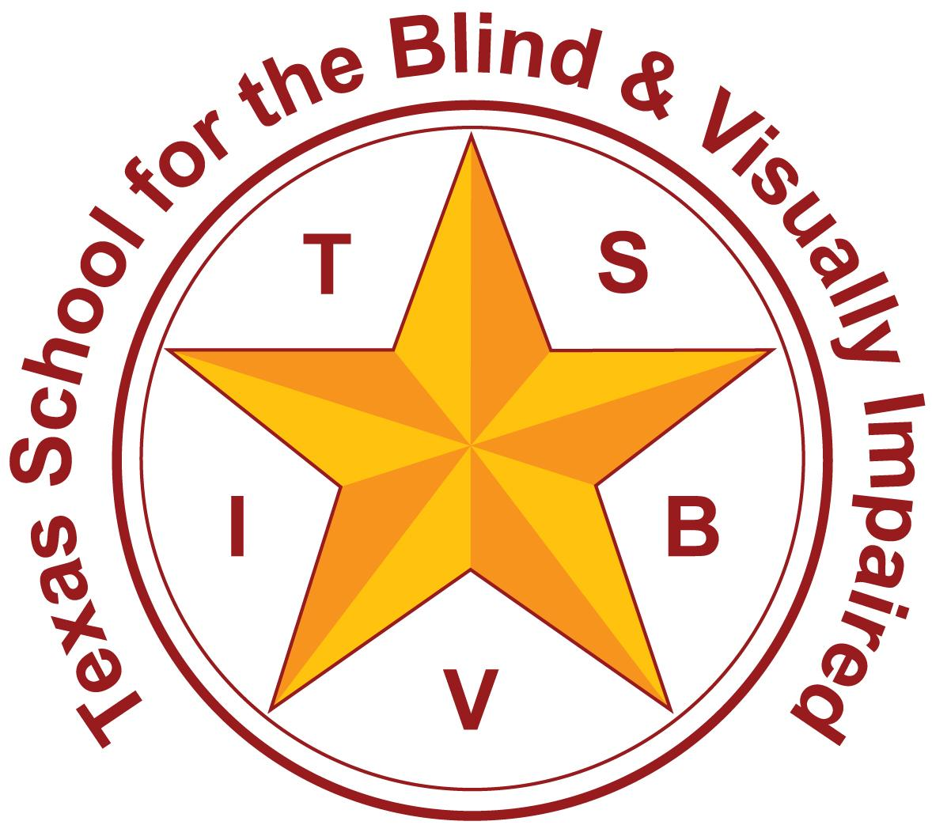
Texas School for the Blind and Visually Impaired
Outreach Programs
www.tsbvi.edu | 512-454-8631| 1100 W. 45th St. | Austin, TX 78756

Coffee Hour
General Considerations for Supporting Students who are Deafblind

August 16, 2021
Kaycee Bennett, Education Consultant, Texas Deafblind Project

Today’s Agenda
- Eligibility criteria for deafblind
- Teacher of Students who are Deafblind
- Intervener basics
- What to do when you get a student who is deafblind in your class or on your caseload
- How to get more information

Federal Definition
Deaf-blindness means concomitant hearing and visual impairments, the combination of which causes such severe communication and other developmental and educational needs that they [the children] cannot be accommodated in special education programs designed solely for children with deafness or children with blindness (34CFR, Part 300, Subpart A, 300.7 (c)(2))

Four Ways to Qualify
Way 1

meets the eligibility criteria for auditory impairment specified in subsection (c)(3) of this section and visual impairment specified in subsection (c)(12) of this section;

Way 2

(B) meets the eligibility criteria for a student with a visual impairment and has a suspected hearing loss that cannot be demonstrated conclusively, but a speech/language therapist, a certified speech and language therapist, or a licensed speech language pathologist indicates there is no speech at an age when speech would normally be expected;

Way 3

(C) has documented hearing and visual losses that, if considered individually, may not meet the requirements for auditory impairment or visual impairment, but the combination of such losses adversely affects the student's educational performance; or

Way 4

(D) has a documented medical diagnosis progressive medical condition that will result in concomitant hearing and visual losses that, without special education intervention, will adversely affect the student's educational performance.

Why do we need Deafblind Eligibility?
The deafblind label can help the education team identify resources and strategies around counseling, braille instruction, tactile sign, Orientation and Mobility, and other supports that may be beneficial to the student and family.

Teacher of Students who are Deafblind
- Why isn’t a TDHH and a TVI enough?
- What do I do if I get a student who is deafblind and my district doesn’t have a TDB?
- Are they required members of the committee?
- What does the future look like for TDBs?

What is an Intervener?
A trained person who works one-on-one with a person who is deafblind to facilitate communication and access. They develop a trusting relationship with the student and do things with them, not for them. They make sure the student has access to not only the communication happening around them, but also their environment.

How Do I Know if my Student Needs and Intervener?

Determining the Need for an Intervener in Educational Settings- 2nd Edition

Basic Strategies
- Hand UNDER hand
- Collaboration in Orientation and Mobility
- Calendar Systems
- Making choices and learning sequencing
- Adapting literacy materials based on hearing AND vision
- Tactile sign
- Functional routines

Routine

Slide shows screenshot of the beginning of a routine sheet with activites in the left column, scaffolding steps in the midde column, and phrasing to use in the right column.

Anticipation Calendar
- Slide shows picture of a “now basket” represented by a white round colander and a “finished basket” represented by a yellow, rectangular plastic bucket.

Daily Calendar
Slide shows an image of a horizontal carpet strip with red vertical lines separating the activities. Each activity has a photograph and some have additional photographs below it.

Tactile Symbols

Slide shows an image of a horizontal strip of carpet with pieces of rope laying vertically on the carpet to separate each activity. The activities are represented by tactile symbols and some have additional tactile symbols below them.

Sequence Boxes

Slide shows image of three black sequence boxes are attached together. Each has a tactile symbol in it.

Evaluation
- Teaming is KEY!
- Consider the effects of the combined loss
- Consult with other providers administering evaluations
- Don’t forget the family’s input! They know the student best.

Evaluation Tools
https://txdeafblindproject.org/topical-resources/

Slide shows a screenshot of the txdeafblindproject.org website listing 11 citations of assessment tools.

Where do I Put The Results?
- These assessments can be compiled into the appropriate sections of the FVE/LMA and Communication Evaluation.
- The FVE/LMA, Communication Evaluation, and Orientation and Mobility Assessments need to have the functional hearing/vision addressed throughout for deafblind students in order to contain an accurate reflection of their abilities.
- Example- https://docs.google.com/document/d/1lK_hvhtREppHwS_tjYuZ1gMvRTNDiplPvfOLRw9o46E/edit?usp=sharing

IEPs for Students who are Deafblind
IEP Quality Indicators http://www.tsbvi.edu/attachments/other/IEP_Indicators.pdf

Accommodations
Image of a screenshot of an accommodations page with detailed accommodations listed in unique categories.

IEP Goal Example
Goals for supporting consistency example: When Student initiates interaction by taking a staff members hand, staff member will respond by presenting real pictures of needs/people/preferred activities (i.e. food, teacher, bathroom, etc) while asking “What do you want?” in a positive affect, then Student will pick up desired photo of activity/person/need to communicate his choice 3 out of 5 trials per day.

Resources

- Texas Deafblind Project Website- www.txdeafblindproject.org

- Toileting Routine- https://drive.google.com/file/d/1YuSfqtLQ5P5pY7s09L-5CjfCELaSKYfd/view?usp=sharing
- Calendars for Students with Multiple Impairments including Deafblindness- http://www.tsbvi.edu/store/ecom/index.php?action=ecom.pdetails&mode=calendars_disk
- O&M for Students who are Deafblind- https://www.livebinders.com/play/play?id=1804265

Contact Us
Kaycee Bennett
bennettk@tsbvi.edu

txdeafblindproject@tsbvi.edu

