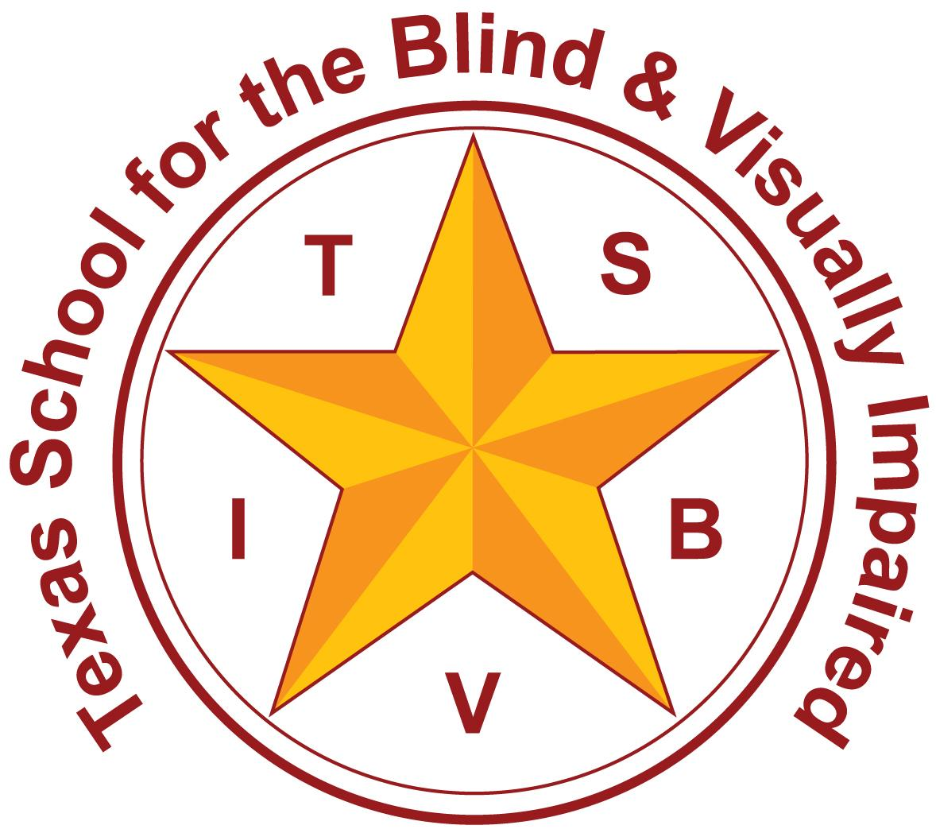
Texas School for the Blind and Visually Impaired
Outreach Programs
www.tsbvi.edu | 512-454-8631| 1100 W. 45th St. | Austin, TX 78756

Coffee Hour
Literacy for Little Ones: A Pilot Project

April 12, 2021
Debra Sewell, Curriculum Director, TSBVI
Kathi Garza, Early Childhood Specialist, TSBVI Outreach
K. Renee Ellis, Early Childhood Specialist, TSBVI Outreach
Cyral Miller, Outreach Teacher, TSBVI Outreach

Literacy for Little Ones
- Reading does not come naturally!
- Tactile learners need specially designed instruction
- Reading success (especially tactile reading) is the culmination of MANY prior experiences and skill development.

Early Foundations of LIteracy
- Motor skills
  - Gross motor skills
  - Fine motor skills
  - Tactile skills
- Concept development
- Language Acquisition
  - Becoming aware of oral and written language and how they facilitate literacy
- Emergent reading and writing skills

Early Literacy
Literacy begins at birth and continues as a young child develops.
- The ability to communicate
- Sensory awareness
- Visual and/or tactual discrimination skills
- An awareness of books, print or braille, and their purpose

Emergent Literacy
- Emergent literacy refers to the period in a child’s life from birth until formal reading and writing begins.
- Young children develop knowledge and skills and gradually “emerge” into literacy.
- Think about all the literacy skills you have used today.

Literacy Needs
- What does a child need to become literate; to read and write with meaning?
- Access and exposure to a wide variety of meaningful experiences
- Opportunities to explore their world
- Experiences that link words to meaning
- Knowledge about language
- Knowledge about letters & letter sounds

Motor Development

Motor Skills
The importance of motor skills to literacy development
- Movement is a critical foundation of learning
- Movement builds muscle memory and promotes motivation, curiosity, and exploration
- Moving with others develops social skills

Gross Motor Skills
- The importance of gross motor to literacy development
- Gross motor development is crucial for knowing where you are in space
- Gross motor develops stability for sitting and movement
- If a child is using all of his/her energy to maintain their core stability, learning is difficult if not impossible

Fine Motor Skills
The importance of fine motor to literacy development
- The development of fine motor skills is tied to the development of gross motor skills
- Developing/refining finger strength and dexterity that may be needed for braille writing and reading

Connecting Motor to Literacy
Slide shows a graphic representing stairs with each bullet of text ascending upwards.
- Experiences with movement develop and expand concepts.
- Concepts support understanding of the world.
- Increased understanding makes reading & writing (literacy) fun!

Hierarchy of Tactile Skills
Object/Graphic recognition should develop from concrete to abstract
(adapted from Kershman, 1976)

Slide shows an image of a real spoon, a raised line drawing of a spoon, and the braille word “spoon.”
- Real Objects
- Object Representations
- Graphic Representations
  - Two dimensional objects
  - Solid embossed shapes
  - Outlines of objects
  - Raised lines (solid & broken)
  - Symbols/letters

Concept Development

Concrete to Abstract
Slide shows 3 images
- Image shows a young child holding a real fish
- Image shows a line drawing of a fish
- Image shows the print word “fish”

Slide shows an image of a pyramid divided into 3 sections and titled “Learning for the Typical Child”
- The top section includes the text “Direct Learning” and makes up about 10% of the total pyramid.
- The middle section includes the text “Secondary Learning” and makes up about 10% of the total pyramid.
- The bottom section includes the text “Incidental Learning” and makes up about 80% of the total pyramid.

Slide shows an image of an upside down pyramid divided into 3 sections.
- The top section includes the text “Direct Learning Hands on experiences are essential. The best way to learn” and makes up about 80% of the total pyramid.
- The middle section includes the text “Secondary is difficult” and makes up about 10% of the total pyramid.
- The bottom section includes the text “Incidental usually does not occur and is not effective” and makes up about 10% of the total pyramid.

Concepts are Everywhere
Slide shows an image of children walking through tubs with a variety of items in them.

Connecting Concepts to Literacy
Slide shows a graphic representing stairs with each bullet of text ascending upwards.
- Experiences develop and expand concepts
- Concepts support understanding of the world
- Increased understanding makes reading & writing (literacy) fun!

Language Leads to Literacy

Language Acquisition
Language Acquisition is…
- Critical for young children’s development
- An essential key for learning
- Important for communicating and building relationships
- A tool to help children make sense of the world around them

Emergent Reading & Writing
Slide shows two images. The image on the left is a clear plastic tub with bath items next to it. The image on the right is a book made of plastic with bath items attached to the visible open pages.

Components of Reading
To become a competent reader, children must develop:
- Phonemic Awareness
- Awareness of Phonics
- Vocabulary
- Fluency
- Comprehension

Vocabulary
Vocabulary is critical for reading with meaning.
- As children learn language they are building vocabulary.
- They learn that words stand for things, people, actions, concepts.
- Children learn that words are used and sequenced in sentences.

The Connection
Reading and writing are connected.
- Young children need reading to help them learn about writing
- Young children need writing to help them learn about reading
- Young children need oral language to help them learn about both.

Writing
Writing begins with:
- Scribbling/drawing
- Letter-like forms and shapes
- Letters
- Words and sentences/stories

Scribbling and Drawing
Watch and discuss a video of a young child scribbling with her braillewriter

Connecting the Dots
A solid foundation for literacy must include:
- Gross Motor
- Fine Motor
- Tactile Skills
- Concept Development
- Language Acquisition
- Reading and Writing

References
- “Typical Learning vs. Deafblind Learning” from Alsop, L; Berg, C; Hartman, V; Knapp, M; Lauger, K; Levasseur, C; Prouty, M; and Prouty, S. (2012). A Family's Guide to Interveners for Children with Combined Vision and Hearing Loss, (p. 13-16). SKI-HI Institute, Utah State University, Logan, Utah. Pyramid reference Book available for purchase on Interveners.org
- Kershman, S. M. (1976-1977). A hierarchy of tasks in the development of tactual discrimination: Part two. Education of the Visually Handicapped, 8(4), 107-115.

Contact Us
Cyral Miller - millerc@tsbvi.edu
Debra Sewell - sewelld@tsbvi.edu
Kathi Garza - garzak@tsbvi.edu
Renee Ellis - ellisr@tsbvi.edu

Thank you for joining us!
Image shows a quote by Dr. Suess with drawings of Thing 1 and Thing 2, little characters in red outfits with spiky blue hair. “The more that you read, the more things you will know. The more that you learn, the more places you will go.”

