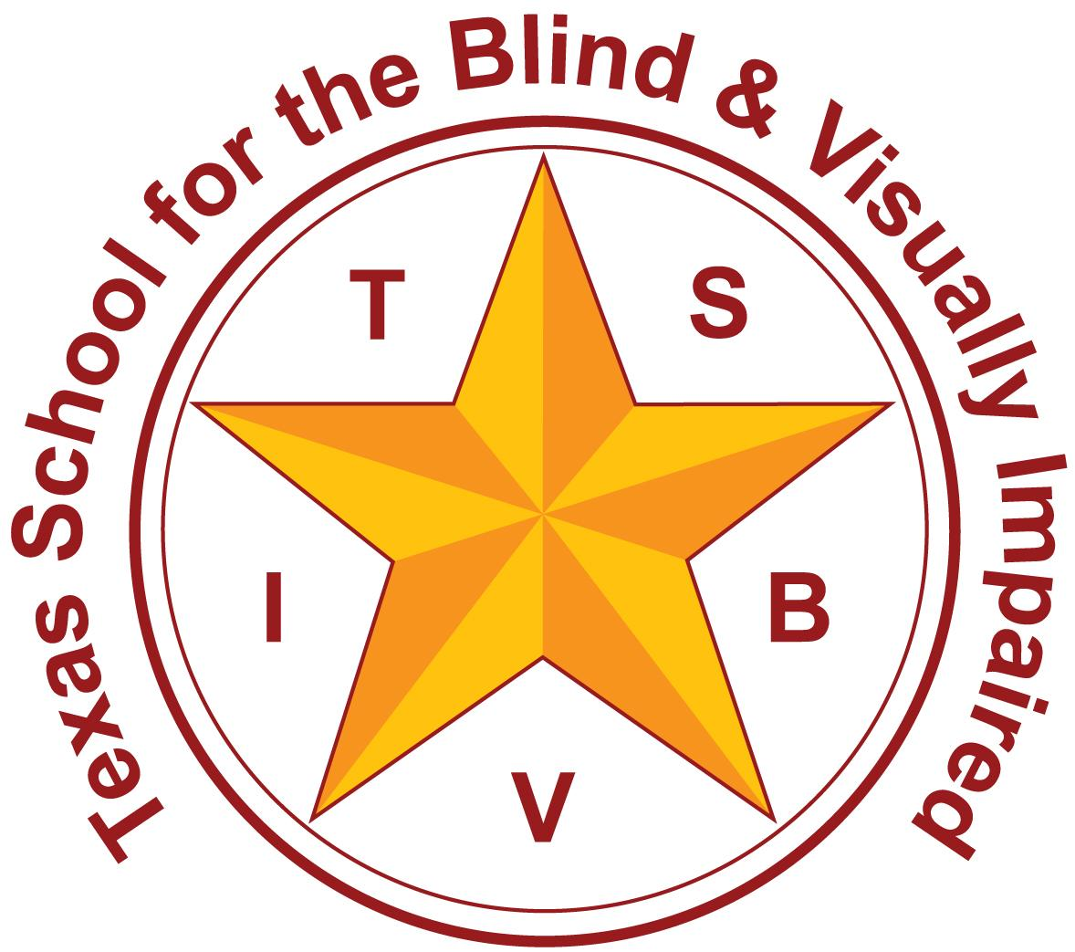
Texas School for the Blind and Visually Impaired
Outreach Programs
www.tsbvi.edu | 512-454-8631| 1100 W. 45th St. | Austin, TX 78756

Coffee Hour:
ECC Personal Hygiene: Bathroom Skills and Complex Learners

March 10th, 2025

Presented by

Lisa Ricketts, OT

Lynne McAlister, TVI

Sensory and Emotional Development
- Typical Learners

Impact of sensory impairments
- Lack of Incidental Learning and Imitation
- May have communication issues-why?
- Consistency- home & school

Impact of sensory impairments and Autism (ONH)
- They already have a routine
- Hormone involvement
- Sensory overload

Safety
- Postural Control
- Sensory Defensiveness

The Routine
- Routines provide structure and allow for anticipation
- Anticipation allows for independence
- Independence=Privacy
- Reduces anxiety
- Can be consistent across settings

Pre- Bathroom
- Objects/Pictures
- Sequence/Routine (Eat, take a walk, then toilet)
- Elimination Diet/Schedule

The Space
- Auditory
- Tactile
- Olfactory
- Visual
- Memories

Manipulating Clothing
- Diaper vs Pullup
- Clothing

The Toilet
- How long to sit
- Playing in water
- Wiping
- Flushing

The Sink
- Water- hot and cold
- Soap/sanitiser
- Rinse
- Towels/Dryer
- Trash location

Other Thoughts
- Backward Chaining
- Infuse fun and interests

References
- Toilet Training for Individuals with Autism or Other Developmental Issues: Second Edition September 1, 2007 by Maria Wheeler, Carol Stock Kranowitz (Foreword)
- Toilet Training for Autism & SEND: A step-by-step guide to toilet-training children & adults with autism and other disabilities. March 24, 2023 by Faria Arsh
Thank you for joining us today!

Lisa Ricketts

rickettsl@tsbvi.edu

Lynne McAlister

mcalisterl@tsbvi.edu

Texas School for the Blind & Visually Impaired Outreach Programs
Coffee Hour: ECC Personal Hygiene: Bathroom Skills and Complex Learners

Thank you for joining us!

Texas School for the Blind & Visually Impaired Outreach Programs
Figure 7: TSBVI logo


Figure 8: IDEAs that Work logo and OSEP disclaimer.

