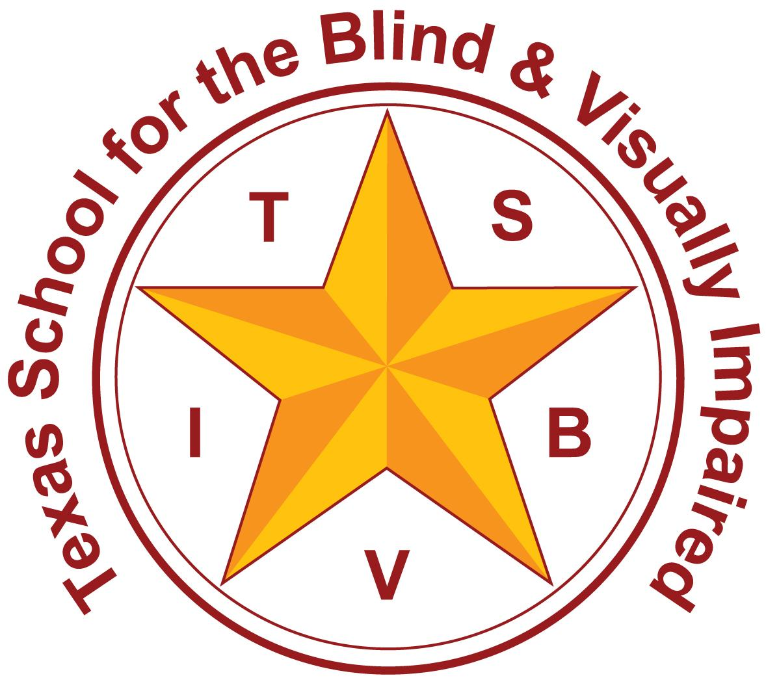Texas School for the Blind and Visually Impaired
Outreach Programs
www.tsbvi.edu | 512.454.8631 | 1100 W. 45th St. | Austin, TX 78756

Genetic Testing and Emerging Gene Therapies for People

with Inherited Retinal Diseases

Foundation Fighting Blindness

Ben Shaberman, Senior Director, Scientific Outreach,

Michelle Glaze, Associate Director, Professional Outreach

Slide 2 About the Foundation

Largest private funder of retinal degenerative disease research in the world – raised $816 million.

Research funded: lab, translational, clinical trials, career development awards, natural history, registry, genetic testing.

Entire spectrum of RDDs including: retinitis pigmentosa, Stargardt disease, Usher syndrome, Leber congenital amaurosis, dry AMD.

Slide 3 Resources

Website: www.fightingblindness.org

Patient Support: 1-888-394-3937 or Email: info@fightingblindness.org

Chapters: 40+ volunteer-led chapters across the U.S.

Research Updates: Chapter Webinars, Clinical Trials May

Events: VisionWalk, Hope from Home, Dining in the Dark

Continuing Education Courses: April 5th

My Retina Tracker Genetic Testing Program

Slide 4 Why Genetic Testing for IRD Patients?

Can confirm or change clinical diagnosis.

InformedDNA study showed that clinical diagnoses for IRD patients changed in 13% of cases after genetic testing.

Provides more accurate prognosis for patient.

Confirms inheritance pattern, risk for other family members.

Potential qualification for clinical trials or gene therapy (RPE65, LUXTURNA®).

Currently ~40 IRD clinical trials underway, most require genetic diagnosis.

Slide 5 Best-in-Class Partnership for No-Cost Genetic Testing and Counseling
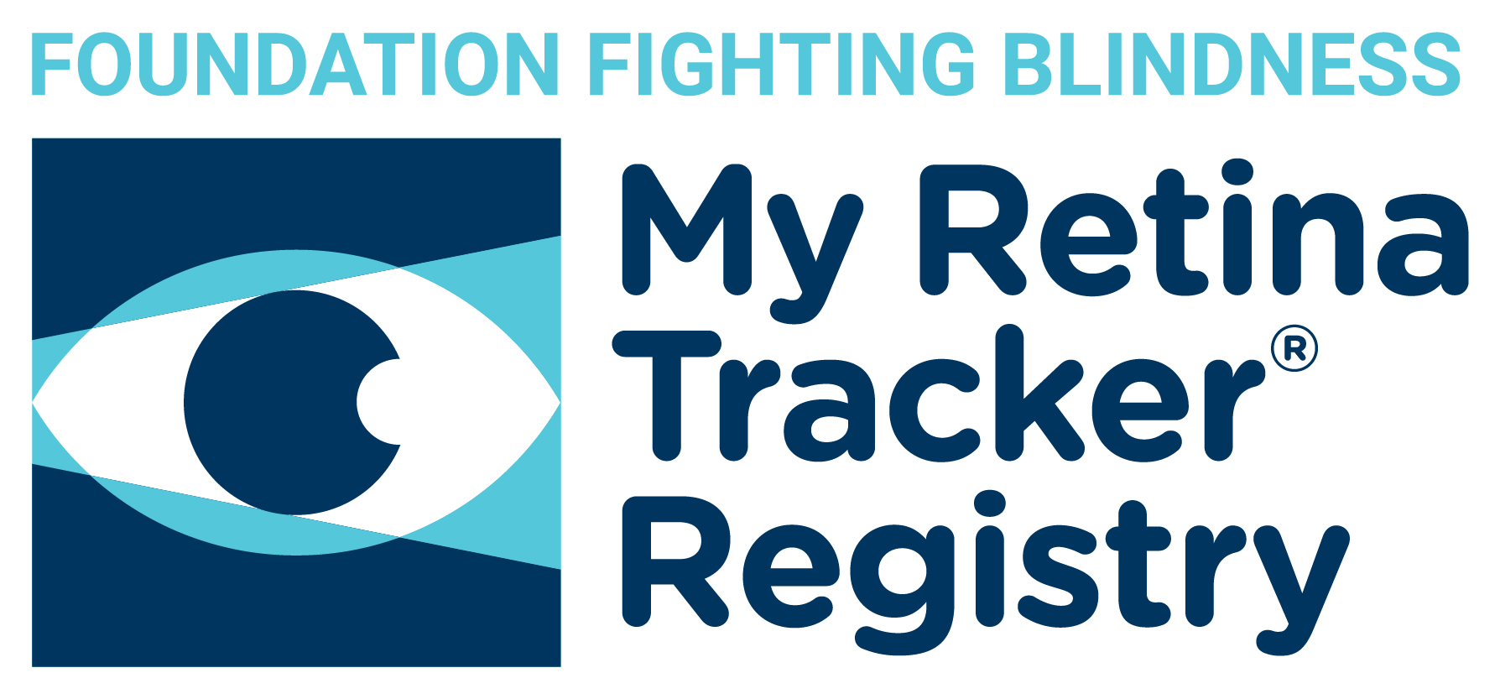

Images 1-3 Logos for Blueprint Genetics, InformedDNA, and the My Retina Tracker Registry

- Helping patients and families manage IRDs.
- Drive clinical research for patients with inherited retinal diseases.
- Getting patients on path to clinical trials and treatments.

Slide 6 Open Access Genetic Testing

- Open to all patients in the US clinically diagnosed with an IRD. (Not patients who have received genetic testing during the past four years using a panel of >32 genes, WES, WGS.)
- More than 8,000 people have ordered test (since 2017).
- Doctor orders genetic test online through Blueprint. The process is straightforward.
- ~4 weeks turnaround time for results.
- Patients are encouraged to join My Retina Tracker Registry.
- Genetic counseling through InformedDNA or doctor/clinic.

Image 4 Hand holding a test tube, genetic code (the letters A, C, T, and G) in the background

Slide 7 Patient’s Personal Information Always Protected

Patient Privacy

Patient’s personal information is never released or disseminated through the genetic testing program or the registry.

Only de-identified data provided.

Slide 8 Best-in-Class Testing Panel

- 322 gene panel
- Includes RPGR (XLRP), leading cause of retinitis pigmentosa:
  - 5.7% (90/1582) of IRD patients had RPGR mutations
  - 24% of RPGR patients were females with milder disease
  - ORF-15 region well covered
- Identifies copy number variants (insertions, deletions)
- Identifies non-coding variants (intronic mutations)
Image 5 Logo of Blueprint Genetics

Slide 9 Best-in-Class Counseling

More than 3,000 patients with IRDs counseled in last 3 years

More than 90% of doctors using My Retina Tracker Program used InformedDNA

Counselors have an average of 7 years of clinical genetic counseling experience

Licensed counselor for every state

Telephone-based, flexible hours

Sessions: 60-75 minutes

Genetic counseling required

Slide 10 My Retina Tracker Registry

Global, Free, Secure, Easy-to-Use

Patient-Controlled

Researchers use for clinical trial recruitment

Only de-identified data is shared with researchers and companies

~16,000 active/useful registrants

~150 requests for access (researchers/companies)

www.MyRetinaTracker.org

Images 5-7 HIPAA compliance logo to ensure data privacy in the US, GDPR logo to ensure data privacy and protection in the EU, Section508 logo to meet US government compliance standards.

Slide 11 Clinical Trials

40+ Clinical Trials Underway

Foundation-funded research attracting commercial investments

Foundation’s portfolio: 90 projects (global)

Slide 12 LUXTURNA: Spark’s RPE65 (LCA & RP) Gene Therapy

First FDA-approved gene therapy for the eye or an inherited disease. Patients receiving commercial therapy.

Image 8-9 Yanick Duwe (gene therapy recipient and his father: Spark Therapeutics logo

Slide 13 Gene Replacement Therapies in Development

AGTC: XLRP (RPGR), achromatopsia (CNGA3, CNGB3)

MeiraGTx/Janssen: XLRP (RPGR), achromatopsia (CNGA3, CNGB3)

Biogen: Choroideremia (CHM), XLRP (RPGR), RP (PRPF31)

4DMT: Choroideremia (CHM), XLRP (RPGR)

Horama: RP (PDE6B, CRB1)

Novartis: RP (RLBP1)

Iveric bio: RP (RHO), LCA (CEP290), Best disease (BEST1), USH2A

Atsena: LCA (GUCY2D, MYO7A-USH1B)

Odylia-MEE: LCA (RPGRIP1)

Numerous other genes targeted: ABCA4

Slide 14 Optogenetics

Restores light sensitivity to retina affected by advanced disease.
- Allergan (US)
- GenSight (UK)
- Bionic Sight (US)
- Vedere
Image 10 -11 Light hitting neuron to signify activation of optogenetic therapy; Side view of retina. The “X” through photoreceptors signifies someone who is completely blind. The oval around ganglion cells that can be targets for optogenetic therapy.
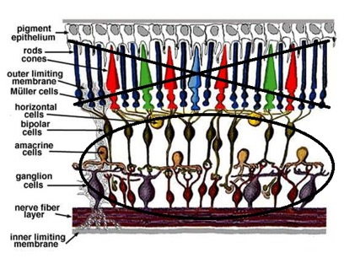

Slide 15 Three Major Foundation Investments

Nacuity (Dallas) – up to $7.5 million

NACA – strong antioxidant to slow vision loss (RP, others)

Phase 1/2 clinical trial launching in Australia for Usher syndrome

Similar to NAC, N-acetylcysteine (FDA-approved)

SparingVision (France) – up to €7 million

RdCVF – rod-derived cone viability factor (protein)

Saves cones (RP, others)

Developed at Institut de la Vision

ProQR (Netherlands) – up to $7.5 million

Antisense oligonucleotides (like genetic tape/mask)

USH2A exon 13 (FFB-funded) – Vision improvements, Phase 1/2

LCA (CEP290) – Vision improvements, Phase 2/3

RP (RHO-P23H) – Phase 1/2

Slide 16 Stem Cells

ReNeuron (Mass Eye and Ear)
- Transplant partially developed photoreceptors
- Functionally replace lost photoreceptors
- Improved visual acuity for patients in Phase 2 –
~3 lines on an eye chart at 12 months
- Jason Comander leading trial
- Significant funding from FFB

Image 12 Dr. Jason Comander, Mass Eye and Ear, lead investigator on ReNeuron trial

Slide 17 Thank You

FightingBlindness.org

ClinicalTrials.gov

MyRetinaTracker.org

