Texas School for the Blind & Visually Impaired
Outreach Programs
www.tsbvi.edu | 512-454-8631| 1100 W. 45th St. | Austin, TX 78756

Coffee Hour – October 1, 2020
Introduction to the Chromebook
Presented by
Bruce McClanahan, Washington State School for the Blind, (360) 947-3360
and Cecilia Robinson, TSBVI, (512) 206-9464

Topics
- Chromebook:
- What it is and is not
- Screen sizes and types
- Apps and extensions
- Keyboarding skills and tutorials
- Built-in accessibility:
- Display and appearance
- Screen magnifier
- Mouse and keyboard options
- Select-to-Speak
- ChromeVox
- Tips and resources

Chromebook Keyboard
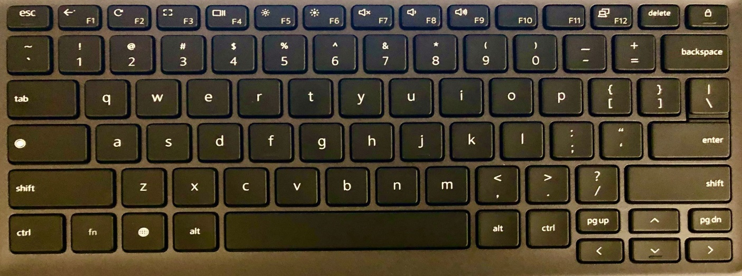
Figure 1: Chromebook keyboard with “unique keys” highlighted by a yellow frame.

Unique Keys
← | F1 | Previous Page
 | F2 | Refresh Current Page
 | F3 | Full Screen
 | F4 | Show All Open Windows
 |  | Search
 |  | Launcher

Home Screen
From lower left to right:
- Launcher (Alt + shift + L): Search for apps, access to Settings and other features
- Apps
- Select to Speak (Search + s)
- System menu (Alt + shift + s): connection, group: battery, time and other options

Supports for Students with Low Vision
Settings > Advanced > Accessibility:
- Always show accessibility option in the system menu

- Manage accessibility features
- Text-to-Speech
- ChromeVox
- Select-to-speak
- Select-to-speak settings: speech and highlighting options
- Text-to-Speech voice settings: rate, pitch and volume options

- Display: contrast, magnifier choices, display device settings, appearance settings
* Display device settings:
- Show home button
- Show bookmarks bar
- Font size
- Customize fonts

* Appearance settings:
- Font size
- Customize fonts
- Page zoom – can also use Ctrl + or Ctrl -
- Advanced – Spell check options

- Keyboard and text input:
- Enable dictation (speak to type)

- Mouse and touchpad: show large mouse cursor; adjust cursor size; highlight mouse cursor when moving
* Mouse and touchpad device settings:
- Touchpad speed
- Reverse scrolling

Supports for Students Who Use Speech
Settings > Advanced > Accessibility:
- Always show accessibility option in the system menu

- Manage accessibility features
- Text-to-Speech:
- Enable ChromeVox (spoken feedback) – Ctrl + alt + z (toggle command)
- Search key – ChromeVox key
- Ctrl – pauses speech
- Open ChromeVox settings
- ChromeVox Options

ChromeVox Options
A manual on using the Chromebook with the screen magnifier and ChromeVox is available here.
There are also 14 videos on this site that cover accessibility options in the Chromebook.

Tips and Strategies
- Work with your IT department and ask for an “organizational unit,” if necessary.
- Help students make sense of keyboard shortcuts (e.g. editing commands use Ctrl; menu use Alt: Ctrl + f for Find; Alt + f for file menu).
- Encourage accurate keyboarding skills.
- Use bookmarks to facilitate efficiency.
- Know where to locate Chromebook resources when you need them.

Resources
Washington State School for the Blind: Statewide Technology Services

Wisconsin Center for the Blind: ChromeVox: From Basics to Mastery Online Class

Chrome Accessibility Features for the Classroom

Paths to Literacy: Chromebook Basics for Students with Low Vision

Google for Education: Chromebook Accessibility

