Handout: Driver or Active Traveler- What’s My Role with Students?

Slide 1
Driver or Active Traveler- What’s My Role with Students?
TSBVI Coffee Hour
December 5, 2022

Cindy Bachofer, PhD, CLVT
TSBVI Low Vision Consultant
bachoferc@tsbvi.edu
(512) 206-9320

Chuck Huss, COMS
Driver Rehabilitation Specialist
chuck_huss@hotmail.com
(304) 767-1497

Slide 2

Goal of Presentation
- Bring attention to VI professional’s role in transition planning and travel
- Highlight TSBVI modules re bioptic driving and teaching telescope skills

Slide 3

Objectives
- Overview of the concept of bioptic driving
- Sampling of misconceptions re bioptic driving
- Overview of visual criteria for restrictive driving privileges across the United States (including bioptic telescope allowance)
- Visual and other requirements for bioptic driving in Texas
- COMS role in pre-driver readiness – basic pedestrian safety skills
- Summary of workshop data & results,‘12-’22
- Development of bioptic driving e-course modules

Slide 4
Bioptic Driving? Answer: Operation of a motor vehicle by a person who uses a duo optical lens system* to accommodate for known central vision loss

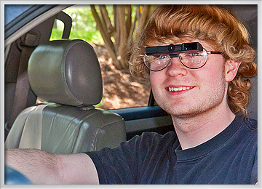
Figure 1; Young person wearing bioptic lens system while behind the wheel of a car, smiling and turned toward the camera.

Slide 5

Central vs. side vision
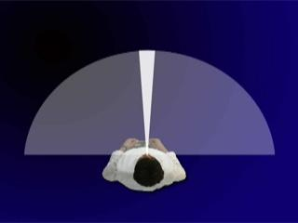
Figure 2: Graphic of person standing with half circle in front of them, showing 180 degrees, and a small sliver in the very center with about 10 degrees highlighted as central vision.
Source: BiopticDrivingUSA.com
Slide 6

Misconceptions re bioptic driving
- Low vision drivers need miniature telescopes to see.
- Low vision drivers view continuously through the telescopic portion of the bioptic lens system while driving.
- Few states allow bioptic driving with mild to moderate levels of central vision loss, much less the use of bioptic lens systems.
- Low vision drivers need not use bioptics in familiar outdoor driving environments.
- Few safeguards are needed when developing or implementing formalized programs of bioptic driver education training.
- Persons with the same type and/or level of central vision loss perform identically under dynamic driving conditions.

Slide 7

Carrier vs. telescopic lens viewing
Bioptic lens users view through the larger carrier lenses 90-95% of the total driving time.
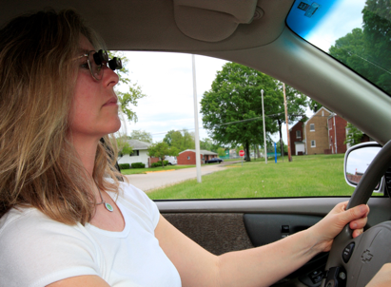
Figure 3: Driver wearing bioptic lens system who is looking straight ahead

Bioptic lens users view through the larger carrier lens 90-97% of the total driving time. Bioptic lens users view intermittently for 1-2 seconds per fixation through the telescopic portion of their lens system (a mere 5-10% of the total driving time).

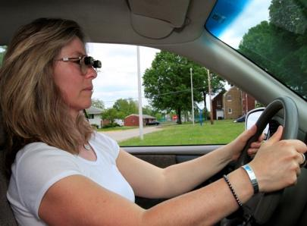
Figure 4: Driver wearing bioptic lens system who is dipping down with her head slightly to look through the telescope portion of the glasses while continuing to look forward
Slide 8

Basic vertical spotting technique
- Carrier lens viewing
- Tilt head back and look directly below
telescope
- Forward and lateral scan

- Telescopic lens viewing
- Dip down into miniature telescope(s)
for 1-2 second intervals
- Straight stretches of roadway only,
- Good sight distance ahead
- Absence of critical objects in surrounding
space cushion

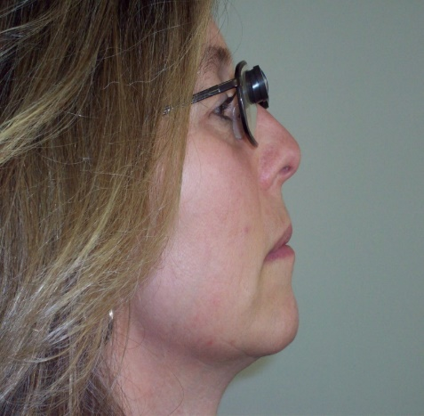
Figure 5: Person demonstrating carrier lens viewing, looking through the bottom portion of the carrier lens, just below the bioptic telescope
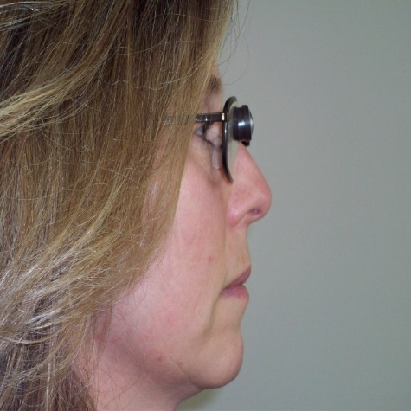

Figure 6: Person demonstrating telescopic lens viewing, looking through the top portion of the carrier lens, where the bioptic telescope is located

Slide 9

Sampling of areas covered when teaching and reinforcing basic bioptic usage for driving:
- Nearness illusion
- Restricted field of view
- Movement of magnified field in opposite direction to head turn
- Maintenance of peripheral reference points (due to vertex distance)
- “Jack in the Box” effect (created by mid-block street crossing, unsafe passing or lane change, lane-jumping)

Slide 10
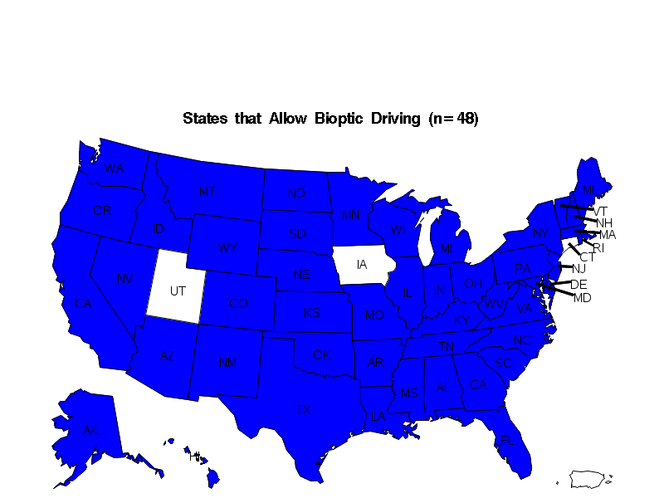
Figure 7: Map of the United States of America with 48 states highlighted, representing the number of states in 2022 that allow bioptic driving
Slide 11

LIST OF STATES BY CARRIER LENS ACUITY LEVEL FOR RESTRICTED DRIVING PRIVILEGES

- 20/40 … HI, NE*, VT* (3)

- 20/50 … DE, NJ* (2)

- 20/60 … AR, ID, SD*, (3)

- 20/70 … CO*, DC, FL, MI*
NH, OH* (6)

- 20/80 …. MN, NM (2)

- 20/100 … AK, IL, MD, MA, ME,
MT, NY, OK, RI, UT,
WS, WY (12)

- 20/120 … NV, WA, SC (3)

- 20/130 … ND (1)

- 20/160 … MO, TX (2)

- 20/199 …. CA, IA (2)

- 20/200 … AL, AZ*, CT, GA,
IN*, KS*, KY, LA
MS, NC, OR, PA ,
TN, VA, WV (15)

Slide 12

Vision and other requirements for bioptic driving in Texas
- Best corrected visual acuity through the carrier lens: 20/80-20/160
- Enhanced visual acuity of 20/40 or better
- Use of no greater than a 4X mounted telescope
- 140° visual field (uninterrupted)
- Color vision testing for commercial driving purposes only
- Adequate cognitive ability and no physical problems that would preclude safe driving

Slide 13

Training requirements for new bioptic drivers in Texas
- Less than 18 years of age:
- 32 hrs. of classroom instruction
- passage of written instructional test @ DPS
- 44 hrs. of behind-the-wheel (BTW) training
with at least ten (10) hrs. of night training
- 18 years of age or older:
- Passage of six (6) hr. classroom (in-person or on-
line) prior to permit testing
- Other requirements (same as listed above)

Slide 14

Pre-driver readiness competencies (centering around pedestrian safety skills) before starting bioptic driver training:
- Take in, remember and follow route instructions
- Travel and reverse a route of travel
- Detect, identify and react in time to critical objects
- Cross stop sign and traffic light-controlled intersections
* Major finding - WV Pilot Low Vision Driving Study, ‘85-’98, those clients found to be pre-driver ready were able to perform these basic pre-driver readiness skills

Slide 15

Pre-driver readiness guide
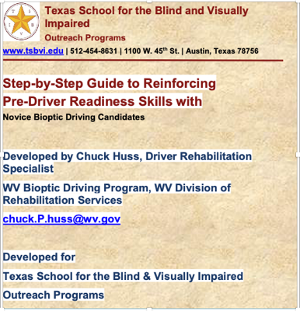
Figure 8: Screenshot of the cover page of the presentation titled “Step-by-Step Guide to Reinforcing Pre-Driver Readiness Skills with Novice Bioptic Driving Candidates”.
- Free standard or large print size copies
- Send e-mail request to: chuck_huss@hotmail.com

Slide 16

Alternative forms of transportation as a non-driver
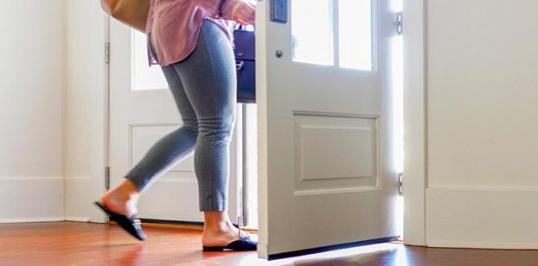
Figure 9: Photo of person heading out the door with a brief case in one hand and a large shoulder bag
- Heading out the door as an active traveler.

Slide 17

Transportation Options for Active Travelers
- Personal (non-vehicle) travel: walking, cycling
- Rides from family, friends
- Hired drivers (contract)
- Taxi
- Rideshare request apps (e.g., Lyft, Uber)
- Paratransit
- Mass transit-bus, train, subway

Most likely option as Plan A & Plan B?

Slide 18

How is life different when you are not at the wheel?
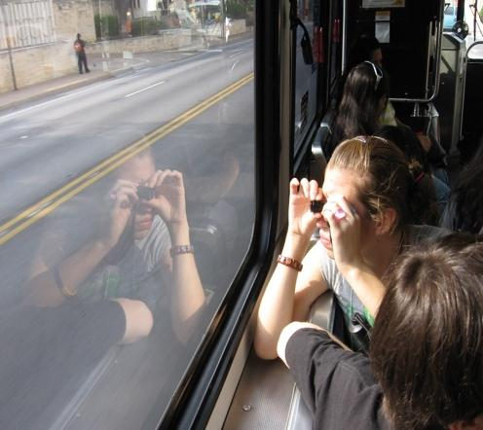
Figure 10: Student on a bus uses a monocular to view the outside environment as the bus is in motion
- My responsibility in ride planning and paying
- The expense decision: time or money?
- Flexibility with change in the schedule
- My preferred back-up plan
- Good use of wait time

Slide 19

Community Choice
- What are the places I want to get to besides school/work?
- What are 3 options within this community for getting around when I’m not driving?
- What skills do I have that I can swap for rides?

Slide 20

It’s in the Bag
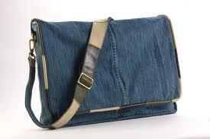
Figure 11: Photo of a large shoulder bag
What do you make sure you have?

Slide 21

Developing Active Traveler Skills
- Take the active passenger challenge
- Set up time for practicing travel safely
- Work out an exchange rate (not favors) for rides
- Estimate & keep a record of costs (time, money)
- Make a plan, work up to that 1st solo trip
- Discuss parent support for select travel expenses

Slide 22

Travel Skills for Students
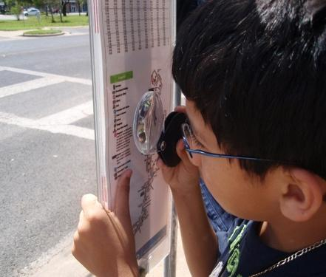
Figure 12: Student uses hand held magnifier to read local transit information posted on a bus pole
- Using travel tools: GPS, apps, maps, compass, timetables
- Using optical devices
- Getting travel directions, info (phone, internet)
- Building communication skills
- Practicing problem solving
- Choosing appropriate times for self-advocacy, assertiveness
*Keeping a sense of humor

Slide 23

A Guide for Active Traveler Lessons
Figure 13: Cover of Finding Wheels book

- Finding Wheels:
Strategies to Build Independent Travel Skills for Those with Visual Impairments (2020)

- Dr. Anne Corn and
- Dr. Penny Rosenblum

Slide 24

Uncovering the Hidden Population in Low Vision
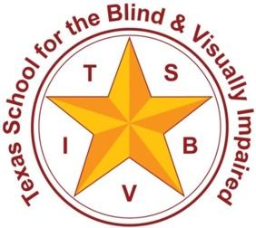
Figure 14: TSBVI logo, star with the letters TSBVI around the star, which is surrounded by a circle around which are the words Texas School for the Blind and Visually Impaired
A 10 year look at the benefits of a driving program for a student-parent workshop
Cindy Bachofer, PhD, CLVT

Slide 25

Summary of student demographics, outcomes and impact of workshop
- The Who
  - Personal characteristics of study respondents
- The Why
  - Outcomes and impact of the workshop

Slide 26

Attendees
- Least likely to identify as visually impaired → least likely to connect to services
- Most likely to receive consult → reduced services
- Best level of vision → most resistant to coming to that campus

Slide 27

“What will it take to get a license?”
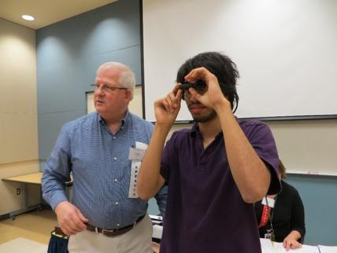
Figure 15 : Young man wearing a bioptic device standing next to Chuck Huss during a presentation
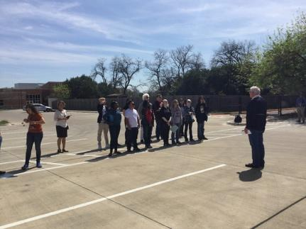
Figure 16: Young people standing in a parking lot, in two lines, shoulder to shoulder and facing Chuck Huss

Slide 28

Driving Points of the Data
- What are the characteristics of participants who qualify for driving?
- What factors predict likelihood of getting a license?
- How do participants rate the impact of DSW?

Format: phone interviews (15 questions) with young adult or parent (2012-2022 workshop)

Total attendees n=148; Study participants n=111

Slide 29
75% response rate
Attendees want to talk about this!

Slide 30

Characteristics
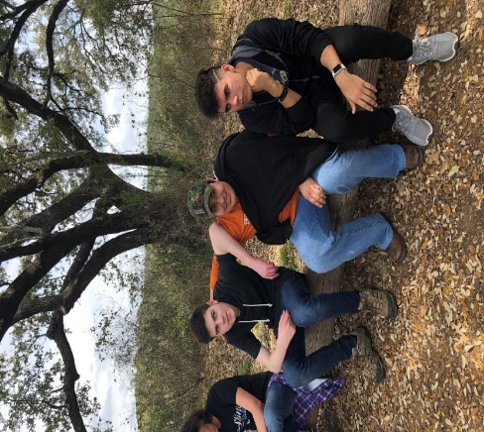
Figure 17: Photograph of students sitting together on a log
Gender
- 60% Males
- 40% Female

Year in school (C1 & 2)
- 11% / 26% Freshmen
- 33% / 24% Sophomore
- 25% / 25% Junior
- 31% / 25% Senior

Slide 31

Eye Conditions for Cohort 1 & 2
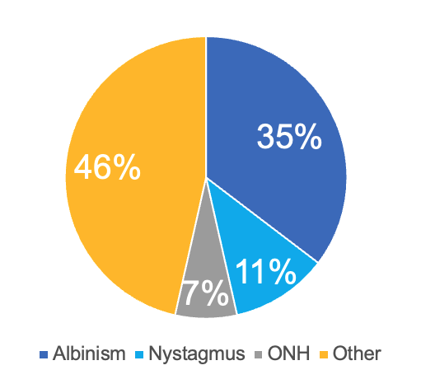
Figure 18: Pie chart of eye conditions for Cohort 1 showing 46% Other, 35% Albinism, 11%Nystagmus, 7% ONH

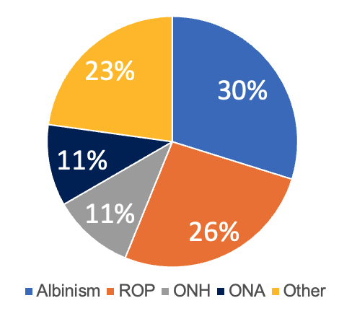
Figure 19: Pie chart of eye conditions for Cohort 1 showing 23% Other, 30% Albinism, 26% ROP, 11% ONH, 11% ONA

Slide 32

O&M Years of Service
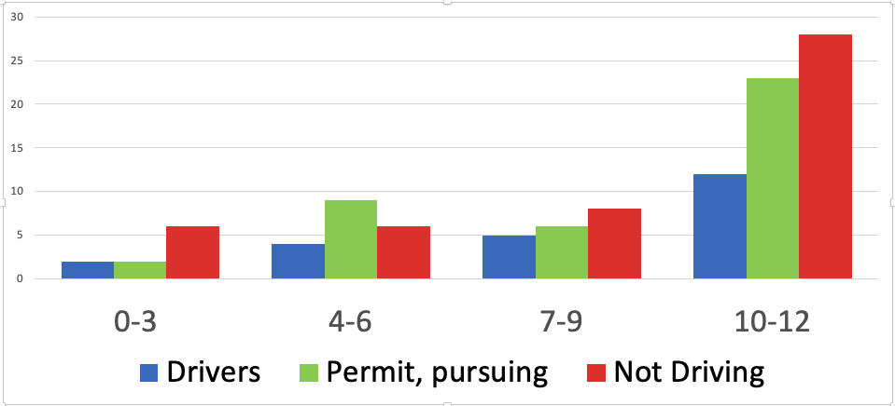
Figure 20: Bar graph showing number of years of O&M service received by students who were drivers, permit or pursuing, and not driving; greatest number of responses were clustered in the 10 to 12 years of service for all categories. Not driving had the greatest number overall in that category.

Slide 33

TVI Years of Service
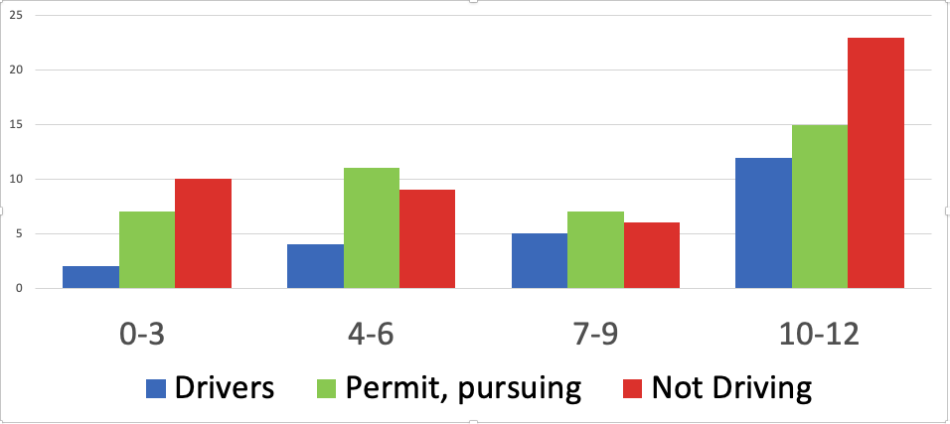
Figure 21: Bar graph showing number of years of TVI service received by students who were drivers, permit or pursuing, and not driving; greatest number of responses were clustered in the 10 to 12 years of service for all categories. Not driving had the greatest number overall in that category.

Slide 34
Use of Bioptic by Drivers & Pursuing
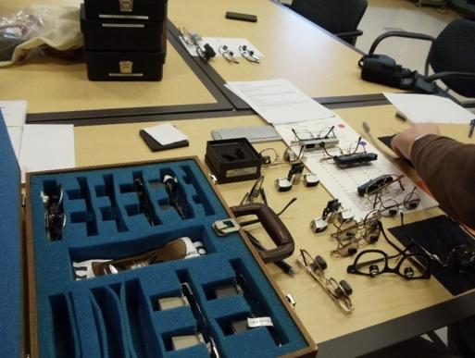
Figure 22: Photo of bioptic device demonstration kit
Cohort 1, 58%
Cohort 2, 47%

4x - most common power
“I use my bioptic for everything – at the rodeo, in school, on the forklift at work.”

Slide 35

Factors Impacting Decision
- Family attitude to encourage, discourage
- Mindset for demands of driving
- Problem solving through barriers
- Financial support for bioptic, operating a vehicle

Slide 36

Reason for not Driving
 | C1 (%) | C2 (%)
Not ready, too nervous | 12% | 44%
Interested, working on confidence | 12% | 26%
Not interested, other system in place | 36% | 22%
Other | 40% | 8%

Slide 37

Impact of Driver’s Seat
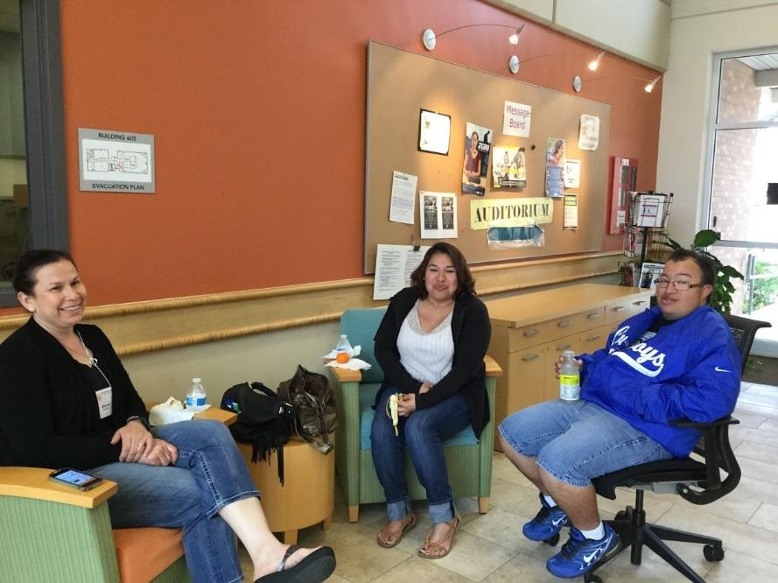
Figure 23: Photo of parents sitting together and talking
97% “Very Positive” or “Somewhat Positive”

100% Recommend the workshop to others

Slide 38

Stories
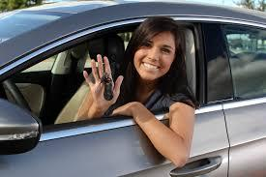
Figure 24: Photo of young driver behind the wheel of a car, dangling keys with a big smile
"Once you get past the nervous part, you take control. I wanted independence and I wanted to prove to others that I was a safe driver."

“He is hyper-aware of safety now following his accident (no injuries). In his first year of driving, he did not wear his bioptic.”.
(Mom shared that her son is visually impaired because he was hit by a car at age 3)

“You have to understand your limitations. Use your bioptic.“
(her son)

Slide 39

“I met people like me.”
“Connecting with a peer group who had low vision was powerful for him.”

“Meeting her peer group was wonderful. They are still in contact, and they push each other to meet their goals.”

“Finding a peer group helped her become so much more comfortable with her low vision.”

Slide 40
“It was life changing!”
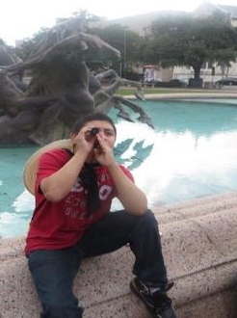
Figure 25: Young person sitting on a fountain and looking out with a monocular
“He came back and was changed. He had a much stronger sense of independence. He feels more self-reliant and believes he can get a job.”

"This program put a new spark in him. He saw he could lead a regular life. He had no idea of the possibility of driving.”

“It helped her feel more independent and gave her more hope for the future.”

Slide 41

A Tough Decision for Parents
“I want to let you know I had mixed feelings about sending you the photograph of my son with his car. Mainly because it’s a big decision for parents. Circumstances for each child is different. … I want to believe he can maneuver safely.”

“The program was very positive on practical points, but it was negative on emotional points. This is such a scary idea to think of my child driving.”

Slide 42

“We needed help at the DMV.”
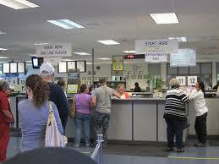
Figure 26: Photo of people standing in line and at the counter at the Department of Motor Vehicles
“It was frustrating, disappointing, and humiliating. They had no idea what to do and showed no interest.”

“DMV shut her down and we don’t know how to appeal.”

“We are struggling to get her permit. They hung up on her eye doctor who was explaining the bioptic.”

Slide 43

Benefits Beyond Driving
“We learned about so many other VI topics”
- O&M services, use of an identity cane
- Low vision exam
- Transition services, Vocational Rehabilitation info
- Tech, tips, tools
  - Mobile Eye (Collision Avoidance Systems)
  - Hood wrap (or matte finish paint) for reducing glare
  - Side mirror extenders

Slide 44

New Developments for DSW
- Bioptic e-course on TSBVI website
- Social media postings on bioptic driving
- TSBVI Bioptic driving page (resources, studio interviews)
- Driver’s Seat Workshop on the road in Dallas and Houston; sharing model with other states

Slide 45

TSBVI Bioptic Driving e-course
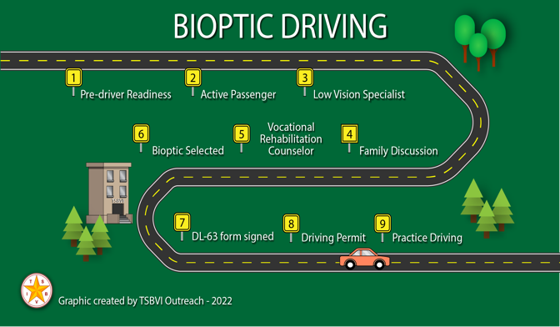
Figure 27: Graphic for the TSBVI Bioptic Driving Program, with a road weaving through the graphic with waypoints set as nine sequential steps through the course.
Contact Steven Landry, Outreach Training Specialist
landrys@tsbvi.edu
ttps://tinyurl.com/BiopticDriving

Slide 46
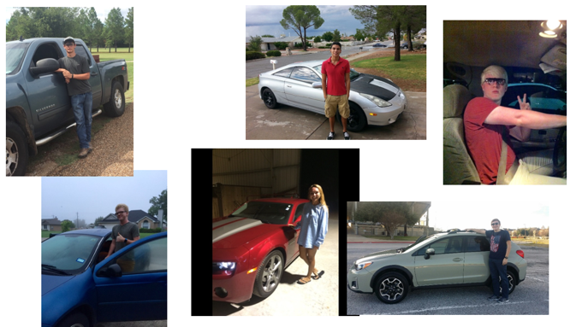
Figure 28: Collage of photos of young people with their vehicles, happy and proud

Slide 47 Contact sources for updated bioptic driving related information & articles
- Cynthia Owsley, UAB et al., bioptic driving research, (owsley@uab.edu)
- Gang Lou et al, Schepens Research Institute, naturalistic bioptic driving practices, (Gang_Luo@MEEI.HARVARD.EDU)
- Amy Doherty et al (hazard detection with monocular bioptic lens systems) (Amy_Doherty@meei.harvard.edu)
- Bart Dankers et al, Netherlands (bartmelis@vision.org)
- John Paul La Chance et al, Quebec, CAN (John-Paul.LaChance@irdpq.qc.ca)
- Brad Dougherty et al, OSU, Columbus, OH, BTLS research (bdoughherty@optometry.osu.edu)
- Cindy Bachofer, TSBVI, In the Driver’s Seat: Introduction to Low Vision Driving Workshops, (bachoferc@tsbvi.edu)
- Paul Freeman, OD, PEN DOT MAB, new PA bioptic driving law, (freemankp@aol.com)
- Laura Windsor, OD, FAAO, Indianapolis, IN (evaluating, fitting and Rx of BTLS), (drlaura@eyeassociates.com)
- Joanne M. Wood, Queensland, AUS, On-road bioptic driving research, (j.wood@qut.edu.au)
- Moya E. McClure, Bioptic Telescopes article,
- (me.mcclure@ulster.ac.uk)
- Alex Bowers et al, Harvard UnIv., (alex_bowers@meei.harvard.edu)
- Maria Cucuras et al (GPS) (mcucur@Midwestern.edu)
- Richard Chun (BD: current perspectives) (rchun@midwestern.edu)
- Chuck Huss (pre-driver readiness, consultations, workshops/in-services) (chuck_huss@hotmail.com)
- Karen Bly (NOAH, Executive Director) (kbly@albinism.org)
- Ike Presley (AFB e-learning re bioptic driving) (ipresley@afb.net)
- Anne Corn (academia – low vision, consumer advocacy, Finding Wheels – ’19, ‘20) (anne123c@gmail.com)
- Steven Landry, TSBVI, bioptic driving e-learning, (landrys@tsbvi.edu)
- Henry Greene (North Carolina, Pediatric Telescope Initiative, (hg@ocutech.com)
- Belinda O’Connor (bioptic driving advocacy efforts in Australia), (beloconnor@hotmail.com)

Slide 48

In conclusion
- Bioptic lens systems are now accepted for use in driving by 94% of licensing jurisdictions in the USA.
- Pedestrian safety skills and active passenger-in-car skills are a plus before application & entrance into a formalized program of bioptic driver training.
- Being pre-driver ready in many instances reduces the costs, length and extent of formalized bioptic driver training in order to obtain a driver’s license.
- It’s OK if your student decides not to explore driving.

Slide 49

Time for Q&A!
For more information:

Cindy Bachofer, PhD, CLVT
TSBVI Consultant
1100 W. 45th Street
Austin, TX 78756
TEL: (512) 206-9434
E-Mail: bachoferc@tsbvi.edu

Chuck Huss, COMS
Driver Rehabilitation Specialist
1332 West Virginia Avenue
Dunbar, WV 25064
TEL: (304) 767-1497 ©
E-Mail: chuck_huss@hotmail.com

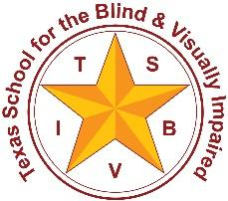
Texas School for the Blind & Visually Impaired
Outreach Programs
Figure 29: TSBVI logo, star with the letters TSBVI around the star, which is surrounded by a circle around which are the words Texas School for the Blind and Visually Impaired
This project is supported by the U.S. Department of Education Special Education Programs (OSEP). Opinions expressed here are the authors and do not necessarily represent the position of the Department of Education.

Figure 30: IDEA logo showing an arrow going around the words “IDEA’s the Work” with IDEA in all caps and the “s” in lower case.

