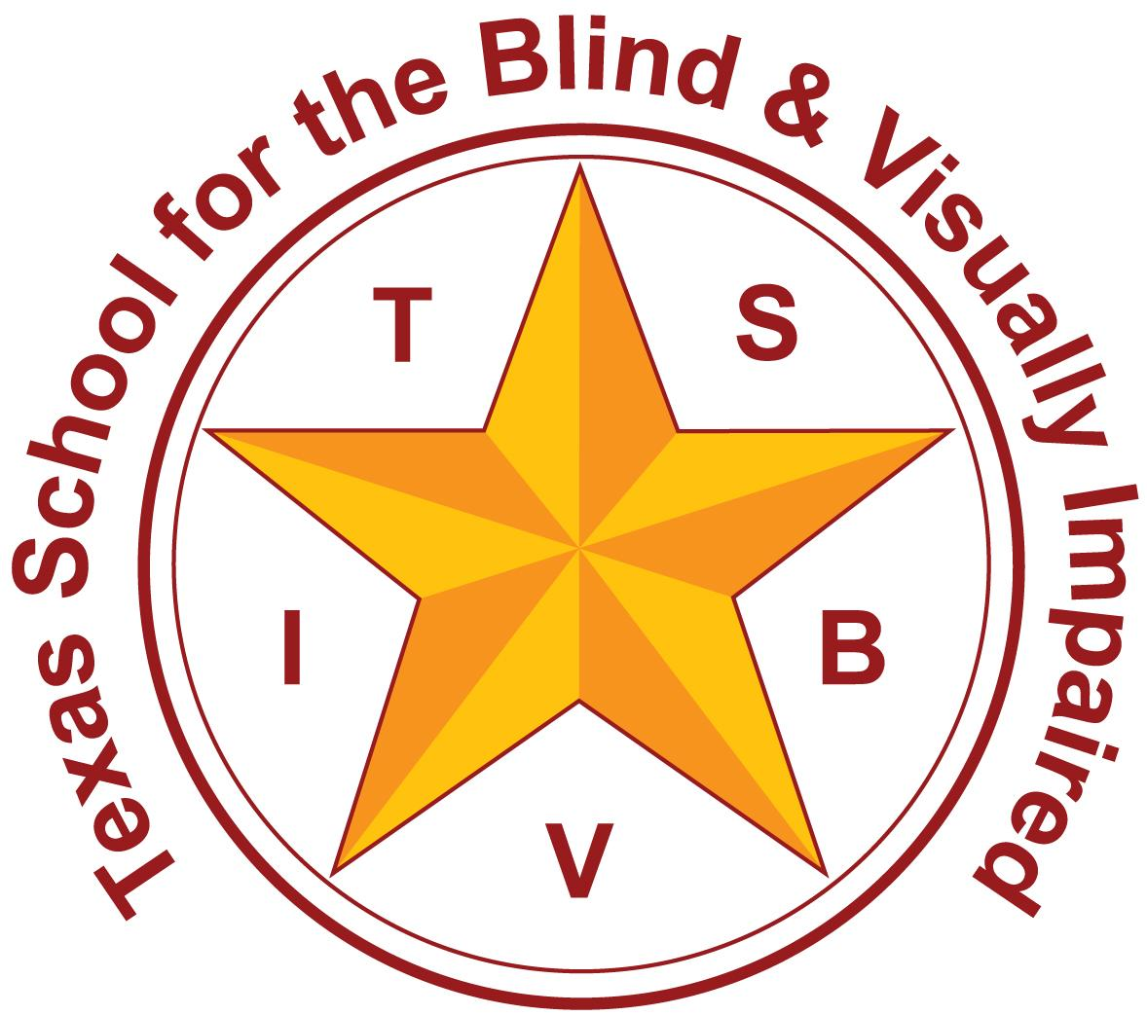
Texas School for the Blind and Visually Impaired
Outreach Programs
www.tsbvi.edu | 512-454-8631| 1100 W. 45th St. | Austin, TX 78756

Coffee Hour
Effective Itinerant Strategies

August 14, 2023
Rachel Collins

Texas School for the Blind & Visually Impaired Outreach Programs
Effective Itinerant Strategies
August 14, 2023
Facilitated by:
Rachel Collins, Deafblind Education Consultant
TSVI, TDHH, TDB
collinsr@tsbvi.edu

Today’s Agenda.
- Differences in serving students in a variety of educational placements
- New VI Professional Year At a Glance
- Forms for Documentation (get creative!)
- How do you decide on service times?
- Where can you go for help?

What is the difference?
Self-contained (in school district) classroom-
- Set schedules
- Small class size (usually!)
- Opportunity for more consistent collaboration
- Control over what happens in your classroom

What is the difference?
Residential school classroom-
- Bell schedules are set by the school
- Small class size
- Support from multiple service providers
- Control!

What is the difference?
Itinerant-
- Varied schedules
- Number of students and service minutes can fluctuate often
- The necessity for TEAMING
- Scope of knowledge must keep up with students
- Lack of control

You just became an itinerant TSVI… What do you do now?
Image Description
- A meme that shows a woman with a distressed facial expression and a caption that reads, “When you get so stressed that your stress starts stressing you out to the point where you’re too stressed to deal with your stress.” https://www.inhersight.com/blog/career-development/stress-meme

First steps…
- New VI Professional Year At a Glance

Beginning of the year madness (prep week!) includes three main things:
- Laying out your caseload
- Setting up travel folders
- Contacting teachers to get class/student schedules and staffings
Also, it’s SUPER helpful to touch base with other VIs/O&Ms that have served your students in the past.

Student Info at a Glance
Image Description
- Table Titled Student Caseload 22-23; columns read: Student Name/DOB, School, Vision, Service Time, FIE Date, ARD Date, FVE/LMA, LVE

Traveling Folder
https://www.livebinders.com/media/get/MTU3NTg0OTc=
Basic folder must-haves:
- Dividers for campuses and students
- Campus maps
- Bell schedules
- Student schedules
- FVE/LMA; Vision/Hearing reports (including field of vision charts, audiogram on speech banana)- could all be included onto a one-pager for easy access
- Most recent IEP goals/objectives
- List of accommodations

Staffings- What do these entail?
- Vision information in basic terms- explain how the student’s eye condition will affect them IN CLASS.
- Accommodations needed to help the student have ACCESS. This includes technology used by the student.
- If there are dual sensory impairments, such as DB, share hearing/vision information using visuals

Staffings- Remember to…
- Keep it simple! Create one-pagers!
- Set up potential meeting frequency and times
- Make your role very clear!

Documentation
ARD Info/IEP Goals/Objectives:
- Forms in eSped or other ARD documentation software
- Google Forms
- ARD Info
- IEP Documentation
- Google Docs
- Good ol’ pen and paper

eSped Tracking Sheets
Image Description- screenshot of the tracking sheets automated from eSped

Documentation
Consultations/meetings:
- Shared docs through Google- everyone can have access and contribute to it! Great for extending concepts across multiple service providers
- Meeting notes- creating action plans
  - Running log
  - Consult Form.

Service Times- How do you decide this?
https://www.tsbvi.edu/statewide-resources/professional-development/publications/vissit
- TSBVI Home Page > Professional Development > Publications > VISSIT

Need more help?
- Local Education Service Centers!
- Coffee Hours- access to a variety of topics; and the ability to view whenever you have the opportunity to do so
- TSBVI Outreach (or YOUR state) Support- we’re here if you need us!

Contact Me
Rachel Collins, Deafblind Education Consultant
Texas Deafblind Project
collinsr@tsbvi.edu

Thank you for joining me!

