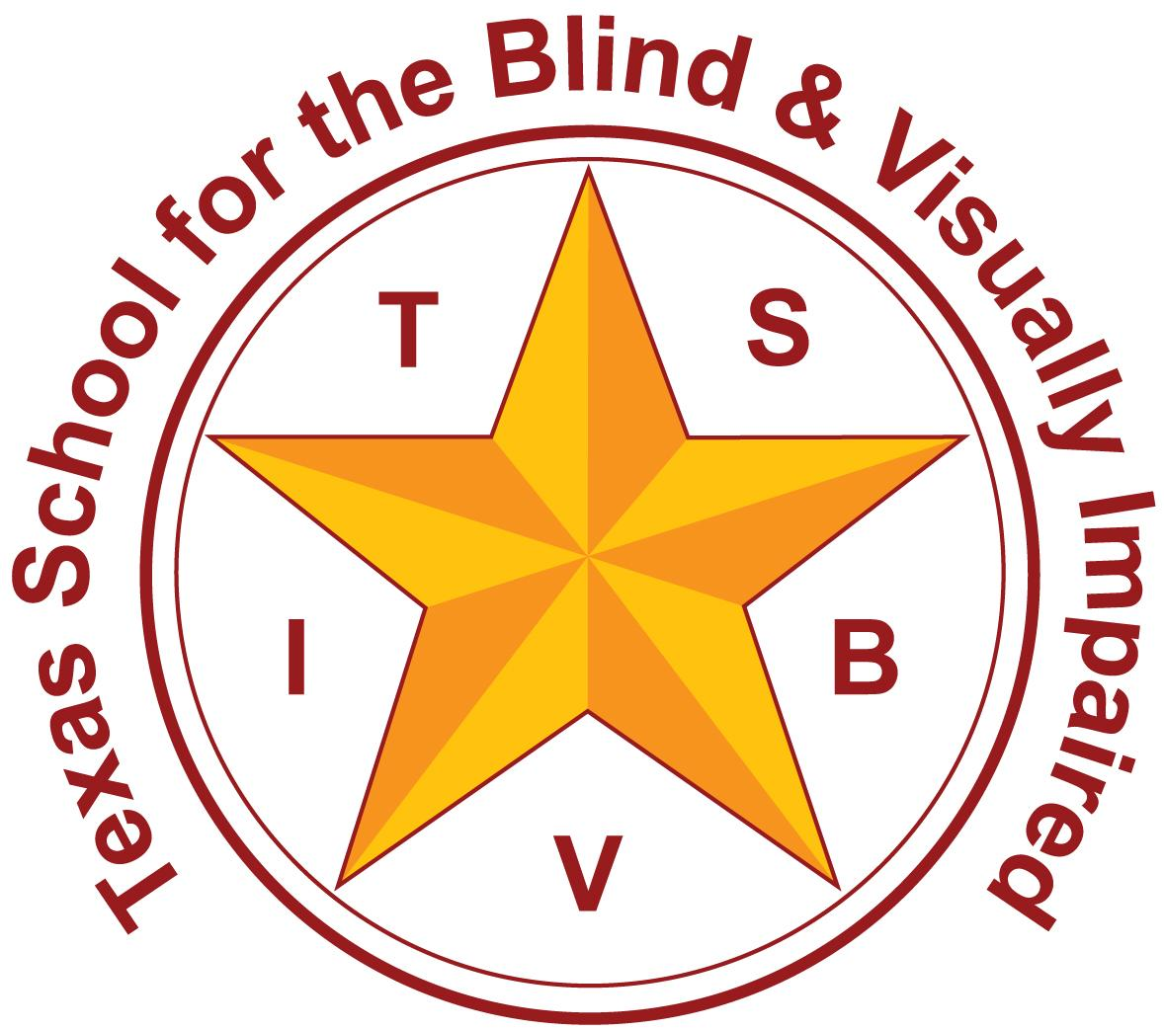
Texas School for the Blind and Visually Impaired
Outreach Programs
www.tsbvi.edu | 512-454-8631| 1100 W. 45th St. | Austin, TX 78756

Coffee Hour
Who are Proficient Communicators and How Can We Support Them?

March 25, 2024
Rachel Collins

Proficient Communicators
Currently, we are seeing an increase in congenitally deafblind students who are proficient communicators. The majority of these students have different etiologies than Usher Syndrome and were deafblind from birth.

Who are Proficient Communicators
Characteristics of Proficient Communicators:
- Language/Communication: The student primarily uses conventional language (asl, english, spanish, other sign systems- as opposed to modes typically used by emerging communicators (prelinguistic object cues).
- Intellectual ability: Intellectual functioning and cognitive abilities indicate functioning in the normal range as opposed to an intellectual disability. NOTE: We have to be very careful with this, as cognitive testing is not normed for students who are deafblind; far too often our students are at risk for being labeled ID due to inappropriate testing.
- Curriculum: The learner uses the state adopted general education curriculum. The curriculum may be adapted in regards to scope, but is not an alternative curriculum.
- State testing on state adopted curriculum: The student takes state testing with or without accommodations.
- Diploma track: The student is working towards a high school diploma that meets state requirements for graduation with or without accommodations. NOTE: Be on the lookout for some proficient communicators that may be inappropriately tracked.
- Social: The student may have a good understanding of social dynamics, be keenly aware of peers, and be able to compare themselves to others, but may still need support to interact with peers and make friends.

2023 Texas Deafblind Child Count
2023 Texas Deafblind Child Count = 846
(2024 Texas Deafblind Child Count = 873!)
- 448 students STAAR tested
  - Regular State Testing w/wo accommodations = 161 (36%! More than ⅓ of our DB Count!)
  - School for the Deaf/School for the Blind= 16
  - Served by Regional Day Programs for the Deaf= 73
  - In the regular education classroom 80% = 100
  - In the regular education classroom 40-79%= 26

2023 Texas Deafblind Child Count cont’d.
- Of the 161 students:
  - Cochlear Implants= 39
  - CHARGE Syndrome= 10
  - Usher Syndrome= 17
  - Interveners= 22 (4 certified)

Proficient Communicators…
…are faced with some of the same underlying problems as emerging communicators.
- They have issues with gathering important incidental information that can lead to missing or incorrect key concepts as they grow up.
- Additional time is required to gather information, process and respond.

How do proficient communicators fit

in the federal definition?
Federal Definition again- “Deaf-blindness means concomitant hearing and visual impairments, the combination of which causes such severe communication and other developmental and educational needs that they [the children] cannot be accommodated in special education programs designed solely for children with deafness or children with blindness (34CFR, Part 300, Subpart A, 300.7 (c)(2))”
- This means there is a need for specialized instruction that is unique to their dual sensory impairment. What does that look like?

Gathering Common Needs
Over time and across multiple on-sites, our Project compiled a list of 12 specific recurring needs for Proficient Communicators.

12 Considerations for Specialized Instruction for Proficient Communicators
IEP Checklist for Proficient Communicators

1. Concepts
Address Requisite Concept (foundational concept) development through assessment and instruction.
- Being deafblind results in gaps in foundational information that are essential for concept development. Identifying and remediating these gaps is necessary for progress in the general curriculum. Requisite concept development is an area that must be systematically evaluated.

2. Modify
Modify the curricular content; develop standards-based IEP in cor subjects
- Gathering information takes much longer for students who are deafblind than for typical learners. The pace of instruction should slow down. With varying degrees of hearing and vision, incidental learning is prohibited throughout the student’s life. This results in the student having less essential background information in comparison to peers. The scope of information in a general education classroom can be overwhelming, so modifying the curricular content prioritizes the curriculum so that it is manageable and instructive.

3. Comprehension Checks
Define comprehension checks and include an individualized description in the student’s accommodations.
- We can gain insight into a student's understanding through effective comprehension checks. Effective comprehension checks should be open-ended questions that allow for the student to explain what the information means to them or how it relates to other information that they know. Instead of asking a Yes/No question such as “Do you understand?”, a more effective comprehension check may be “Can you explain that word or concept to me?” or “What does that mean to you?”

4. Time
Build time into the day to intervene; add an elective or time in a resource classroom.
- Students who are deafblind need additional instruction to master essential concepts. There is often inadequate time in the current schedule to provide appropriate instruction in these concepts. An elective period and be created (i.e. Innovative Courses) to pre-teach, re-teach, provide targeted comprehension checks, and allow extra time for inquiry and investigation.

5. Adapt
Apply adaptations and modifications to homework assignments; shorten, provide additional time, allow oral responses. Consider assigning alternative projects, and/or reducing or eliminating homework.
- Students who are deafblind have to work much harder than their peers to gather information and often experience fatigue. Strategies to reduce or eliminate homework may be necessary for some students. Provide alternative assignments that allow the student to apply knowledge that will help with concept development and understanding.

6. Technology
Consider the student’s technology needs. Develop a technology plan in the ARD minutes or deliberations.
- Students who are deafblind often require technology to compensate for the varying degrees of combined vision and hearing levels. They often acquire, and may be responsible for, many more devices than other students in special education.

7. Stress
Monitor indications of stress.
- Students who are deafblind are working harder than their peers to keep up with real time instruction over the course of a school day, and well into the evening hours. This can result in extremely high levels of stress as well as feelings of inadequacy.

8. Behavior Distress
Consider the impact of being deafblind on behavioral issues.
- High levels of stress can lead to distress. Individuals who are deafblind or have visual and multiple impairments pose unique challenges to the educators who work with them because of their unique learning style resulting from reduced or missing access to information through vision and hearing. Frequently the way these individuals behave in response to this lack of information is interpreted as intentional “bad behavior”. In fact, these troublesome behaviors are a natural response to stress caused by feelings of fear and confusion. We want to ask educators to reframe their thinking about behavior these students may exhibit and see a child in distress rather than a child who is willfully “acting out”.

9. Social Skills
Consider the unique social skills needed for a student who is deafblind; include these in the IEP and provide direct instruction.
- Being deafblind impacts the ability to form relationships and respond to interactions with others in typical ways. For example, a lack of environmental information makes it difficult to identify people, locate them, know what they are doing, or understand what they want. It is not unusual to see withdrawal and problems with bonding. It is important to consider that social problems for a student who is deafblind are often the result of an on-going lack of essential information.

10. Self-Advocacy
Consider the unique skills needed in self-advocacy for a student who is deafblind, include these in the IEP, and provide direct instruction.
- Being an effective self- advocate about communication and access to information is essential for success in higher education, employment, and other community settings.
Note regarding advocacy fatigue: It is important to acknowledge that each child differs in their ability to be a self-advocate and that the demands of constantly having to advocate for basic needs related to access can be incredibly fatiguing for an individual.

11. Supplemental Services
The discussion for supplemental needs and services considers the need for additional resources, training and/or staff to provide in-class support.
- Certain related services and supports are designed for students with sensory impairments, and should be considered for all students who are deafblind. For example, an intervener is a paraprofessional with special skills and training who is designated to work individually with a student who is deafblind. Students in general education classes may need these supports. Sign language interpreting and Orientation and Mobility are also examples of specialized services.

12. Transition
Consider the unique transition needs of a student who is deafblind and include these in the IEP.
- As a student enters the teen years and nears graduation, there are considerations for both educational programming (are they planning to go to college, get a job, live independently, and what skills need to be targeted to help them be better equipped for these things ) do they understand and are they able to access community services (especially those designed for people are who are db (community interveners, co-navigators, db job coaches and case managers).
- Transition Resources

Join our ListServ!
You may have joined before, but since COVID, there have been a lot of changes in the Project. We would love to hear from you again!
- PC ListServe

Contact Me
Rachel Collins
collinsr@tsbvi.edu

Thank you for joining me!

