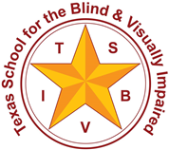

Tactile Language Development in Students who are Congenitally Deafblind

August 29, 2022

Presented by
Kaycee Bennett, Education Consultant, Texas Deafblind Project, bennettk@tsbvi.edu
www.tsbvi.edu | txdeafblindproject.org

Developed for

Texas School for the Blind & Visually Impaired Outreach Programs

Coffee Hour

Tactile Language Development in Students who are Congenitally Deafblind

Slide 2: Upcoming Book Study

If you can see it, you can support it- A book on tactile language from the Nordic Welfare Centre (free download!) https://nordicwelfare.org/en/publikationer/if-you-can-see-it-you-can-support-it-a-book-on-tactile-language/
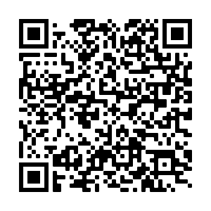

Slide 3: Register for the Free Book Study
Dates (3:30-4:30 Central): https://txtsbvi.escworks.net/catalog/session.aspx?&session_id=40535
Sept 29, 2022
Oct 27, 2022
Nov 17, 2022
Dec 15, 2022
January 26, 2023
February 16, 2023
March 30, 2023
April 27, 2023
May 18, 2023

Slide 4: Quotes
Today’s overview will be a series of quotes from the book along with a discussion of these quotes.

Slide 5:
“Persons with congenital deafblindness have limited access to conventional sign language as a first language unless they have sufficient functional residual vision. This creates problems with access; accessing visual sign language may prove difficult. When looking at the expressions made by the person with congenital deafblindness themselves, we can see that the expressions most often are not based on the visual sign language; rather the linguistic expressions arise from what they are sensing through the bodily and tactile modality.” -Goran Andreas Gregor Caspian Forsgren pg. 84
Slide 6:
“First we have to believe that they can and will tell their stories, and then try to understand how and what they sense. The language of this person, and how it expresses her thoughts.”- Kari Schjoll Brede pg.33

Slide 7: When is it Language?

“Nothing is a linguistic sign unless it is interpreted as one.” -Nedelina Ivanova on Charles Peirce’s Sign pg.34
Slide 8: 1989 Gallaudet Study

“It appears to us to be unrealistic to think that a person who does not know a language and who cannot receive it in the form presented could learn much from someone trying to communicate in that language.”- Johnson, Liddell & Erting pg.43
Slide 9: Using the Tactile Sense

“It is through the tactile sense that the child with congenital deafblindness can most easily “unlock his or her curriculum”.” - Arfinn Muruvik Vonen pg.46
Slide 10:
“Today, there is also research that shows that the brain has the ability to reorganise and develop areas. This means that the tactile area in the brain takes over when vision and hearing do not work fully. It is therefore legitimate to assume that people with congenital deafblindness have a greater ability to perceive and interpret information from the tactile sense than sighted/hearing persons have.” -Caroline Lindstrom pg. 54

Slide 11: McGurk Effect
Note the sounds being made in each of these two clips. https://www.youtube.com/watch?v=yJ81LLxfHY8

Slide 12: We Hear with Our Brains
Understanding speech is a process between the ears, eyes, and brain. We use vision to support and even alter the information coming in auditorily. This is why even mild impairments compound to create a significant need.

Slide 13:
“If we as hearing care professionals only focus our rehabilitation efforts on the ear, then we ignore a significant part of the challenge; we forget that the brain needs the best possible signals from both the ears and the eyes and in many cases also the tactile sense.”- Rolf Mjones, AuD pg.52

Slide 14: Upcoming Book Study

If you can see it, you can support it- A book on tactile language from the Nordic Welfare Centre (free download!) https://nordicwelfare.org/en/publikationer/if-you-can-see-it-you-can-support-it-a-book-on-tactile-language/

Slide 15: Register for the Free Book Study
Dates (3:30-4:30 Central): https://txtsbvi.escworks.net/catalog/session.aspx?&session_id=40535
Sept 29, 2022
Oct 27, 2022
Nov 17, 2022
Dec 15, 2022
January 26, 2023
February 16, 2023
March 30, 2023
April 27, 2023
May 18, 2023

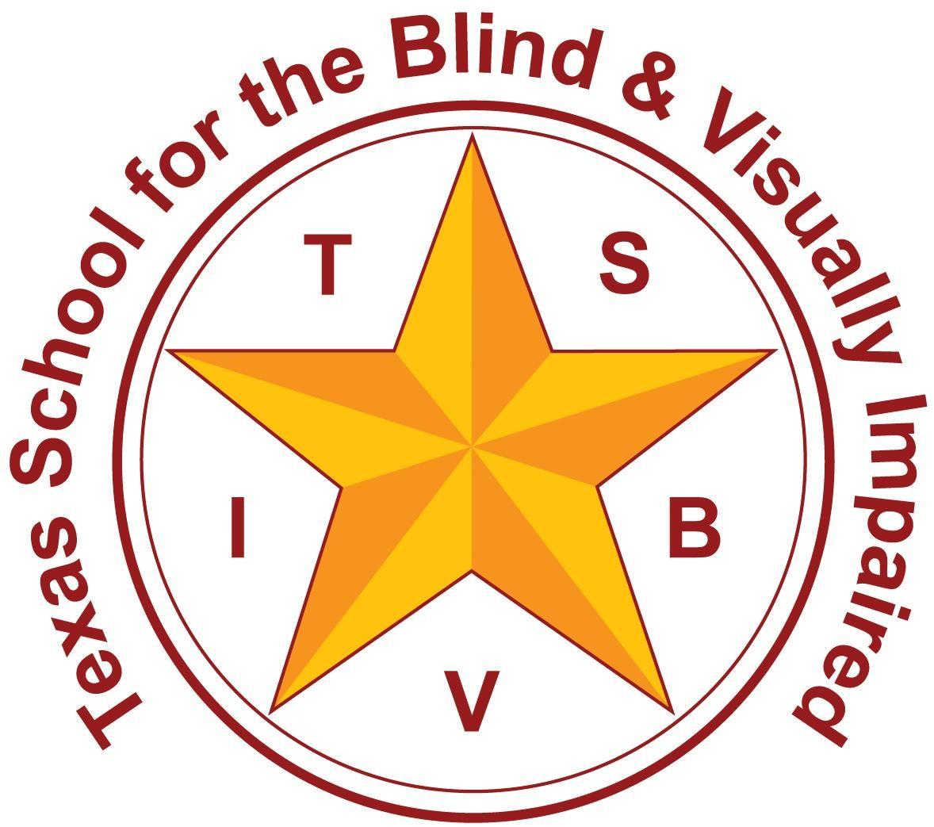
Figure 3: TSBVI Logo

The contents of this presentation were developed under a grant from the U.S. Department of Education, #H326T180026. However, those contents do not necessarily represent the policy of the U.S. Department of Education, and you should not assume endorsement by the Federal Government. Project Officer, Susan Weigert.

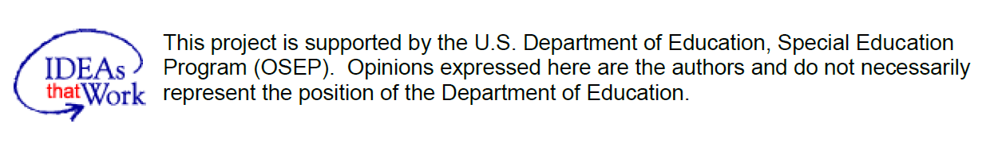
Figure 4 IDEAs that Work logo and OSEP disclaimer.

