Assessing spatial dysfunction in O&M and the classroom
Dr Lil Deverell & Dr Ian Stuart
TSBVI Coffee Hour – 13 February 2023

What is spatial cognition?
Making sense of space, getting your bearings, continually updating as you move, mental mapping, self-to-object relationships, object-to-object relationships, orientation.
Spatial concepts: Lines, angles, 2D & 3D shapes, parallel, perpendicular, adjacent, diagonal, tessellation, nesting, layers, left, right, contralaterality, clockwise, anticlockwise, under, over, behind, in front, longer, shorter, bigger, triangulation, dead reckoning.

Recognising spatial dysfunction in O&M
Observe: imprecise hand reach, groping & hand-trailing, ricochet wayfinding, easily disorientated, veering, foot-shuffling, uncertain at turns, rarely a fluent, graceful traveller.
When teaching O&M: Vague/wrong about directions, can’t point accurately, difficulty following route instructions, trouble learning new routes, needs chaining, rote learning, lots of practice, difficulty retracing steps or reversing a route, hates maps
Life choices: Likes accompanied travel, travels in social places where help is available, uses live assistance apps, great social skills, prefers familiar, limited life-space, not anxious about being lost - pervasive disorientation is normal
What’s happening in the brain? - Neuropsychology assessment
Left side of the brain: WAIS; Speech and language: verbal understanding, verbal memory, learning a word list, learning a short story, memory for instructions; Writing
Right side of the brain: Look for fragmentation of space in visual-spatial tasks: Block Design subtest, Rey Complex Figure; Blindfold tasks: 3D Block Constructions; Stuart Tactile Maps.
What about braille?
Language centres in left brain need to connect with spatial cognition in right brain.
Language disorder OR spatial dysfunction can cause problems learning braille.

Spatial fragmentation – Oliver Zangwill
Father of British neuropsychology – worked with Soldiers with traumatic brain injury in WW2. Damage to RIGHT parietal lobe showed: spatial disorientation, difficulty with constructional tests, neglect, left homonymous hemianopia.
Rey Complex Figure Test shows fragmentation.

1. Parietal lobes
Sensory perception and integration in real time (no memory)
Left parietal: Language integration; Damage… spoken/ written language deficits
Right parietal: Spatial integration; Damage… visuo-spatial deficits

3D Block Constructions
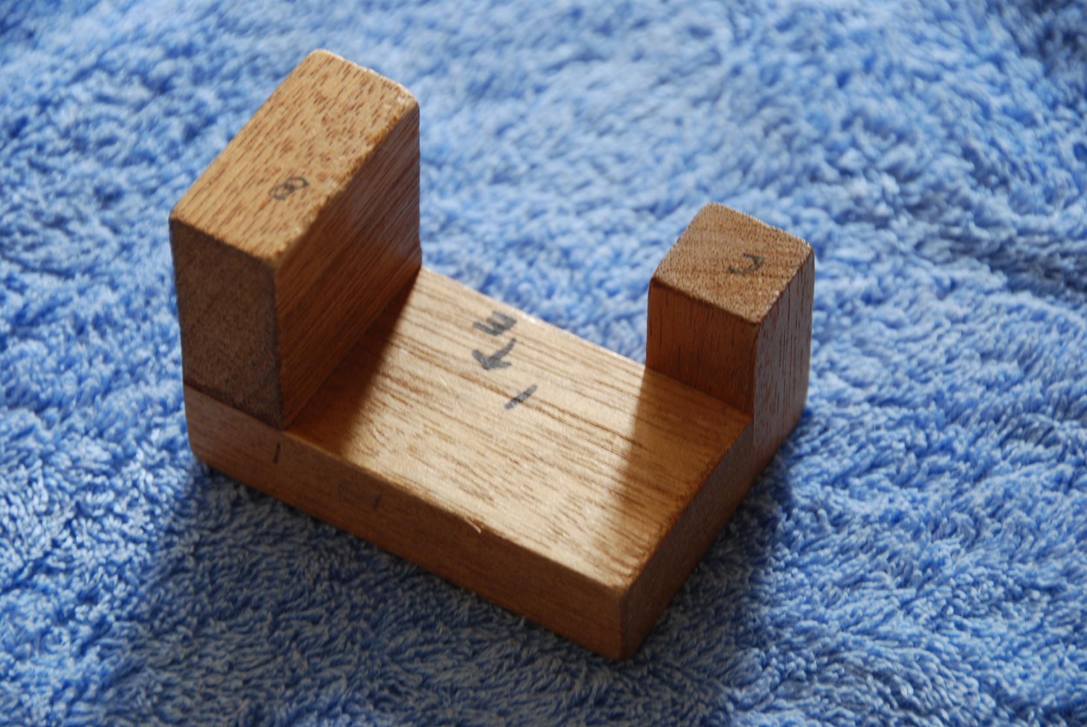
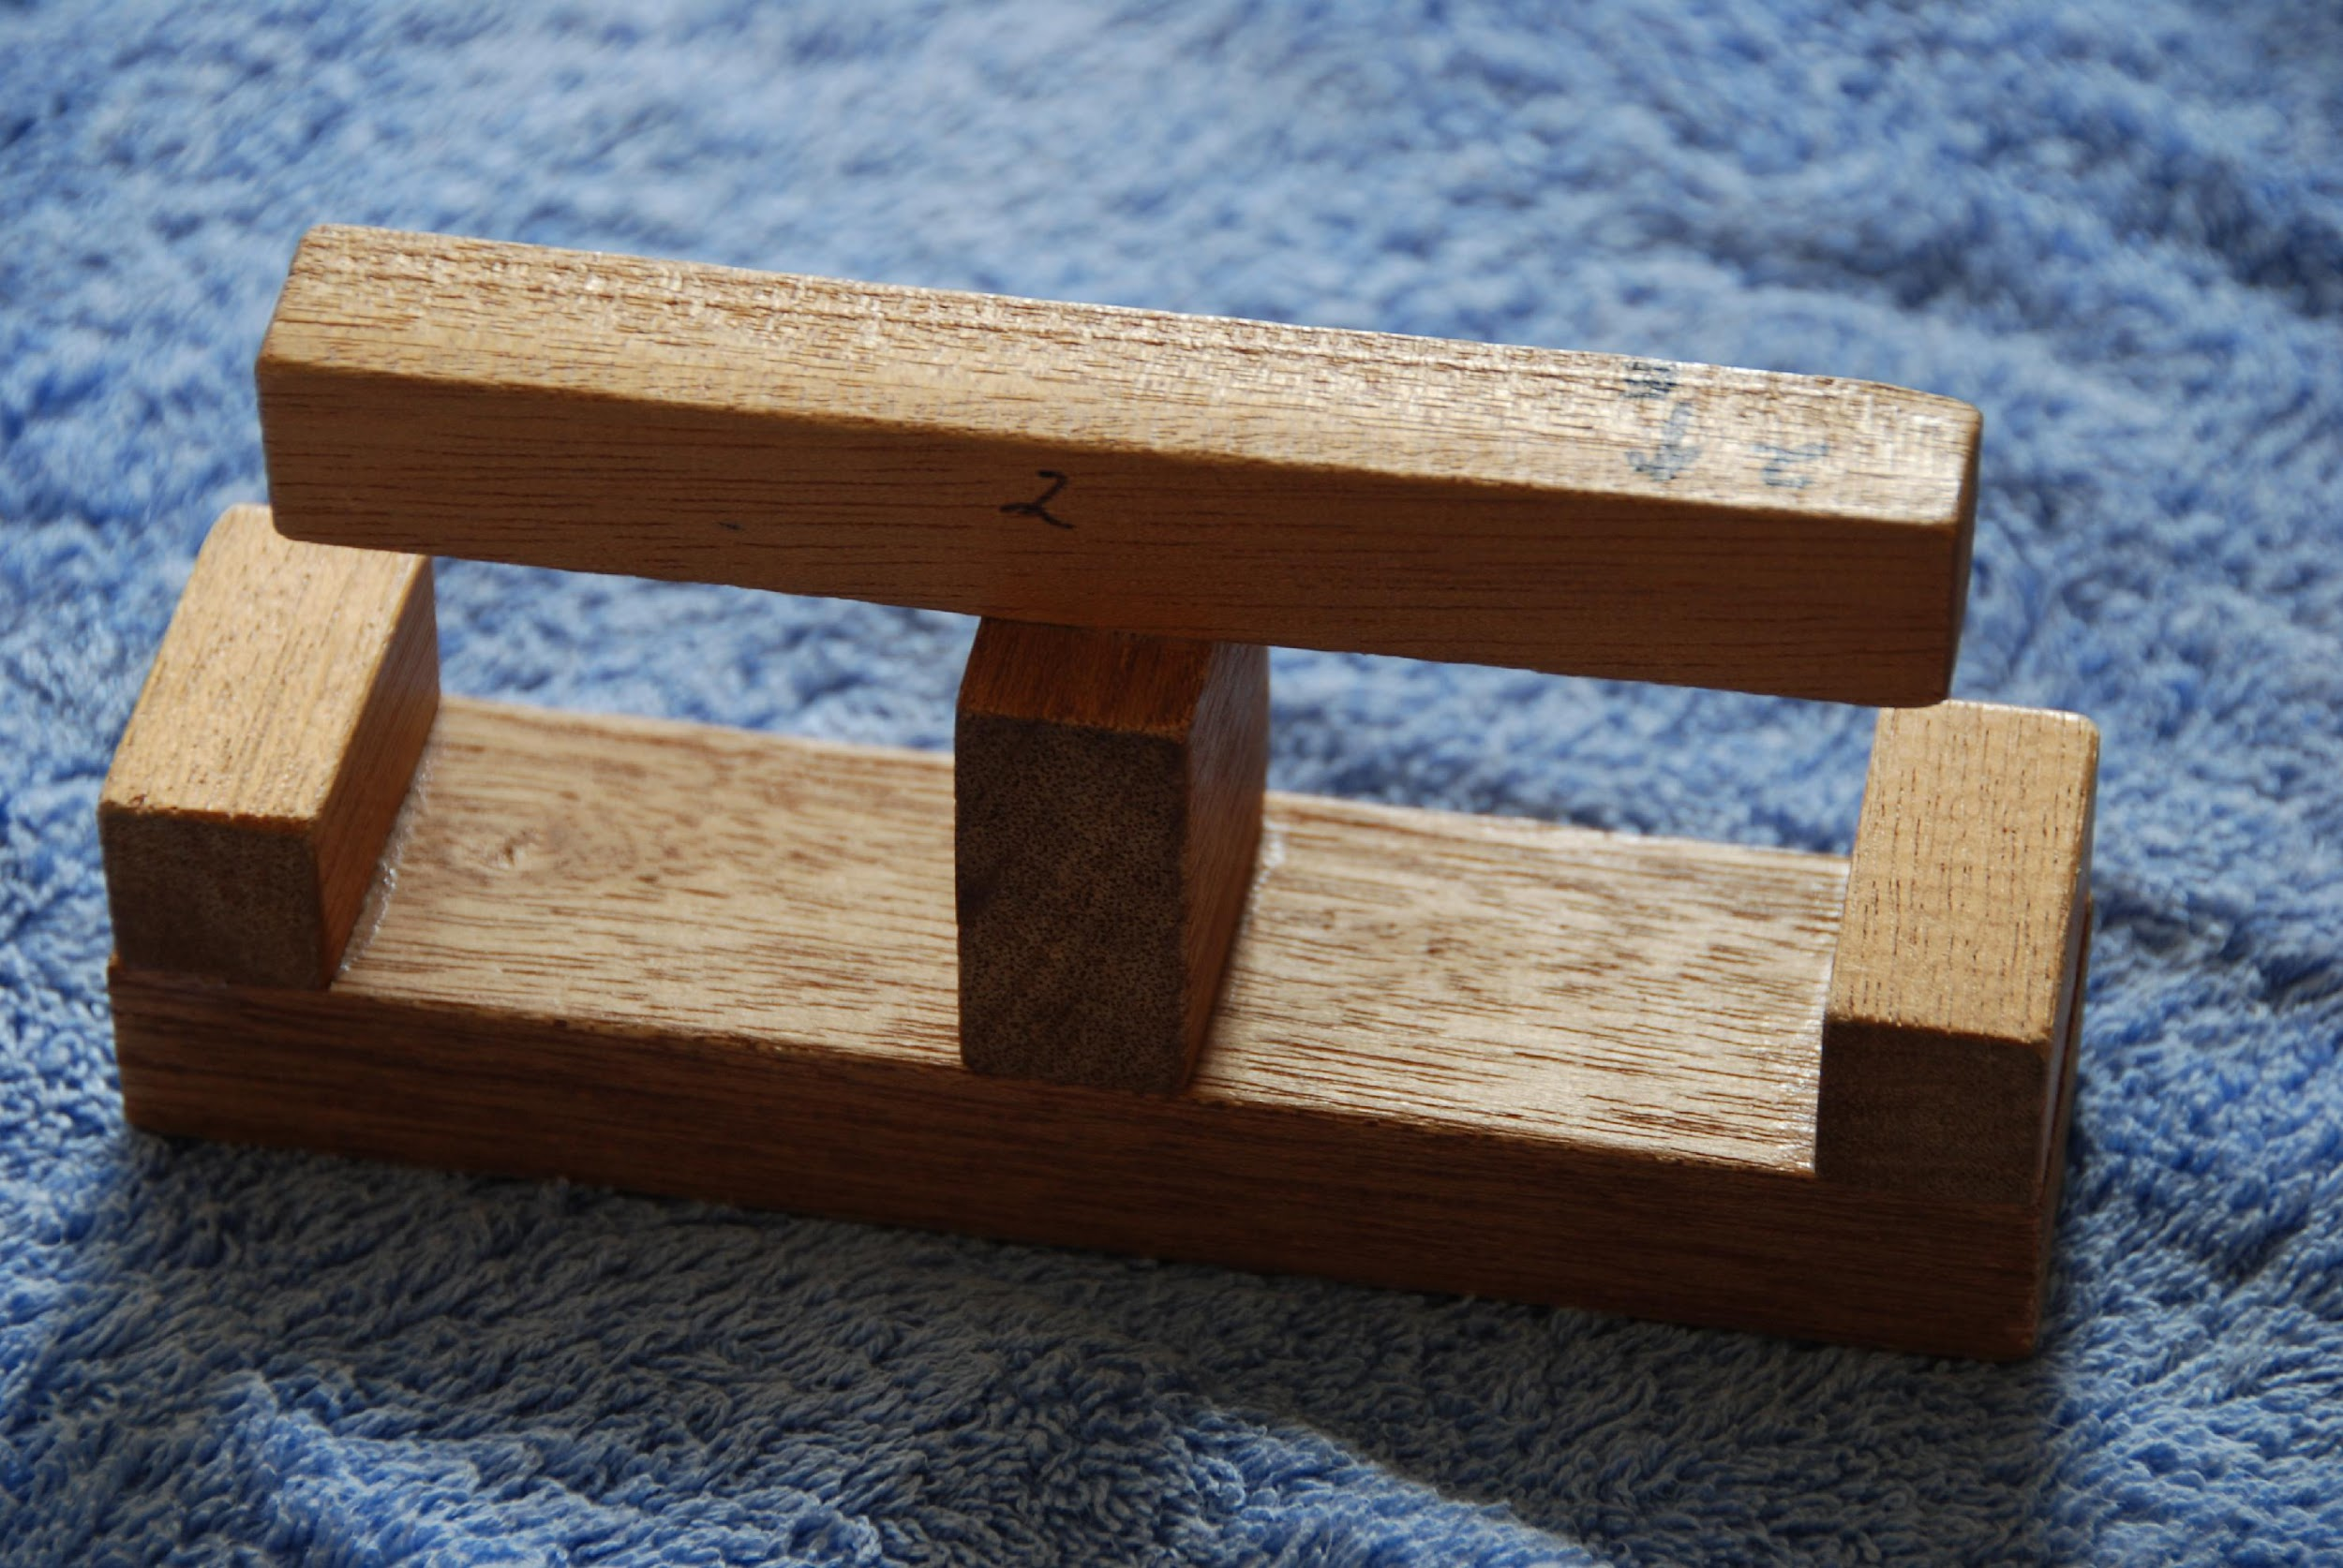
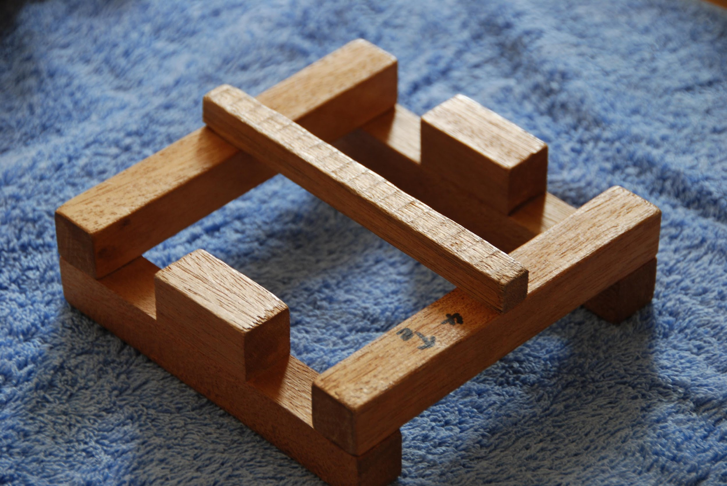
Spatial assessment test created by Ian Stuart. Copy the fixed model with the loose blocks: Two hands, free exploration; actively comparing - no memory needed; sequenced complexity.

Hey kids – try this at home! Make your own 3D block models from commercially available blocks and craft glue, or head to the shed and crank up the power tools. Right angles are simpler than triangles, cylinders and spheres. Stick with cuboids when assessing spatial dysfunction – don’t try to build the Taj Mahal!
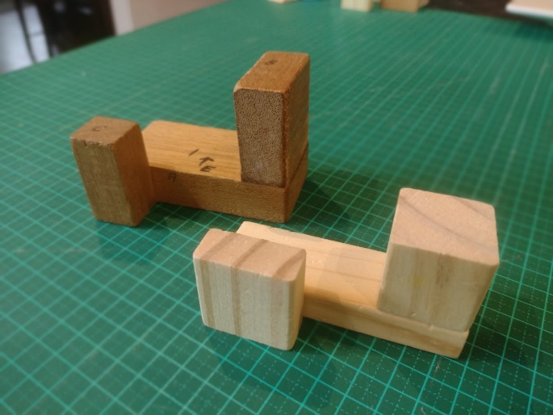
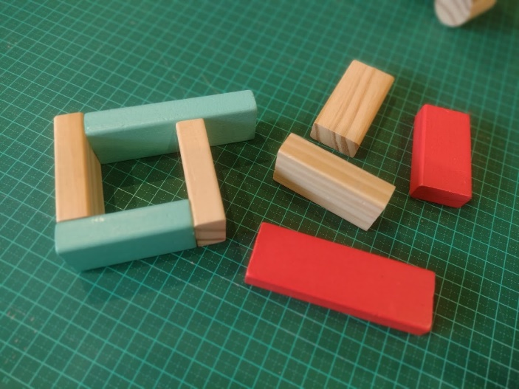

2. Hippocampus
Memory for recent events; Susceptible to brain damage
Right hippocampus: spatial memory = mental mapping

Stuart Tactile Maps
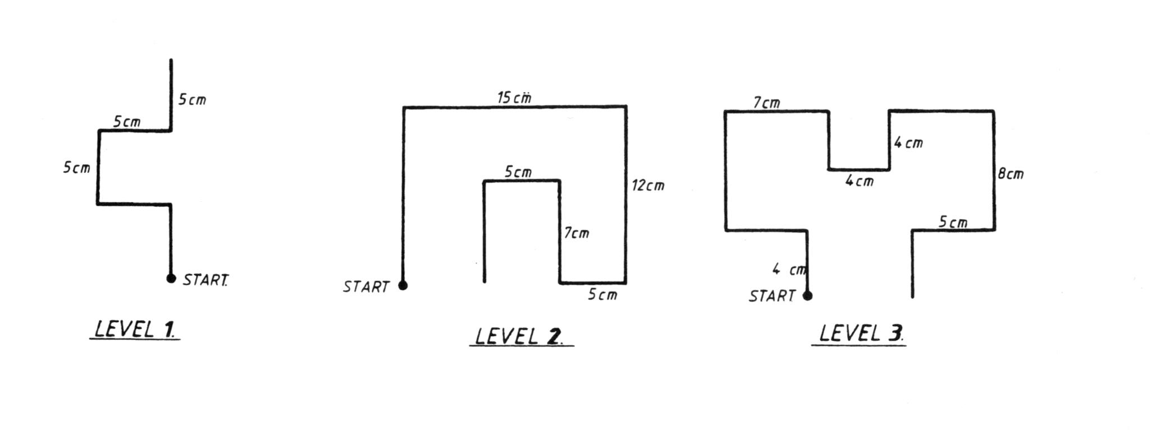
Can s/he remember a sequence of lines/turns? How complex? How much practice is needed?

Stuart Tactile Maps - Assessment kit is available through www.lildeverell.net and includes Instruction manual, Map Sets A & B, Non-slip mat, Blindfold. (Or you can make your own.)
Cost AUD$55: approximately US$60, CAD$80, €55, £50, ¥350, NZ$70

In summary
Parietal lobe understands the spatial relationships (3D blocks); Hippocampus glues the information together (STMaps)
Understanding + some glue = might learn a spatial map
No understanding + no glue = cannot learn a spatial map - Need wayfinding methods that don’t use mental mapping, and consider the implications in the classroom.

Wayfinding without mental mapping
Ricochet wayfinding, Shorelining, Rote learning, Counting steps, Kinaesthetic learning, Landmark recognition (beacon navigation, echolocation, Google streetview), Self talk, GPS apps – audio directions, Taxi, Uber, rideshare, Landmark lists (written, audio, story, song, photos, Compics, video, sequenced objects); Social navigation (social places, human guide, live apps – Aira), Dog mobility…

References
Paterson, A., & Zangwill, O. L. (1944). Disorders of visual space perception associated with lesions of the right cerebral hemisphere. Brain: A Journal of Neurology, 67, 331–358. https://doi.org/10.1093/brain/67.4.331
Paterson, A., & Zangwill, O. L. (1945). A case of topographical disorientation associated with a unilateral cerebral lesion. Brain, 68(3), 188-212. doi: 10.1093/brain/68.3.188. PMID: 21017986
Stuart, I. (1995). Spatial orientation and congenital blindness: A neuropsychological approach. Journal of Visual Impairment & Blindness, 89(2), 129-141. https://psycnet.apa.org/doi/10.1177/0145482X9508900208
Stuart, I. (2019). Spatial Navigation in Rats and Humans: A Neuropsychological Perspective. Brain Impairment, 20(3), 251-267. doi:10.1017/BrImp.2019.5

Contact us
Dr Lil Deverell, COMS, lil@lildeverell.net
Dr Ian Stuart, Neuropsychologist, ianstuart2222@gmail.com

