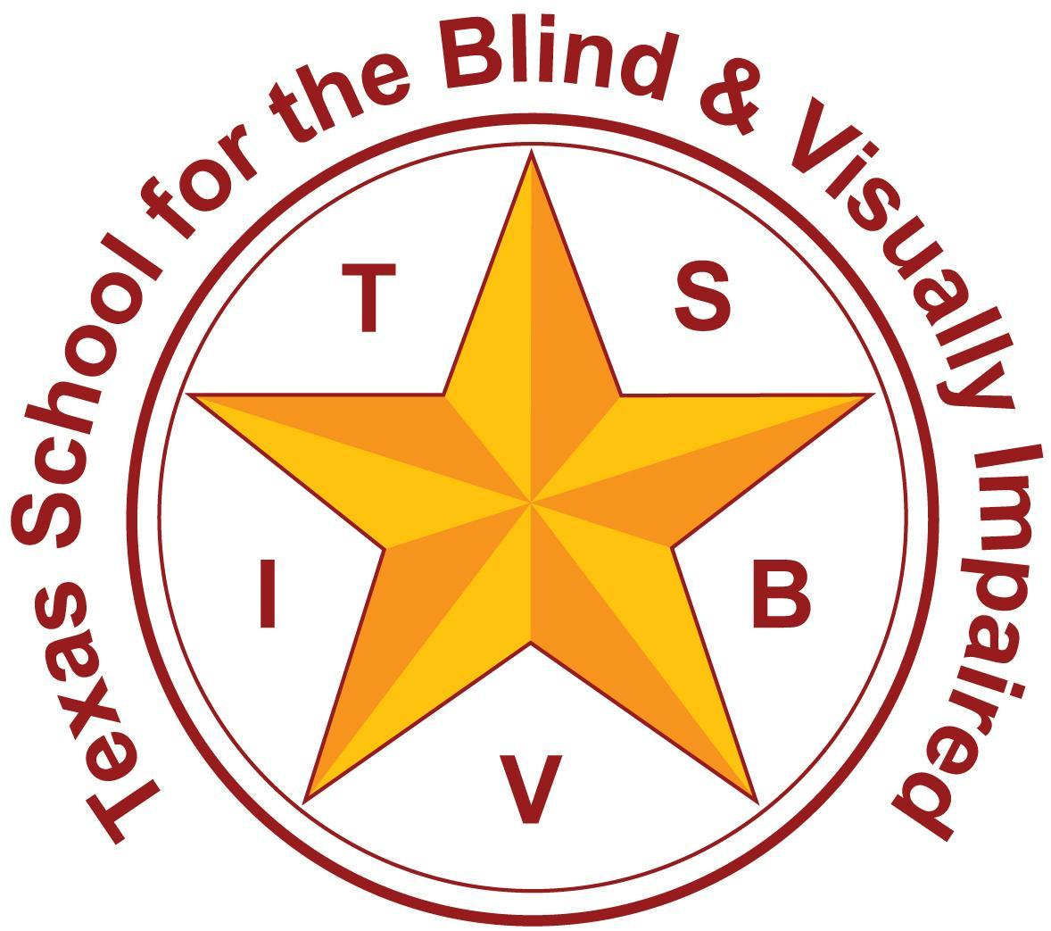
Texas School for the Blind and Visually Impaired
Outreach Programs
www.tsbvi.edu | 512-454-8631| 1100 W. 45th St. | Austin, TX 78756

Standardized Infant Functional Vision Screening Using Neonatal Assessment Visual European Grid (NAVEG)
October 6, 2025
Diane Sheline
Hillary Keys

Objectives
Participants will:
- Explain the rationale for using the NAVEG
- Identify conditions associated with CVI
- Become familiar with the screening materials
- Have an understanding of the screening components of the NAVEG
- Learn about training options

Agenda
- Conditions Associated with CVI
- NAVEG Rationale
- Components of NAVEG
- NAVEG Training

Conditions

What’s the brain got to do with it?

Some Conditions Associated with CVI
- Prematurity
- Periventricular leukomalacia (PVL)
- Hypoxic ischemic encephalopathy (HIE)
- Focal damage to the brain (hemorrhage, tumor, dysplasia)
- Neonatal hypoglycemia
- Infantile spasms and epilepsy
- Hydrocephalus/shunt failure
- Chromosomal or genetic disorders
- Metabolic disorders
- Meningitis and encephalitis
- Cerebral Palsy (CP)

Babies Count
- Results from 2022-2023 National Data:
- 32% of babies with visual impairment have the diagnosis of CVI
- Age of diagnosis of CVI: 14.5 months
- Age of referral to services for a child with CVI: 12.4 months
- Age at enrollment for BVI services: 13.4 months
- Babies Count Database (2023)

Synaptic Development
Visual connections begin before birth, and actually start to decrease by six months. This means vision is not only present, but this early time period is critical for vision development.

What do we know?
- Babies are capable of using vision, even at 37 weeks gestation!
- This could change the standard of care.
- Early brain plasticity can rewire visual pathways.
- With early parent and team training, we expect to see improvement in the use of functional vision.
- Families find information empowering.

Why does it matter to us?
- Early Intervention
- Early brain plasticity means we can help young children improve the use of their functional vision (Demaster et al., 2019)
- The earlier a positive screening, referral, and diagnosis are made, the better the functional vision outcome

Why use the NAVEG? Rationale

PROVIDES:
- Identification of at-risk infants and referral
- Greater understanding of visual development
- Increased diagnosis of CVI
- Standardized visual screening
- Not invasive
- Easy to learn how to use and to train others

Screening Disclaimer – How a Screening Differs from an Evaluation
A Screening…
- is a broad assessment that’s usually brief
- is often used to identify whether an individual demonstrates characteristics of a specific condition
- does not provide a diagnosis
- uses only a few, specific tools
- usually can be conducted by anyone with training

Components of the NAVEG

Organization of the screening steps
- Ocular Visual (4 components)
- Motor Visual (9 components)
- Perceptual (4 components)

Organization of these screening steps
Each Grouping:
- Contains both observational and interactive screening components
- When conducting screening, proceed through all observational and then all active components
Some components include using a bright light, and these should occur at the end of the screening
- May be aversive
- Constricts pupils

Observational Components: Ocular Visual
- Eye abnormalities
- Fundus abnormalities (information from the eye report)

Observational Components: Motor Visual
- Sunsetting
- Nystagmus
- Paroxysmal deviation
- Strabismus
- Erratic eye movements

Observational Components: Perceptual

Interactive Components: Ocular Visual
- Pupillary light reflex
- Red reflex

Interactive Components: Motor Visual
- Fixation
- Horizontal and vertical pursuit
- Saccadic movements

Interactive Components: Perceptual
- Contrast sensitivity
- Visual acuity
- Visual field
- Optokinetic nystagmus (OKN)

Scoring the NAVEG Screening
- Seven components can be completed through record review and observation.
  - non-invasive
  - simple to complete, especially when paired with the
- NAVEG Scoring and Code Dictionary (also known as the “cheat sheet”)
  - helps with consistent scoring.
- A total score of 6 or over indicates risk and referral to an ophthalmologist.

NAVEG Training

What will TSBVI/Outreach NAVEG training look like?
- Currently teaming with organizations to train others to conduct the screening
- Offering training at ESCs
- Investigating opportunities to train ECI providers and medical staff

What to Expect
- What should you expect from these trainings?
  - Option 1 - training screeners
  - Option 2 - training of trainers
  - Ongoing support

Thank you for joining us

TSBVI NAVEG training team
- Lynne McAlister mcalister@tsbvi.edu
- Diane Sheline strategytosee@gmail.com
- Hillary Keys keysh@tsbvi.edu
- Emily Leeper leepere@tsbvi.edu

References
Barnard, P. J., & Teasdale, J. D. (1991). Interacting cognitive subsystems: A systemic approach to cognitive-affective interaction and change. Cognition & Emotion, 5(1), 1–39. https://doi.org/10.1080/02699939108411021
Bauer, C. M., & Papadelis, C. (2019). Alterations in the Structural and Functional Connectivity of the Visuomotor Network of Children With Periventricular Leukomalacia. Seminars in Pediatric Neurology, 31, 48–56. https://doi.org/10.1016/j.spen.2019.05.009
Boonstra, F. N., Bosch, D. G. M., Geldof, C. J. A., Stellingwerf, C., & Porro, G. (2022). The Multidisciplinary Guidelines for Diagnosis and Referral in Cerebral Visual Impairment. Frontiers in Human Neuroscience, 16. https://www.frontiersin.org/articles/10.3389/fnhum.2022.727565
Dehaene-Lambertz, G., & Spelke, E. S. (2015). The Infancy of the Human Brain. Neuron, 88(1), 93–109. https://doi.org/10.1016/j.neuron.2015.09.026
DeMaster, D., Bick, J., Johnson, U., Montroy, J. J., Landry, S., & Duncan, A. F. (2019). Nurturing the preterm infant brain: Leveraging neuroplasticity to improve neurobehavioral outcomes. Pediatric Research, 85(2), 166–175. http://dx.doi.org/10.1038/s41390-018-0203-9
Lowery, R. S. (2006). Cryptic cerebral visual impairment in children. British Journal of Ophthalmology, 90(8), 960–963. https://doi.org/10.1136/bjo.2006.094250
Micheletti, S., Merabet, L. B., Galli, J., & Fazzi, E. (2023). Visual intervention in early onset visual impairment: A review. European Journal of Neuroscience, 57(12), 1998–2016. https://doi.org/10.1111/ejn.15841
National Research Council. 2000. From Neurons to Neighborhoods: The Science of Early Childhood Development. Washington, DC: The National Academies Press. https://doi.org/10.17226/9824.
Ortibus, E., Fazzi, E., & Dale, N. (2019). Cerebral visual impairment and clinical assessment: The european perspective. Seminars in Pediatric Neurology, 31, 15–24. https://doi.org/10.1016/j.spen.2019.05.004
Rossi, A., Gnesi, M., Montomoli, C., Chirico, G., Malerba, L., Merabet, L. B., & Fazzi, E. (2017). Neonatal assessment visual european grid (naveg): Unveiling neurological risk. Infant Behavior and Development, 49, 21–30. https://doi.org/10.1016/j.infbeh.2017.06.002
Sakki, H. E. A., Dale, N. J., Sargent, J., Perez-Roche, T., & Bowman, R. (2018). Is there consensus in defining childhood cerebral visual impairment? A systematic review of terminology and definitions. British Journal of Ophthalmology, 102(4), 424. http://dx.doi.org.unco.idm.oclc.org/10.1136/bjophthalmol-2017-310694
Yang, J., Kanazawa, S., Yamaguchi, M. K., & Motoyoshi, I. (2015). Pre-constancy Vision in Infants. Current Biology, 25(24), 3209–3212. https://doi.org/10.1016/j.cub.2015.10.053

