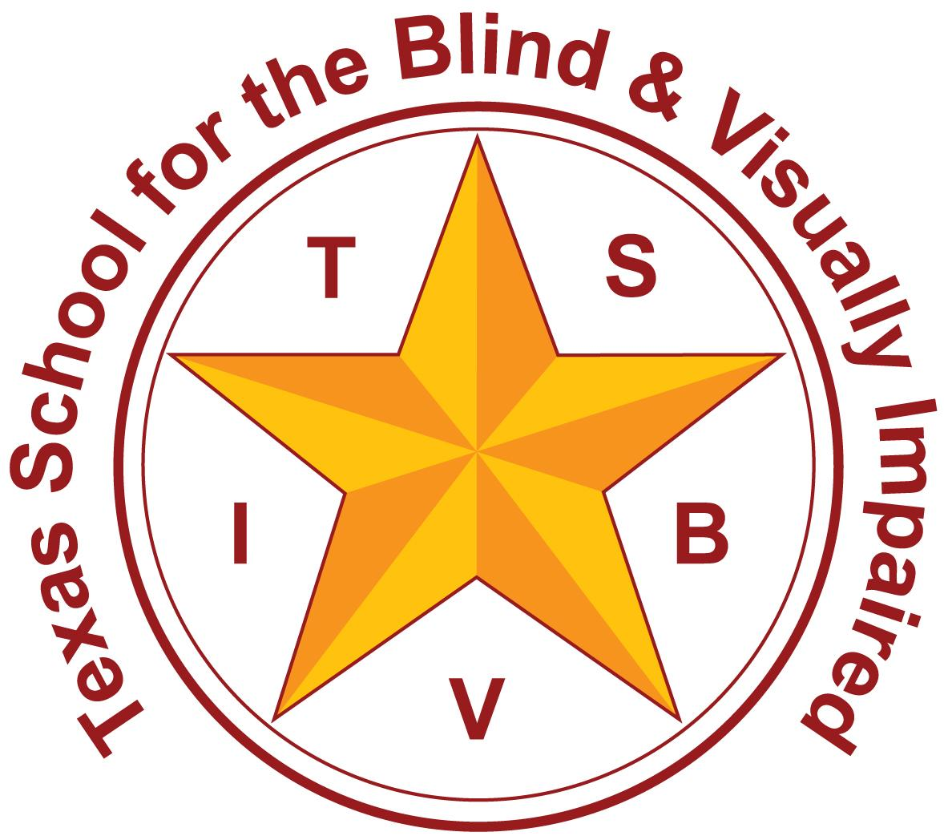
Texas School for the Blind and Visually Impaired
Outreach Programs
www.tsbvi.edu | 512-454-8631| 1100 W. 45th St. | Austin, TX 78756

Coffee Hour: Key Concepts of Behavior Guidance

February 5th, 2024

Facilitated by

Emily Leeper, VI Education Consultant

leepere@tsbvi.edu

Lynne McAlister, VI Education Consultant

mcalisterl@tsbvi.edu

All the Reasons We Exhibit Behavior According to eSped Functional Behavioral Assessment
- Control
- Escape
- Revenge
- Attention Seeking
- Sensory Stimulation

Reasons We Exhibit Behavior According to Life…
- “I’m bored”
- “I don’t feel good.”
- “I’m confused.”
- “I’m not ready.”
- “I’m scared.”
- “I’m embarrassed.”
- “This is too hard.”
- “I’m lonely.”
- “I need help.”
- “I want to have some input into this decision.”

Tax Time

A Child exhibits BEHAVIOR

A Child experiences DISTRESS

“Two men looked out from prison bars, One saw the mud, the other saw stars." - Dale Carnegie

What are some ways that sensory impairment may impact behavior?
- Misinformation & misunderstanding
- Constant signaling and hypervigilance
- Sensory defensiveness such as tactile or auditory defensiveness
- Situations may be confusing or threatening due to incomplete, distorted, or missing information from other people and the environment.
- Anxiety and fear in response to something perceived as threatening.
- Communication attempts may go unrecognized or misunderstood by others.
- Situations may remind the student of a past trauma or adverse experience.
- Different perceptions of what is interesting, important, motivating, or punishing.
- Difficulty forming complete concepts.

Sensory Impairments and Learning

Visual
- Allows for simultaneous perceptions
- Information can be gained in single viewing
- Allows gathering at a distance

Tactual
- Requires that information must be gained by exploration of one aspect at a time
- Must engage in multiple explorations
- Requires immediate proximity

Methods of Learning
- Incidental Learning- Learning by Accident
- Trial and Error- Trying several solutions and finding one that works
- Imitation- Learning by watching others
- Direct Teaching- Being specifically taught by others

Concrete to Abstract
- Image of child holding fish, a line drawing of a fish, and the word fish

Research on Touch
- https://www.sappi.com/video-3

Hand Over Hand- What Does it Teach?

Hand Under Hand

Barbara Miles makes the following points:
- Remember that hands are eyes
- Touch should be non-controlling
- Focus on shared attention
- Student is ‘watching’

Hand-Under-Hand

Takeaways

Hand OVER Hand Promotes
- Defensiveness
- Distrust
- Retreating
- Limited Exploration
- Dependence
- Negative Behaviors

Hand UNDER Hand Promotes
- Respect
- Trust
- Bodily Autonomy
- Exploration
- Independence
- Tactile Feedback

Safety and Neuroception
- Neuroception: The process by which our nervous system evaluates risk outside of our awareness. Our brain’s subconscious security guard working hard to consistently keep us safe.
- If a child falsely senses threat, it’s still neuroception.
- Instead of focusing on eliminating behaviors, we need to provide children with signals of safety.
Mona Delahook, ‘Beyond Behavior’

Ideas
- Safety is imperative
- We experience safety/threat from sensory information
- Students with sensory impairments have limited access to this information
- Students with sensory impairments may have disordered sensory systems

Summary
- It’s not the stimulus that goes in, it’s the way the nervous system reacts to the stimulus

Co-Regulation
- Co-regulation lies at the heart of all human relationships. According to Polyvagal theory, it is the reciprocal sending and receiving of signals of safety. It is not merely the absence of danger but connection between two nervous systems; each nourishing and regulating the other in the process.
- Because it is baked into our evolutionary past, it is not a desire, but a need – one developed to facilitate survival. As humans, we therefore are programmed to seek interpersonal connection: it is a biological imperative.
- Co-regulation is the process of someone with a regulated nervous system, perhaps a parent, effectively sharing their calm with someone whose nervous system is spiralling out of control, for example, a tantruming toddler.

Human Presence
- The way that we interact with other people defines our role in their life.
- We each have an ‘Emotional Signature’.
- If we are seen as demanding or having negative feelings, others may want to avoid us.
- If we are seen as a rewarding, empathetic person, others will want to be around us.
- “If the majority of our words and contacts are given for the purpose of instructing or correcting, then it is likely that human interaction will come to represent the onset of demand.”

Social Interactions
- Human presence may signify demand
- Interests may be quirky and cause others to avoid them
- Infrequent low-demand friendly ‘hanging out’
- Task focus vs relationship focus
- Safety and Security
- Predictability
- Fairness
- Meaningful, Fun,
- and Rewarding Activities

VS
- Demand/Control
- Fear
- Loss of Freedom
- Helplessness
- Instability
- Confusion

Have Fun!

References

TSBVI Behavior Guidance Document

Typical Learning vs. Deafblind Learning” from Alsop, L; Berg, C; Hartman, V; Knapp, M; Lauger, K; Levasseur, C; Prouty, M; and Prouty, S. (2012). A Family's Guide to Interveners for Children with Combined Vision and Hearing Loss, (p. 13-16). SKI-HI Institute, Utah State University, Logan, Utah. Pyramid reference Book available for purchase on Interveners.org

McGee, J. J. (1987). Gentle teaching: a non-aversive approach to helping persons with mental retardation. New York, N.Y., Human Sciences Press

References

Beyond Behaviors: Using Brain Science and Compassion to Understand and Solve Children's Behavioral Challenges Dr. Mona Delahook, March 19, 2019

Texas School for the Blind & Visually Impaired Outreach Programs

Coffee Hour: Key Concepts of Behavior Guidance

Thank you for joining us!

Texas School for the Blind & Visually Impaired Outreach Programs
Figure 7: TSBVI logo

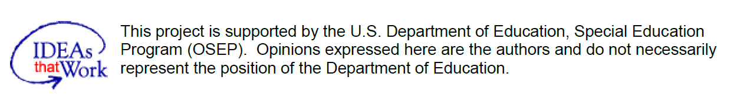
Figure 8: IDEAs that Work logo and OSEP disclaimer.

