Plug In, Power Up, Braille On! Meet Paige Connect

Introduction

Pre-Survey
- Pre-Survey Link
- Your professional title(s).
- How familiar are you with the topic of today’s professional development session?
- How confident are you in applying instructional strategies related to today’s topic in your professional practice?
- How comfortable are you with adapting teaching strategies related to today’s topic to meet the unique needs of your students?
- What is one way you might use the information from this training in your work?

Presenter
- Dr. Stephanie Walker
- APH Education and Outreach Specialist, SouthCentral Region

Learning Objectives
- Demonstrate how Paige Connect connects a Perkins-style braille writer to digital devices for interactive use.
- Engage with curated online exercises that make braille practice enjoyable and effective.
- Identify ways Paige Connect can empower learners, teachers, and families to bridge low-tech and high-tech braille tools.

Perkins Brailler
“Braille is knowledge, and knowledge is power.” — Louis Braille

Uses of the Perkins Brailler
- Braille lessons
- Short classroom work
- Spatial math work
- Written work needing hard-copy braille, such as oral presentation notes
- Labeling
- And more

Drawbacks of the Perkins Brailler
- When used in the classroom or as a learning tool:
  - No audio feedback for what is written
  - If someone who knows braille is not present, braille mistakes are not caught until later, which can lead to bad habits
  - Sighted peers and classroom teachers cannot read what is written
  - Lower tech and less engaging than tools used by sighted peers

Benefits of Adding Technology to Braille Learning
- Instant feedback so learners can correct mistakes quickly
- Motivating and engaging for students
- Potential for more interaction with sighted teachers and peers
- Lower cost, so learners could have this at home for more practice with family and friends

Paige Connect: Instant Translation and Gamified Learning

Background
- Originally developed by a group of engineers as a college project
- They quickly saw the practical applications for this tool
- Committed to keeping it available at a low cost
- Now used by more than 2,000 braille learners
- Focused on making braille easier to learn and more accessible for all

An Introduction
- Easy to attach to a traditional braille writer
- Audio feedback
- Musical key feedback can also be fun and motivating
- Mistakes in braille can be caught quickly
- Learning is fun and engaging

The Guts
- 9 U-shaped black optical sensors
- USB-A power cord
- Round hole in the back of the board for the power cord
- Replaces the bottom of a traditional braille writer
- Durable board
- Connects with Bluetooth
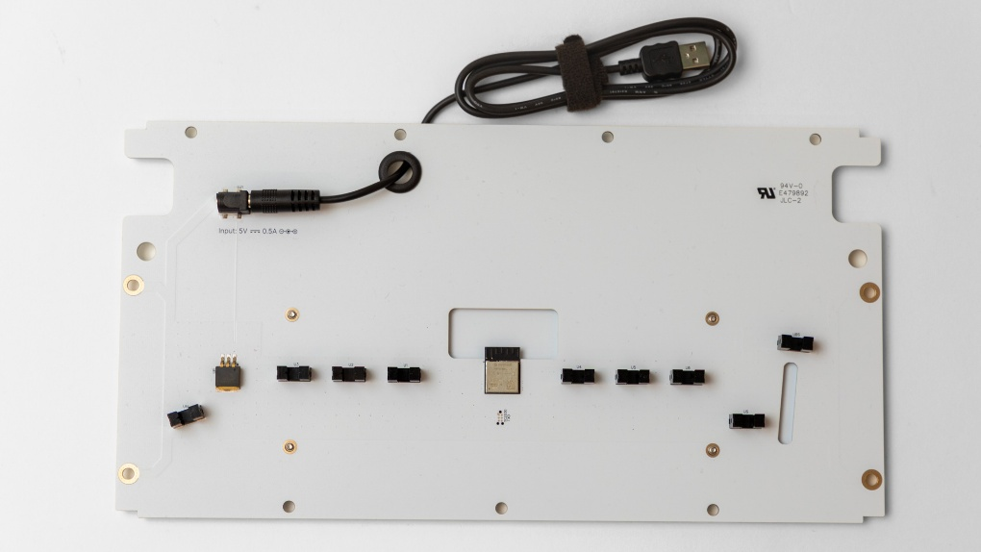

Connecting to a Brailler
- Unscrew the base of the brailler
- Replace it with the Paige Connect board
- Put the screws back in the same spaces, but do not tighten them yet
- Make sure the space key can lower fully
- Tighten the screws
- Suggestion: store the original base in the Paige Connect box

Connecting to Power
- USB-A power cord
- Battery pack
- Computer
- Tablet
- Cell phone (with a dongle)
- Any USB power source that supplies 5V DC at 0.5A or more will work

Connecting to a Device
- Make sure power is connected to Paige Connect
- Search for Bluetooth devices and pair with Paige Connect
- Only one device may be connected at a time. If it won’t connect to a new device, check that it isn’t still paired to another one.
- If Paige Connect disappears from the device list, turn the power off and back on
- Screen reader users: turn off typing echo so the screen reader doesn’t say “S D F J K L” along with the braille

Benefits in the Classroom
- Sighted peers and teachers can quickly read what is written
- Students can hand in the translated text so work can be graded alongside sighted peers
- Export to Word or BRF to share work
- Works with most websites and apps that support six-key entry

Paige Connect Benefits to Literacy
- Students practice reading and writing
- Dual media learners are more engaged with braille, so they are more likely to use braille in class work
- The engaging nature encourages students to keep learning
- A great transition to other braille technology
- Braille literacy has proven benefits for future employment

When Not in Use
- Use the included Velcro strap to bundle the cord
- Consider adding a Velcro command strip to the back of the brailler to hold the bundled cord

PaigeBraille: Translate
Website: PaigeBraille Translate

Paige Braille Website
- The Translate and Learn software is free for you and your learner
- Try it with just a computer keyboard before buying
- Works on any device, browser, and screen reader

Six Key
- The website does not need a Perkins Brailler to work
- On a computer keyboard, S, D, and F are dots 1, 2, and 3; J, K, and L are dots 4, 5, and 6; the space bar is the space
- A word appears in print once it is finished: press space or start a new line
- Turn six-key entry off in Settings when typing from a braille display keyboard, so the keys act as normal letters

Choose Your Braille Code
- Open Settings (the gear icon) to pick your braille code
- Six codes work offline; others download the first time you choose them
- The braille code changes what is spoken, so choose carefully
- Math code: Nemeth or UEB Technical
- Braille pane options: show ASCII braille instead of dots, and six-key entry
- Translation is powered by Liblouis. To request a code that isn’t listed, email hello@paigebraille.com

Speech Settings
- Speech: app voice, screen reader, or off
- Choose a voice
- Speak each letter, each finished word, or each sentence
- Speak where the cursor moves
- Beginners: turn on letters so each cell is spoken as it is written
- Press the Control key at any time to stop speech
- Screen reader users (JAWS, NVDA, VoiceOver): turn off typing echo and hints so you don’t hear everything twice

Save, Load, and Export
- Save as eBraille (.ebrl), which keeps the document structure, including math
- Export a BRF for embossers and braille devices, or a Word (.docx) file for print readers
- Load eBraille, BRF, .brl, or .txt files
- Clear asks before emptying both panels and reads the question aloud
- Ctrl+Z (Cmd+Z on a Mac) undoes ordinary edits

Braille to Print
- Braille is on the left, print is on the right
- Works both ways: print to braille, too
- Click a word to highlight it in both panels; the bar at the bottom explains each cell
- A blue dotted underline and a soft ding flag missed contractions
- Shows other ways a word could be written
- Yellow warnings mark cells that can’t be read, and “FYI” notes appear when braille has more than one reading
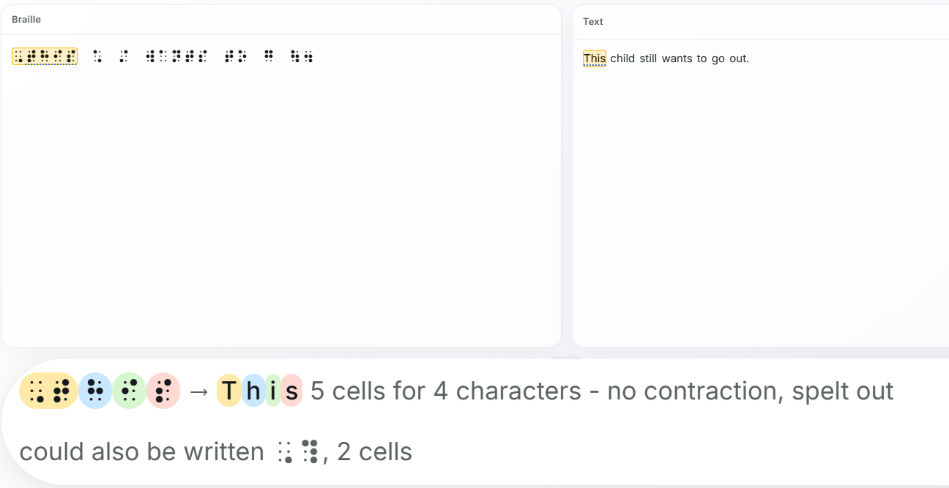

Child’s Writing Example
- A student’s writing, brailled on a Perkins with Paige Connect and translated to print:
  - “A time i did my best is when i made my halowene costume. I got a box and made it look like a robot. I cut hols in it to. It was a lot of fun.”
- Click any word to highlight the matching braille and talk through spelling and contractions with the student

Math Mode
- Press Ctrl+M or check Maths to switch to math
- Choose Nemeth or UEB Technical in Settings
- Shows real fractions, powers, and roots
- The bottom bar explains every math sign
- Ctrl+Arrow steps through an expression one part at a time
- Export to Word with real, editable equations that screen readers can read

Math Errors
- A yellow box appears when only part of the math could be read
- Unrecognized cells are boxed in red
- The message names the cell and its dots, for example “cell 19 (dots 4 6) not recognised”
- It also names what’s missing, such as an unclosed radical
- Students can find and fix errors on their own

Navigating Your Work
- Braille and print stay lined up as you scroll, so a teacher can find exactly where the student is
- Arrow keys move through the braille cell by cell
- Ctrl+Shift+L reads the current line; press it twice to spell it
- The Control key stops speech
- Works with JAWS, NVDA, and VoiceOver; braille displays and routing keys work as normal

Use Your Favorite Software
- Paige Connect works with any software that accepts six-key (home row) entry. Turn on six-key entry in each program.
- Braille learning: UEB Online (literary, math, and music) and Braille Brain
- Math: UEB Math Tutorial, Nemeth Tutorial, and Equalize Editor
- Braille files: Duxbury, BrailleBlaster, Perky Duck, and Braille Zephyr
- Braille input: NVDA and VoiceOver braille keyboard input
- Music: MuseScore braille panel
- Full list with links: PaigeBraille Resources
- Setup: pair Paige Connect with Bluetooth, open your software with home row input turned on, and start brailling

Paige Input (Free)
- Type six-key braille into any app, such as Word, email, or Notes
- Works with a keyboard or Paige Connect
- Grade 1 and Grade 2 translation
- Floating Braille View shows the cells as you type
- Turn it on and off from the menu bar or with a keyboard shortcut
- Free for Mac and Windows: Paige Input download page

PaigeBraille: Learn
Website: PaigeBraille Learn

Create an Account
- Email
- Country
- Password
- Must be over 18 years old
- No personal data is collected
- An account saves your progress in Learn

Track Your Progress
- User stats:
  - XP (experience points)
  - Time spent
  - Days active
  - Which days this week
- Progress for each section

Getting Set Up
- Log in (currently one login per email address)
- Independent navigation of this screen needs screen reader software
- Turn sound and/or musical notes on with the toggles at the top of the page
- Select a lesson
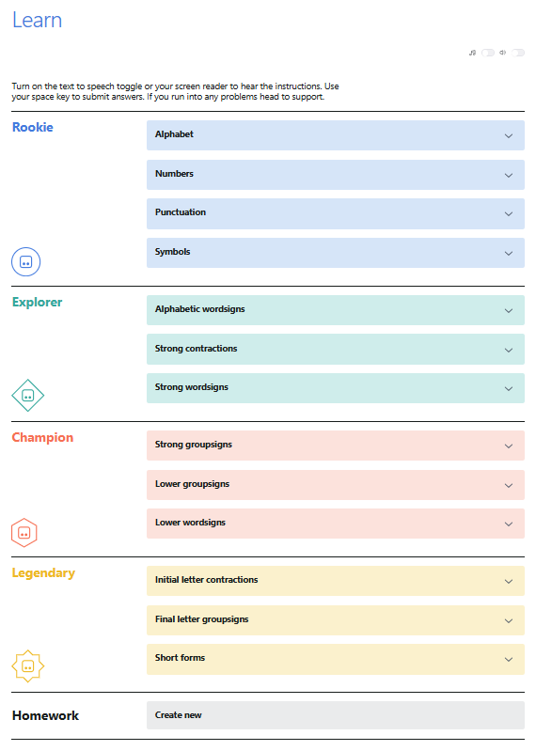

Ready to Start
- Be sure the writing box is highlighted in blue
- If you press space and nothing is spoken, the writing box isn’t highlighted

Tracking Progress During Lessons
- Your place in the current sublevel is shown as a number, such as “1 of 13”
- A blue progress bar grows to match

How It Works
- Four activity types:
  - Write: practice embossing braille
  - Read: copy out what you embossed
  - Review: reinforce what you have learned
  - Challenge: put your knowledge to the test

Hints
- Select the How It Works button
- Shows a list of the write, read, and review prompts

Write Activity
- The first time a letter, symbol, or contraction appears, its braille dots are spoken too
- After the activity, line space twice and return the carriage to be ready for the Read activity

Read Activity
- You can only practice reading right after writing
- Items are identified by number (for example, 1 to 12) and asked in order
- The letter order for each lesson is in the handout

Review Activity
- Can be completed without the write and read parts of a level
- Not available for punctuation, symbols, or short form words
- Same letters, words, and sentences in the same order each time
- Includes letters and punctuation from previous levels

Challenge Activity
- Can be completed without the write, read, and review parts of a level
- Includes all letters, symbols, or wordsigns from that set of levels
- Uses no sentences, unlike the review
- The challenge ends after five wrong answers

Rookie
- Alphabet: 8 levels, 2 challenges
- Numbers: 3 levels, 1 challenge
  - The review doesn’t explain that a number with more than one digit needs only one number sign
- Punctuation: 5 levels, 2 challenges (“full stop” means period)
- Symbols: 4 levels, 2 challenges

Explorer
- Alphabetic wordsigns: 4 levels, 2 challenges
- Strong contractions: 2 levels, 1 challenge
- Strong wordsigns: 2 levels, 1 challenge

Champion
- Strong groupsigns: 4 levels, 2 challenges
- Lower groupsigns: 2 levels, 1 challenge
- Lower wordsigns: 2 levels, 1 challenge

Legendary
- Initial letter contractions: 6 levels, 3 challenges
- Final letter groupsigns: 2 levels, 1 challenge
- Short forms: 6 levels, 3 challenges

PaigeBraille: Homework
“Just six elevated dots, to see the unseen.”

Homework Assignments
- Find Homework at the bottom of the Learn page
- Select Create new and name the lesson
- Type the questions, words, or phrases, then select Translate and Save
- The student opens the homework to practice
- Go back and edit as needed

More from Paige

Paige App for iPhone and iPad
- Learn UEB on iPhone and iPad (iOS 26 or later); Android is coming soon
- Similar format to Learn, from the alphabet to Grade 2
- Games: Daily Braille Wordle, Dot Builder, and Streak Run
- Translator and reference library
- VoiceOver and braille keyboard support
- More information: Paige app page

Paige Connect Basic Information
- Cost: $339
- APH catalog number: 1-08570-00
- Order from APH.org
- Free software: paigebraille.com
- Manual and support: Paige Connect user manual

Post-Survey
- Post-Survey Link
- Your professional title(s).
- After today’s session, how familiar are you with the topic presented?
- After today’s session, how confident are you in applying instructional strategies related to today’s topic in your professional practice?
- After today’s session, how comfortable are you with adapting teaching strategies related to today’s topic to meet the unique needs of your students?
- What was the most useful part of this session, and how do you plan to apply what you learned in your professional practice?

APH OUTREACH SERVICES
Dr. Stephanie Walker • swalker@aph.org
Outreach Services • outreach@aph.org
1839 Frankfort Avenue • Louisville, KY 40206
aph.org • outreach@aph.org
800.223.1839

