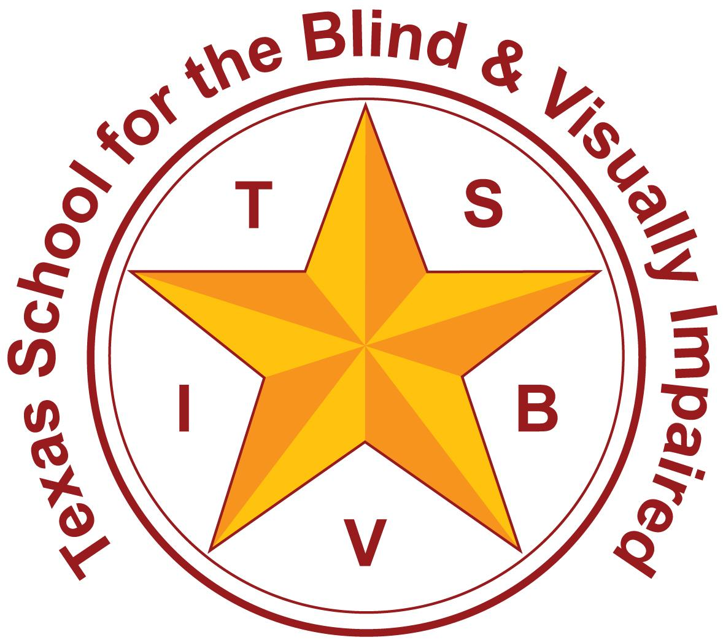
Texas School for the Blind and Visually Impaired
Outreach Programs
www.tsbvi.edu | 512-454-8631| 1100 W. 45th St. | Austin, TX 78756

Coffee Hour
General Considerations for Supporting Students with Visual Impairments

August 9, 2021
Lynne McAlister, Outreach Teacher TSBVI Outreach
Kathi Garza, Early Childhood Specialist, TSBVI Outreach

Today’s Topics
- Touch
- Concept Development
- Incidental Learning
- Social Skills
- Preparing for a New Year

Chat Chatter
What kinds of emotions can touch convey?
- Respect
- Anger
- Gratitude
- Love
- Trust
- Disgust

Research on Touch
David Eaglemen conducted a study on touch and the emotions it conveys.
https://www.sappi.com/video-3

Language of the Hands
Barbara Miles makes the following points:
- remember that hands are eyes
- touch should be non-controlling.
- focus on shared attention
- focus on the child’s experience

Literacy Needs
- What does a child need to become literate; to read and write with meaning?
- Access and exposure to a wide variety of meaningful experiences
- Opportunities to explore their world
- Experiences that link words to meaning
- Knowledge about language
- Knowledge about letters & letter sounds

Hand Over Hand (HOH) vs (Hand Under Hand (HUH)
Video of two adults cleaning a table using hand over hand and an adult working with a student to make muffins using hand under hand.

HOH/HUH Takeaways
Hand OVER Hand Promotes
- Defensiveness
- Distrust
- Retreating
- Limited Exploration
- Dependence
- Negative Behaviors
Hand UNDER Hand Promotes
- Respect
- Trust
- Bodily Autonomy
- Exploration
- Independence
- Tactile Feedback

Chat Chatter
Share about an interaction that went well because you used HUH or an activity where you could apply this skill?

Concept Development
Slide shows a cartoon image of an elephant with 6 characters standing at different parts of the animal. Each person is making a guess about what they see based on an individual part of the larger object.

Visual vs Tactile Learning
Visual Learning (picture of eyes)
- Allows for simultaneous perceptions
- Information can be gained in single viewing
- Allows gathering at a distance
Tactile Learning (picture of hands)
- Information is gained by exploring one aspect at a time
- Requires multiple explorations to build the full picture
- Requires immediate proximity

Concrete to Abstract
Slide shows 3 images
- Image shows a young child holding a real fish
- Image shows a line drawing of a fish
- Image shows the print word “fish”

Slide shows an image of a pyramid divided into 3 sections and titled “Learning for the Typical Child”
- The top section includes the text “Direct Learning” and makes up about 10% of the total pyramid.
- The middle section includes the text “Secondary Learning” and makes up about 10% of the total pyramid.
- The bottom section includes the text “Incidental Learning” and makes up about 80% of the total pyramid.
- See Reference 1 (Alsop)

Slide shows an image of an upside down pyramid divided into 3 sections.
- The top section includes the text “Direct Learning Hands on experiences are essential. The best way to learn” and makes up about 80% of the total pyramid.
- The middle section includes the text “Secondary is difficult” and makes up about 10% of the total pyramid.
- The bottom section includes the text “Incidental usually does not occur and is not effective” and makes up about 10% of the total pyramid.
- See Reference 1 (Alsop)

Concepts
Video showing a young child in a home center at her daycare discussing the plastic food items and a deafblind student learning the concepts for clothing with direct instruction.

Social Skills
- Appropriate body language
- Social communication and etiquette
- Interactions with others
- Development of relationships & friendships

Preparing for a New Year
- Collaborating with the team
- Roles and responsibilities
- Promoting independence for the student
- Conversations with peers

References
- “Typical Learning vs. Deafblind Learning” from Alsop, L; Berg, C; Hartman, V; Knapp, M; Lauger, K; Levasseur, C; Prouty, M; and Prouty, S. (2012). A Family's Guide to Interveners for Children with Combined Vision and Hearing Loss, (p. 13-16). SKI-HI Institute, Utah State University, Logan, Utah. Pyramid reference Book available for purchase on Interveners.org

Resources
- Talking the Language of the Hands to the Hands - Barbara Miles
- Chart of Social Skills and Resources
- David Eagleman Website (touch)
- TSBVI Coffee Hour

Contact Us
Lynne McAlister - mcalisterl@tsbvi.edu
Kathi Garza - garzak@tsbvi.edu

