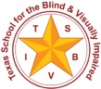 | Texas School for the Blind and Visually Impaired  Outreach Programs  www.tsbvi.edu | 512.454.8631 | 1100 W. 45th St. | Austin, TX 78756

Coffee Hour – September 10, 2020
I Can See More with My Optical Devices
Magnifiers to See Things Up Close & Monoculars to See Things Far(ther) Away
Presented by Cindy Bachofer, PhD, CLVT
TSBVI Low Vision Consultant

I’m glad you are here!
Figure 1: Photograph of Dr. Cindy Bachofer
- Low Vision Consultant at the Texas School for the Blind & Visually Impaired
- My work is primarily with students with low vision-use of tools, self-identity, psychosocial needs
- Student-teacher team support on campus, trainings with Outreach Programs and select classes in Short-Term Programs

Outline of Presentation
- A place for optical devices in a screen-rich world
- What, who, why: the tools, the users, the benefits
- How: an overview of device instruction
- Consideration of roadblocks and solutions to use

Vision Tools of Today
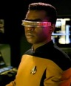
Figure 2: Photograph of Jordie LaForge from Star Trek The Next Generation, wearing his vision visor.
Source: Paramount Pictures
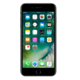
Figure 3: An iPhone
Source: Apple

Problems with the Screen View
- Recharging necessary for frequent camera use
- Limits with expanding picture for detail view (over-pixelate image)
- Glare on screen with outdoor viewing
- Extended screen time concerns (e.g., eye strain, sleep cycle issues)
- No-phone zone at school, work

Law of the over-reliance on one tool for all tasks
“If all you have is a hammer, everything looks like a nail.”

Starter Tools
Figure 4: A magnifier sitting on a page of text
Figure 5: A monocular

What: Magnifiers & Monoculars/Telescopes
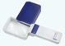
Figure 6: A rectangular magnifier
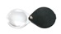
Figure 7: A round flip-out magnifier
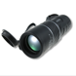
Figure 8: A black monocular telescope
Figure 9: A grey Carson telescope

Skills to Access Visual Information
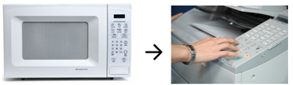
Figure 10: A microwave oven on the left. An arrow points from it to the picture on the right of a hand using a keypad on a printer.
Figure 11: On the left a picture of school-age wrestlers during a match. An arrow points right to a picture of a street performer breakdancing in front of a sign that reads "Street Performer Series."

Access to What’s Meaningful
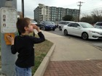
Figure 12: A young person at a city crosswalk. They use a monocular to look across the street.
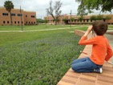
Figure 13: A young person looks across a grassy yard on a school campus using a monocular.

Motivation
- High expectations
- High interest
- High success
Figure 14: Two students use monoculars to read price tags in the produce section of a supermarket.

What Do You Look At?
- Through a monocular
- Through a telescope

The Rule on Shape and Size
- Magnifiers
- Bigger lens is lower power with lower magnification
- Smaller lens is higher power with more magnification
- Telescopes
- A shorter scope is lower power with lower magnification
- A taller scope is higher power with lower magnification

Matching the user to the device
- Power, distance, and size
- What’s my power? (3x/12D mag; 6x16 scope, 9° field)
- How far away and how big is my target?
- Concepts of magnification
- Relationship between the device lens and field of view (field of view = ease of use)
- Importance of work distance (E↔L↔M)
- Eye to lens
- Lens to Material
- More light or less light
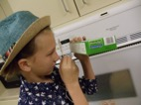
Figure 15: A young person uses a magnifier to read the side of a box of frozen food.
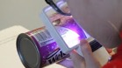
Figure 16: A young person uses a magnifier to read the side of a can of grape juice concentrate.
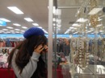
Figure 17: A student uses a magnifier to look at jewelry in a display case in a store.
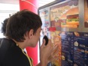
Figure 18: A student uses a magnifier to read a fast food menu.
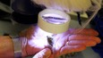
Figure 19: A person looks at an insect through a lighted magnifier.
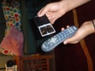
Figure 20: A person looks at buttons on a television remote with a magnifier.
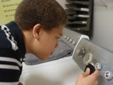
Figure 21: A young person looks at the controls on a clothes dryer using a magnifier.

Strategies to Practice
- Magnifiers
- Find the sweet spot of focus
- Stabilize your holding hand
- Use a line guide, sticky note to mark your spot
- Build stamina with daily practice, specific tasks
- Keep a record (reading time/speed, variety of uses)
How are you doing? Is it working?
Figure 22: A young person looks at a life-size statue of a dinosaur through a monocular.
Figure 23: A young person watches live chickens in a farmyard through a monocular.
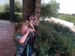
Figure 24: Five young people look over a hedge using telescopes.
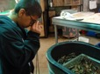
Figure 25: A young person looks at shellfish in a bin using a telescope.

Strategies to Practice
- Telescopes
- Find an object through the scope (big, bold)
- Stabilize your holding hand for a steady view
- Set focus by changing the barrel from short to tall
- Stay fixed on an object or follow a moving one
How are you doing? Is it working?

Roadblocks to Device Use
- Conscious of peer reactions (perceived, direct)
- Device use doesn’t equalize things
- Doesn’t get “benefit” of device, lack of visual curiosity
- Lack of support to build use as habit
- Low expectations, limited accountability
- Training issues (e.g., inconsistent, unmotivated)

Roadblocks: What makes it hard?
- Building the skill-Practice, practice, practice
- Building the confidence (Is someone staring at me?)
- Building the habit (expectation, motivation to use)

Making My Wish List
- New ideas for cool things I want to see…
  - __________________________________
  - __________________________________
- New ideas for places I want to go to try my device…
  - __________________________________
  - __________________________________
- New ideas for challenges, goals I want to set…
  - __________________________________
  - __________________________________
Capturing Attention!
Contact Cindy Bachofer.
Thank you for joining our Coffee Hour and sharing your ideas.

