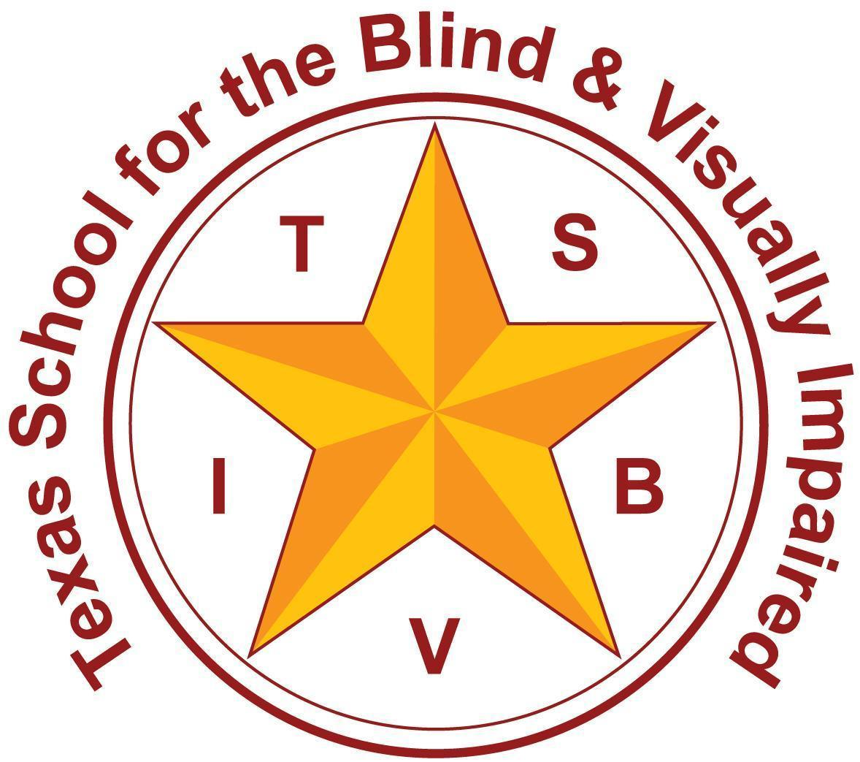 | Texas School for the Blind and Visually Impaired  Outreach Programs  www.tsbvi.edu | 512-454-8631 | 1100 W. 45th St. | Austin, TX 78756

Vision to Reality: Designing Transition Plans that Work

Belinda Fayard, Outreach Assistant Director
fayardb@tsbvi.edu
tsbvi.edu/outreach

Objectives
- Identify the legal requirements of Transition
- Clarify the VI Professional’s Role
- Identify Resources and Tools that lead to Transition Plans that work for your students

Transition Requirements
- Begin at 14 in Texas
- Based on age-appropriate assessments
- Include coordinated, measurable, annual goals
- Training/Education
- Employment
- Independent living skills, where appropriate
- The student must be involved
- Family members/guardians must be involved - at 18, the student chooses
- Opportunities to develop decision-making skills
- Options supporting students’ legal choices for independence

Defining a Transition Plan
- Student driven
  - Evaluation
- Community connected
  - Input gathered
- Experience matters
  - Discovery activities
- INDIVIDUALIZED

Transition Plan Requirements

The “Plan” must include:
- Course of Study
- Employment
- Functional Vocational Evaluation
- Community Experiences
- Post-school and adult living objectives
- Daily Living Skills
- Related Services

Functional Vocational Evaluation Sources
Formal and Informal data are gathered from a variety of sources to complete a Functional Vocational Evaluation - it is not a “single test.”
Formal Sources
- Intelligence Tests
- Achievement Tests
- Adaptive Behavior and Independent Living Tests
- Aptitude Tests
Examples:
- Woodcock-Johnson-Cognitive Ability and Achievement
- Vineland
- O*Net Ability Profiler
Informal Sources
- Interviews
- Questionnaires
- Direct Observation
- Environmental or Situational Analysis
- Curriculum-Based Assessments
- Transition Planning Inventories
- Self Determination Scales
- Independent Living Inventory
- School Performance Measures
Examples
- Student Portfolios
- Attendance
- TSBVI’s Evals
- Perkins Total Lifelong Learning
- The ARC’s Self Determination Scale
- TSBVI’s Discovery Document

What is the VI Professional’s role?
- Coordinate instruction in the ECC
- Advise team about special issues of concern: guide dog school, transportation, Medicaid Waivers, etc.
- Knowledge of vision-related community services
- Connection to adults who can be mentors

Resources
- Discovery Document - Informal Resource created by TSBVI, appropriate for all students
- Sample Visual Transition Plan
- Visual Transition Plan Template - this is one tool a team can use to create a Transition Plan. It can be archived into your special education student data system as a standalone Transition Plan, or the data from this plan can be entered into the system’s existing forms.

TSBVI Outreach Transition LiveBinder - includes, among other resources, roles and responsibilities for VI professionals, success stories, and links to state agencies.
- Pathways Texas Transition and Employment Guide
- California School for the Blind Assessment Center - This site includes articles about how to test students who are blind, deafblind, or have low vision, and tests are organized by category and age.
- Perkins Assessments - Readers will find a list of vocational assessments for students at this site.
- National Technical Assistance Center Collaborative Assessment Guide for Transition Planning Services - Technical assistance toolkit for educators, families, and students.

Outreach can provide training through workshops for families and students, as well as on-site consultations.
- Game of Life - for families and students who are middle school age
- High School Independence: College and Vocational Prep - for families and students from high school through 22 years.
- Discovering the Future - for families of students, middle school to 22 years, who need lifelong supports, and for whom a traditional college or career path isn’t appropriate. Contact Outreach Transition consultants to learn more.
- Contact Outreach for Support

Belinda Fayard, Email: fayardb@tsbvi.edu, Phone: 512-206-9278
STAY UPDATED! TSBVI programs cover a variety of topics regarding the education of students who are blind, deafblind, or have low vision. Sign up here to tell us about your own areas of interest and to receive regular updates on those specific topics.

