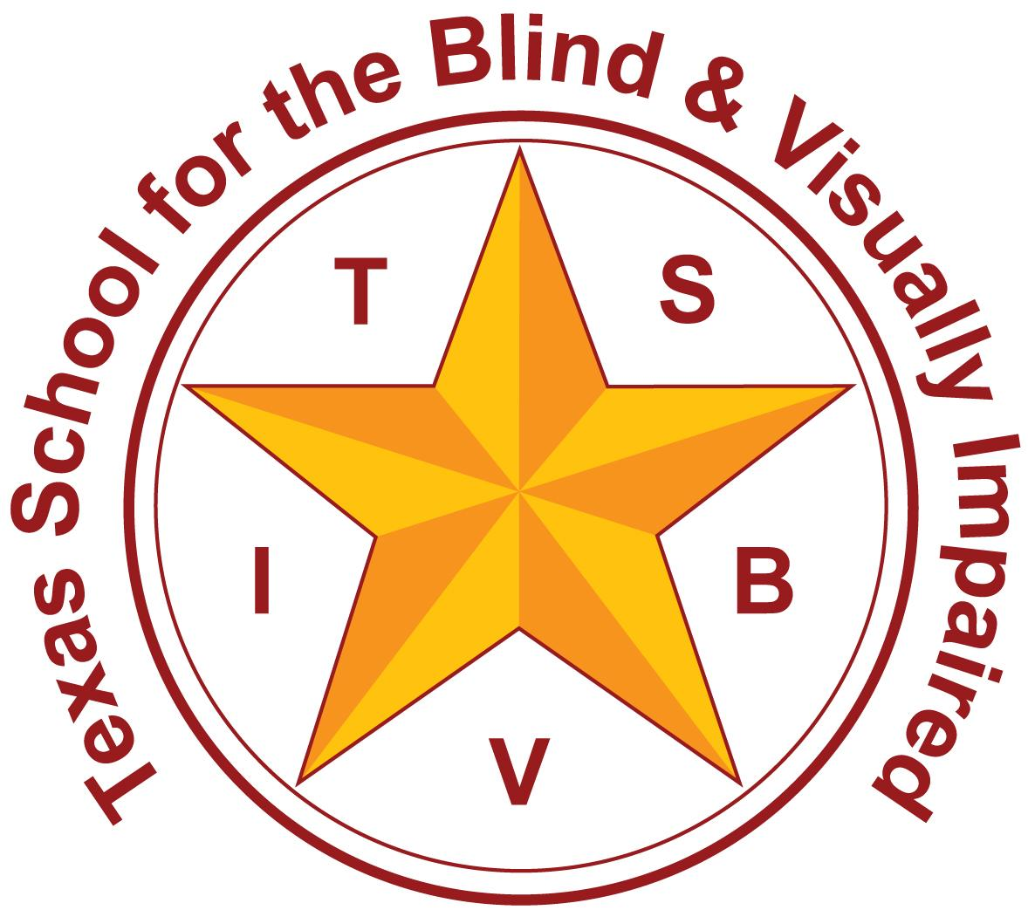
Texas School for the Blind and Visually Impaired
Outreach Programs
www.tsbvi.edu | 512-454-8631| 1100 W. 45th St. | Austin, TX 78756

Coffee Hour
Mulitmedia Learners

April 8, 2024
Kathleen Dalbeck TVI / COMS

Title Slide (Slide 1)
Multimedia Learners
Kathleen Dalbeck - Teacher for the Visually Impaired/Certified Orientation and Mobility Specialist

Replacing Dual Media with Multimedia (Slide 2)
Slide shows a graphic of a tablet with many media icons funneling into it from the top.
- Using the term dual media sets a limit for only two formats.
- All different traditional and technological media really helps increase access.

What is Multimedia (Slide 3)
- Print, braille, audio
- Content that uses a combination of different content forms such as text, audio-visual digital text, hard copy paper braille, electronic braille (such as a braille display), low vision tools, Ai, screen readers, dictation, images etc.

Transition Sets Success (Slide 4)
- Begin transition spring of current year for the following year.
- Elementary choose teacher
- Middle/High communicate with curriculum specialist, a general ed teacher, counselor, resource teacher, principal.
- Coordination of braillist with curriculum team
- Parent IEP, (school Kit)

Determining the Media with the Classroom Teacher (Slide 5)
Slide shows a graphic of a teacher speaking with an adult and student.
- review daily curriculum schedule with teacher
- determine when braille, audio, large print, or digital with accessibility features or setting will be used.

One Student’s Story (Slide 6)
Slide shows an image of a student with albinism wearing glasses, holding a cane, and posing for a picture outside.
- Primary
- Albinism
- Severe light sensitivity
- Severe diplopia
- Low visual acuity

Guided Reading Group Gen Ed (Slide 7)
- Print only (different setting for braille)
- Large print and standard book. separate from books images (deteriorates pictures)
- Hand-held electronic magnifier or CCTV to see images on original standard book

Circle Time Whole Group Story (Slide 8)
- Circle time whole group teacher reading story to students
- Every book read as a whole group is brailled interlined with page numbers.
- Even if book reading level is above independent student reading level, student will follow along as best as possible keeping fingers on the lines (as best as possible). Sit close to teacher to ensure student’s on the right page and lines.

Silent Reading Time Gen Ed (Slide 9)
- Use 3 different alternate book reading formats
- Alternate different mediums different days
  - Two days have to be a braille book of choice.
  - One day audio or audio-digital visual book
  - One day standard print book with CCTV or electronic magnifier.

Content Area: Math (Slide 10)
Slide shows an image of a cart with a CCTV, a remote, and a basket of writing tools.
Large print with standard size available for measurement units.
- Use large print with the CCTV
- Large print worksheets on blue buff paper
- Large print math book ordered from ORC
- PDF option for math for printing large print (relationship with curriculum).

Content Area: Social Studies (Slide 11)
This can also be alternated:
- Provide reading sample (IE: Rosa parks in braille) if the student has a lot of usable vision can use bold interline over the braille. Double space the lines.
- Alternate print and braille for the lessons each week if you choose.
- Print use iPad with Seeing AI.

Content Area: Science (Slide 12)
- Large print with low vision tools CCTV, handheld magnifier
- Students traveled from group to group
- Adaptations of science (APH adapted science equipment)
- Met with science teachers to determine adaptations
- 3d printer can make equipment (markers for beakers, 3d printer)

Content Area: Writing (Slide 13)
- Alternate different weeks for different projects
- Perkins Brailler (by 5th self-determined Perkins)
- Perky duck
- Qwerty keyboard with google doc or word
- Hand-writing
- By 5th grade this student was choosing her own

Teaching Braille (Slide 14)
Slide shows an image of a student wearing glasses looking at a braillewriter from the side and touching braille dots on the page loaded inside.
- Separate setting for teaching print and braille.
- Print in classroom
- Braille in vision class

Non-Braille Vision Related Goals (Slide 15)
Slide shows an image of a student with albinism standing in a hallway with a cane and looking through a monocular.
- Typing
- Low vision tools
- Software and devices
- Pull out
- Push in to show use in the classroom

Communication with Team (Slide 16)
Slide shows an image of a student with albinism in a classroom. She stands in front of a screen with a diagram of an eye on it.
- Student presentation for IEP team
- Student presentation for peers
- Regularly scheduled meetings with teacher

Resources (Slide 17)
- NOAH CARE Project - collection of redacted IEP documents that can be searched by age or by state.
- NOAH SchoolKit - a toolkit for educators and families with ideas for supporting students with albinism in the general education classroom.
- NOAH Website - The National Organization for Albinism and Hypopigmentation
- Dual Media or Multimedia - Perkins article

Contact Me! (Slide 18)
Slide shows a graphic of a hand holding a cell phone in front of contact icons.
Kathleen Dalbeck - mdalbeck@aol.com

Thank you for joining me!

