Texas School for the Blind and Visually Impaired
Outreach Programs
www.tsbvi.edu | 512-454-8631| 1100 W. 45th St. | Austin, TX 78756

The Math Teacher’s Survival Guide:
Teaching Math to a Student with
Visual Impairment
October 3, 2017
3:00pm-4:00pm

Facilitated by
Susan Osterhaus, Education Consultant, TSBVI Outreach
osterhauss@tsbvi.edu
Yvonne Corson TSBVI
corsony@tsbvi.edu
Katie Nash, Itinerant TVI
Katie.nash@lvisd.org

Developed for Texas School for the Blind & Visually Impaired Outreach Programs

Outreach Programs Events Update:
- For upcoming webinars: http://www.tsbvi.edu/2015-10-17-20-13-33/webinar-listings
- For upcoming workshops and conferences: http://www.tsbvi.edu/2015-10-17-20-13-33/outreach-workshops-conferences

Housekeeping
- Download handouts and sign-in roster
- Send sign-in roster to sobeckb@tsbvi.edu or fax to 512-206-9320
- Make sure you registered and complete evaluation within 60 days including code for ACVREP/SBEC credit
- View captions in a separate window at https://tcc.1capapp.com/event/tsbvi/embed
- The code will be announced during the presentation

Adobe Connect Webinar Tour
- For tips about screen navigation go to http://www.connectusers.com/tutorials/2008/11/meeting_accessibility/
- Location of pods
- Power Point content included in your handout
- Poll participation – enter response in chat if you cannot access the poll

Link to enter room: http://tsbvi.adobeconnect.com/math/

The Math Teacher’s Survival Guide:

Teaching Math to a Student with a Visual Impairment

Introductions
- Katie Nash
  - Elementary Mathematics and Itinerant TVI

- Yvonne Corson
  - Secondary Mathematics and TVI

Purpose
- Help math teachers who have students with visual impairments in their classes understand how the TVI can help them with that student (and it helps others, too!)

Getting Started
- Collaborating with the General Ed teachers takes a plan:
  - Develop a rapport
  - Explain the specific visual impairment of the student in their class
  - Plan for the role of the paraprofessional (if there is one_
  - Set up a calendar for times to collaborate – typically planning time

- Meet before school starts with the class objective/test schedules, etc
- Set up a system for getting assignments: a mailbox, a Google Drive
- Discuss and make a plan for providing accessible materials to the student
  - Math teachers may already have MathType in Microsoft Office
  - Or make a plan for other formats

Google Drive
Video illustrating how Google Drive is used to share files

MathType
Video overview of how to use MathType

Setting Up a Classroom
- Seating – based on the specific student’s etiology
- Added tables
- Designated shelves
- Safety – clear pathway for exit door
- Plan for rearranging the room (students can do this!)

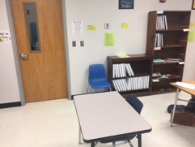
Figure 1 Photo of a clean and tidy classroom

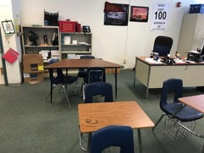
Figure 2 Photo of classroom that is cluttered

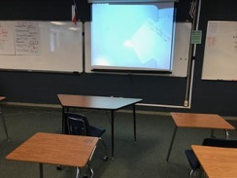
Figure 3 Photo of ideal classroom where outlet is nearby

Elementary Tips

Correspondence
Video illustrating 1-1 Correspondence

Pattern and Sequencing

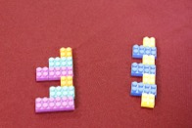
Figure 4

Flash Cards
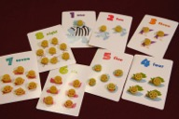
Figure 5 Flash Cards with pasta attached

Magnetic Numbers with Braille
Figure 6 Magnetic Tactile Numbers 1-9 with Braille

Choices for Dice Math Games
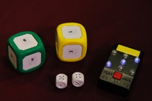
Figure 7 Large yellow and green foam dice, Talking Dice, and 2 Braille Dice

Braille Playing Cards
Figure 8 Braille playing cards

Color by Number Activities
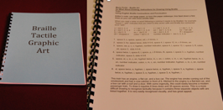
Photo 9 Tactile Art Braille Book

Secondary Tips

APH Graph Board
Video illustration of setting up an APH Graph Board – Basic graphic creation (Cartesian coordinate graphics)

APH Raised Lined Graph Paper
Video of basic graphic creation using raised lined graph paper (Cartesian coordinate graphics)

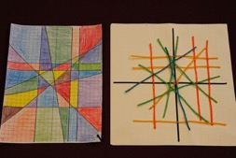
Photo 10 Modified graph project

APH Draftsman
Video demonstrating APH Draftsman

Algebra Aerobics
Video demonstrating technique where students can become active in algebra equations

Pool Noodle
Video illustrating how a pool noodle can tactilely aide in math equations

Testing Tips
- STAAR Formula Charts
  - Get three copies
- STAAR Braille Released Tests
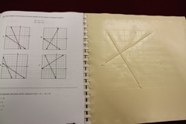
Figure 11 Page from print and braille versions of the STAAR 2016 Algebra 1 Released Test

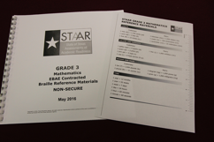
Figure 12 STAAR Grade 3 Mathematics Reference Materials, May 2016, in print and braille
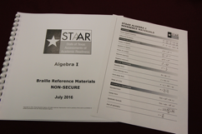
Figure 13 STAAR Algebra 1 Reference Materials, July 2016, in print and braille

Resources
- Braille Art Instructions
- Braille Magnetic Numbers - $9.95 w Free Shipping
- Hard copies of STAAR released braille tests can be ordered by calling ETS Order Services at 800-537-3160

Thank You for Joining Us
Figure 14 IDEAs That Work logo and OSEP disclaimer

Figure 15 The Texas School for the Blind and Visually Impaired logo

