Texas School for the Blind and Visually Impaired
Outreach Programs
www.tsbvi.edu | 512.454.8631 | 1100 W. 45th St. | Austin, TX 78756

Coffee Hour – April 15, 2021
Texas 2 Step
Presented by Jill Brown, TVI, COMS
and Marjie Wood, TVI, COMS

Texas 2 STEPS
(Successfully Teaching Early Purposeful Skills)
An Evaluation and Curriculum for Orientation and Mobility Specialists
Picture depicts the Texas 2 STEPS Logo. An outline of the state of Texas. Within the outline are 2 boots, on one boot is “O” and the other boot “M”. The words Texas 2 STEPS is also written within the picture.

Title: Texas Early Intervention Orientation and Mobility Developing Members
- Debra Sewell- TSBVI
- Tracy Hallak-Burleson ISD
- Stephanie Walker-ESC 11
- Marjorie Wood-O&M Consultant
- Jill Brown-O&M Consultant
- Olga Uriegas-Cook Children’s Medical Center
- Michelle Garrett
- Shay Utley-Mansfield ISD
- Gema Nelson-Mansfield ISD

Title: Contributing Members
- Dawn Adams – ESC Region 8
- Melba Bunch – Retired ESC Region 12
- Steffani Oaks – Private Contractor
- Susan Gordon – HEB ISD
- Gwynne Reeves – ESC Region 6

Title: Curricula Used for Research
- AEPS
- Batelle
- Callier Azusa
- Carolina Curriculum
- DAY C
- Functional Schemes
- Growing Up
- HELP (Hawaii Early Learning Profile)
- INSITE
- Peabody Motor Development Scale
- Preschool O&M Screening
- Oregon Project
- Reynell Zinkin
- TAPS

Title: Where To Start
- Referral information
- Medical Records Review
- Eye Report
- Early Childhood information
- Parent Interview
- Observe

Title: Evaluation Booklet
- 122 pages total
- 98 pages of ongoing evaluation
- General Information
- Directions
- Skill numbering / age correlation
- Scoring

Title: Texas 2 STEPS Evaluation (Successfully Teaching Early Purposeful Skills)
Slide shows a picture of page 3 of the Evaluation booklet. Included is the
STUDENT INFORMATION: Student Name; COMS Evaluator; Student Gender; Date of Birth; Age of student; Visual Condition; Medical Information; Date(s) of Evaluation (including administrative time per session):
PURPOSE: The Texas 2 STEPS Evaluation is specifically designed to appraise orientation and mobility skills for children with visual impairments from birth through 5 years of age. It may also be used to evaluate students functioning developmentally within this age range. This evaluation should be used as an initial and ongoing evaluation tool to determine present level of performance and to monitor student progress.
GENERAL INFORMATION: Key areas of the Texas 2 STEPS Evaluation include orientation concepts and early mobility skills. This evaluation is divided into age ranges, skill sets, the expected behavior, and evaluation suggestions. Age ranges are broken into months so that small increments of progress may be documented. The Orientation and Mobility Specialist should complete the evaluation in both familiar and unfamiliar environments, including indoor and outdoor settings as appropriate. Many of the motor skills included were chosen because they are the building blocks that establish the foundation for independent forward movement. Please read the General Information chapter before beginning an evaluation.

Continuation of picture from Evaluation book
Slide shows a picture of page 4 of the Evaluation booklet. Included is
INSTRUCTIONS: As with any evaluation, the evaluator must have some knowledge of the child’s functioning level. Using the following information, estimate the child’s functioning level, then start the evaluation several months below the estimated level:
- Records review, including the FVE and any medical reports
- Family interview(s)
- Teacher interview(s)
- Multiple observations
It is imperative to review this evaluation tool and become familiar with each section prior to use. This will ensure that any needed materials can be gathered beforehand and that the evaluation sessions will go smoothly. Materials can include items gathered from the child’s environment. The length of time needed to complete the evaluation will depend on the child’s functioning level and stamina. It will most likely need to be completed in several sessions. Refer to the Glossary for further information and more specifics on terminology.
Three scoring columns are provided for documenting multiple evaluations and progress.
The evaluator should score a minus (–) for each item in which a student has not demonstrated competence.
The evaluator should score an (E) for emerging if the student demonstrates some degree of competency or needs a considerable amount of prompting to accomplish the skill.
The evaluator should score a plus (+) for each item in which a student has demonstrated competence.
Evaluated skills that result in a minus (–) or (E) will help determine the area of instruction on which to base goal development. A space for comments is provided to make notations related to the evaluation of that specific skill.
If the skill is not applicable, indicate that by recording NA in the comments and listing the reasons.
For any objective for which a stimulus is used, indicate in the comments section if the stimulus is tactual, auditory, visual, or a combination. Please follow safety precautions when introducing sensory information that is novel.
Indicate if the objective was evaluated in familiar or unfamiliar environments or a combination of both.

SUMMARY OF RESULTS:
The Texas 2 STEPS Summary of Results will provide an outline of the child’s functioning level in each of the categories of both the Mobility and Orientation sections.

Mobility
- Reflexes and Postural Reactions
- Head Control
- Trunk, Arm and Leg Control
- Rolling
- Reaching
- Grasping
- Sitting
- Scooting
- Crawling
- Standing
- Walking
- Jumping
- Climbing
- Kicking
- Running, Galloping, Skipping
- Basic Skills
- Cane Skills

Orientation
- Sensory
- Body Awareness
- Object Permanence
- Cause and Effect
- Environmental Awareness
- Social
- Language
- Directional and Positional Concepts
- Comparative Concepts

Mobility

Slide is a picture of page 13 of the Evaluation Tool. The evaluation tool is in a spreadsheet format: Items that are circled are shown as bolded for scoring purposes.
Age (Mo.) | Skill | Behavior | Date/Score | Date/Score | Date/Score
00.00-01.00 | Head Control 1.1 | Child’s arms and legs are flexed, bent, and asymmetrical, with head not in midline.
 | Evaluation Suggestions: Observe child in natural environment. |  | – E + | – E + | – E +
Comments:
00.00-01.00 | Head Control 1.2 | Child will begin to stretch torso out of fetal position by keeping knees under stomach with bottom held high and arms flexed inward.
 | Evaluation Suggestions: Observe child in natural environment. Child keeps knees and arms under torso, and stretches to lengthen back. |  | – E + | – E + | – E +
Comments:
00.00-01.00 | Head Control 1.3 | When held over adult shoulder, child will attempt to hold up head.
 | Evaluation Suggestions: Observe child in natural environment. |  | – E + | – E + | – E +
Comments:
00.00-03.00 | Head Control 1.4 | When in supine position, child will keep head in midline.
 | Evaluation Suggestions: When child is lying on back, observe child in natural environment. |  | – E + | – E + | – E +
Comments:
00.00-03.00 | Head Control 1.5 | When held upright, child will hold head steady.
 | Evaluation Suggestions: Holding child upright, supported at the trunk, facing you and away from your body, child will raise head and hold head at midline for several seconds. |  | – E + | – E + | – E +
Comments:
00.00-03.00 | Head Control 1.6 | When in prone position, child begins to lift head.
 | Evaluation Suggestions: When lying on stomach, child will keep head to one side and is beginning to lift cheek off surface. |  | – E + | – E + | – E +
Comments:

Orientation

Slide is a picture of page 104 of the Evaluation Tool. The evaluation tool is in a spreadsheet format:
Age (Mo.) | Skill | Behavior | Date/Score
00.00-03.00 | Object Permanence  3.1 | Child shows interest in people.
 | Evaluation Suggestions: Child may show interest by change of biobehavioral state. This can be demonstrated in a variety of ways depending on the ablility of the child. |  | – E +
Comments:
00.00-03.00 | Object Permanence  3.2 | Child shows interest in toys
 | Evaluation Suggestions: Child may show interest by change of biobehavioral state. This can be demonstrated in a variety of ways depending on the ablility of the child. |  | +
Comments:
04.00-06.00 | Object Permanence  3.3 | Child will find a partially covered object.
 | Evaluation Suggestions: When child is interacting with an object, an adult will partially cover it, and then child will uncover it. |  | – E +
Comments:
06.00-9.00 | Object Permanence  3.4 | Child will find a fully hidden toy or object.
 | Evaluation Suggestions: When child is interacting with an object, an adult will fully cover it, and then child will uncover it. Object is not making sound while covered. |  | – E +
Comments:
08.00-12.00 | Object Permanence  3.5 | Child will look for an object or person that has briefly disappeared from view.
 | Evaluation Suggestions: Observe child in natural environment. Child will attempt to locate an object or person by looking or reaching for it. |  | +
Comments:

Evaluation Booklet
- Introduction
  - Skill areas listed
  - Information from the pilot
  - General resources
- Reflex information
- Mobility Activities
- Orientation Activities
- Glossary
- Appendices

Appendices
- Appendix A: Body Parts
- Appendix B: Environmental Sounds
- Appendix C: Environmental Indoor Concepts
- Appendix D: Environmental Outdoor Concepts
- Appendix E: Environmental Tactual
- Appendix F: Sample Report

Appendix D: Environmental Outdoor Concepts

Airplane | Alley | Aambulance
Branches | Broken sidewalk | Bus stop
Bush/hedge | Car | Car door
Car headlight | Car Hood | Column(s)
Corner | Corner | Curb
Doorbell | Driveway | Elevator
Fence | Fire hydrant

Components of Reflexes
- Desired Behavior
- Description
- Age of onset
- Age of integration
- Function as Related to O&M
- Implications as related to O&M

Components of Activity Sheets
- Desired Behavior
- Purpose as Related to O&M
- Activities / Routines
- Infused Skills
- Areas of Concern
- Stepping Forward

Slide shows a picture of an Activity Sheet
Title: Head Control 1.16
Desired Behavior:
1.16 When in prone position, child will elevate head and upper trunk 45 degrees, bearing weight on forearms and hands, and will hold head in midline for 5-10 seconds.
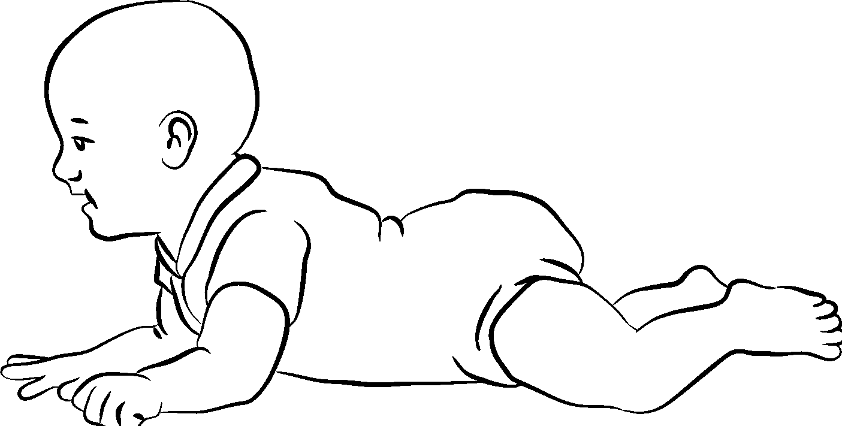
Purpose as Related to O&M:
- Develops overall body tone relates to future balance, sitting and standing skills
- Promotes body awareness
- Provides foundational skills for trunk control
- Strengthens neck and abdominal muscles

Continuation of Activity Sheet
Activities/Routines:
While child lies on tummy, place a small bolster, rolled towel or blanket under the child’s upper body with arms forward. Place a variety of stimuli for child to attend in front or above line of vision. Stimuli may include favorite toys, rattles, person making funny faces and sounds, safety mirror or window.
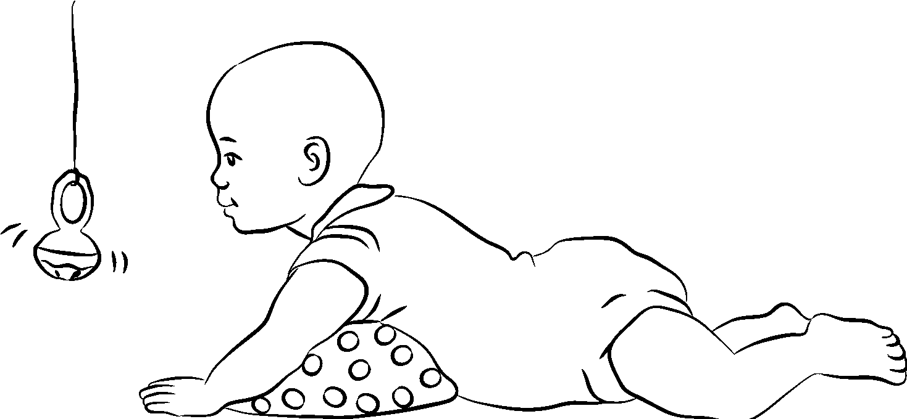

Continuation of Activity Sheet
With adult lying on floor, place child with his tummy on your tummy. Child may need assistance positioning forearms under shoulders. Talk, sing, and encourage child to lift head.

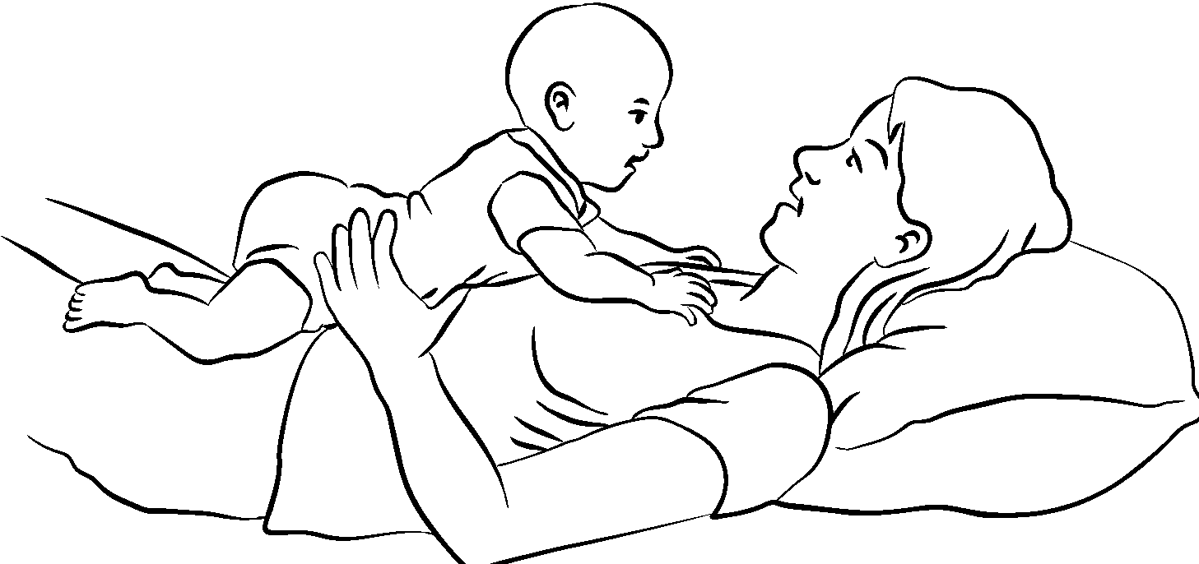

Continuation of Activity Sheet
Using a large exercise ball, place the child on his tummy directly on the ball. Provide assistance with positioning the forearms under his shoulders. Gently move the ball back and forth.
To encourage longer tummy time activities, use gentle massage techniques.
Use prone position as part of the diapering routine, by turning your child onto her stomach and propping her up on her straightened arms for a few seconds.
Infused Skills:
- Localization
- Orientation
- Posture
- Sensory Integration

Continuation of Activity Sheet
Areas of Concern: Consult with Physical Therapist or Occupational Therapist for: hypertonia; hypotonia, other motor impairments
Stepping Forward:
- Increased ability to sustain head in lifted position
- Neck muscles strengthen to facilitate maintaining head in lifted position
- Increased head control for sitting independently
- Weight-bearing on forearms leads to increased balance
- Weight-shifting and increase balance to facilitate reaching for objects

JJ, 18 months
Video Description of “JJ” video
Video begins with 18-month old child lying on her belly on the floor in her bedroom. She is lying partially on the room’s carpet with her arms stretched out in front of her, touching a fuzzy area rug. There is a musical toy on the fuzzy rug about 18 inches in front of her. The child lifts up her left arm in an attempt to reach forward but does not move her body. Child then lays still listening to the music. Responding to vocal encouragement, child gets into a semi-crawl; semi-sit position. Legs are in a “frog” position (legs far apart, bent at the knee with her weight towards her bottom). Arms are straight with hands flat on floor. Child then tries to move self into a standing position with hands still on the floor. She tries to lift arms but falls (rolls) backwards into a sitting position using her left arm to stop herself from rolling onto her back. Child is now in a sitting position with legs apart. She coos as she listens to the music Child kicks her feet while sitting upright with a slightly rounded back. Arms are held in a “high-guard” position for balance. Voice in the background is the videographer talking to the child’s great-grandmother. When she says “she took two steps”, what was seen, was the child reaching forward in a semi-crawl. She then attempts to reach forward between her legs. Upon finding nothing, child sits back up and coos again. There is more verbal encouragement from great-grandmother and videographer. Child then reaches to her left and rolls to her left into a crawl position. The musical toy is now slightly behind her. She then rests her bottom on her feet and rocks back and forth. Child then gets into sitting position and again shifts her position. This time, the musical toy is directly behind her. Child sits, still listening to the music. She reaches out to her sides with both hands. Upon touching the carpet, she then slaps her head. She then rolls (falls) onto her back. Now the musical toy is about 6 inches away on her left side. She rolls herself to the right to sit back up. Child then sits, still listening to the music. In the background, great-grandmother has asked, “What is she doing?” The videographer replies, “She is looking for it.” The child then claps her hands together. In response to her clap, great-grandmother says “That means she wants you to give it to her.” The videographer then tells the child in a firm voice, to get it herself. Child then claps again and sits up with straight back. She rolls to right side to get into a crawl position and reaches forward with her left hand and then her right hand. Not finding the toy, she attempts to stand again. Her legs are very far apart
and she slips backwards onto her bottom. She then uses her left hand to reach to her right side, touching the edge of the fuzzy carpet. Not finding the toy, she regroups by sitting up and scoots back a few inches. She then makes another attempt to reach with her left hand across to her right. Child then uses her right hand to reach forward across to her left side. Not finding the toy, she reaches forward again with her right hand falling onto her stomach. With her arms, she pushes herself forward a few inches and then reaches forward again. This time, she reaches with her left hand and then her right hand. Her right hand finally found the toy.

Sample Evaluation

Slide is a picture of page 42 of the Evaluation Tool. The evaluation tool is in a spreadsheet format: Items that are circled are shown as bolded for scoring purposes.

Age (Mo.) | Skill | Behavior | Date/Score
05.00-06.00 | Sitting 6.7 | Child will sit alone momentarily without support.
 | Evaluation Suggestions: When child is placed in sitting position, child will maintain balance for approximately 10-60 seconds. |  | – E +
Comments:
05.00-07.00 | Sitting 6.8 | Child will maintain head control when actively pulling self to sit.
 | Evaluation Suggestions: When adult grasps child’s hands, child will pull from back to sit while holding head in line with body (i.e., no head lag). |  | – E +
Comments:
06.00-08.00 | Sitting 6.9 | Child will sit alone unsupported and extend arms for occasional support or to protect self from falling.
 | Evaluation Suggestions: When placed in sitting position, child will maintain balance. |  | – E +
Comments:
06.00-09.00 | Sitting 6.10 | When placed in sitting position, child will independently reach in any direction within arm’s reach.
 | Evaluation Suggestions: Child sits unsupported. Hands are free to engage in play. Child will support self when sitting and lean forward to reach for object while maintaining sitting position. |  | – E +
Comments:child was able to reach in all directions but not always maintain balance

Slide is a picture of page 42 of the Evaluation Tool. The evaluation tool is in a spreadsheet format: Items that are circled are shown as bolded for scoring purposes.

Age (Mo.) | Skill | Behavior | Date/Score
06.00-09.00 | Sitting 6.11 | Child will sit alone unsupported with back fairly straight.
 | Evaluation Suggestions: When placed in a sitting position, child will maintain straight back posture. |  | – E +
Comments: sits with rounded back
07.00-08.00 | Sitting 6.12 | When in supine position, child will lift head and shoulders off floor in an attempt to sit.
 | Evaluation Suggestions: When lying on back, child will lift head and shoulders off floor. |  | – E +
Comments:
07.00-11.00 | Sitting 6.13 | Child will move out of sitting position into supine using intentional and controlled movements.
 | Evaluation Suggestions: Child will move from sitting to lying on back using protective arm response or controlled transition movements. |  | – E +
Comments: movements were not always controlled; seems to have motor planning issues
07.00-11.00 | Sitting 6.14 | Child will move from supine into sitting position.
 | Evaluation Suggestions: Child will move from back to sitting by rolling to one side and using arms and hands to push self into sitting position; observe in natural environment. |  | – E +
Comments:

Slide is a picture of page 42 of the Evaluation Tool. The evaluation tool is in a spreadsheet format: Items that are circled are shown as bolded for scoring purposes.

Age (Mo.) | Skill | Behavior | Date/Score
07.00-11.00 | Sitting 7.15 | Child will move out of sitting position into prone.
 | Evaluation Suggestions: Child will move from sitting to stomach; observe in natural environment. |  | – E +
Comments: chile sits with rounded back
07.00-11.00 | Sitting 7.16 | Child will move from prone into sitting position.
 | Evaluation Suggestions: Child will independently move from stomach to sitting; observe in natural environment. |  | – E +
Comments:
10.00-15.00 | Sitting 7.17 | When in sitting position, child will maintain balance when turning trunk, shoulders, and head to reach for objects.
 | Evaluation Suggestions: Child will maintain balance while rotating body. |  | – E +
Comments: has not separated trunk and shoulder movements
12.00-15.00 | Sitting 7.18 | Child will independently transition into a sitting position on a variety of surfaces.
 | Evaluation Suggestions: Child has mastered transitioning in and out of sitting position in a variety of settings. |  | – E +
Comments: this was not observed during lesson. Further observation is needed

Slide is a picture of page 104 of the Evaluation Tool. The evaluation tool is in a spreadsheet format: Items that are circled are shown as bolded for scoring purposes.

Age (Mo.) | Skill | Behavior | Date/Score
00.00-03.00 | Object Permanence  3.1 | Child shows interest in people.
 | Evaluation Suggestions: Child may show interest by change of biobehavioral state. This can be demonstrated in a variety of ways depending on the ablility of the child. |  | – E +
Comments:
00.00-03.00 | Object Permanence  3.2 | Child shows interest in toys.
 | Evaluation Suggestions: Child may show interest by change of biobehavioral state. This can be demonstrated in a variety of ways depending on the ablility of the child. |  | – E +
Comments:
04.00-06.00 | Object Permanence  3.3 | Child will find a partially covered object.
 | Evaluation Suggestions: When child is interacting with an object, an adult will partially cover it, and then child will uncover it. |  | – E +
Comments:
06.00-9.00 | Object Permanence  3.4 | Child will find a fully hidden toy or object.
 | Evaluation Suggestions: When child is interacting with an object, an adult will fully cover it, and then child will uncover it. Object is not making sound while covered. |  | – E +
Comments:
08.00-12.00 | Object Permanence  3.5 | Child will look for an object or person that has briefly disappeared from view.
 | Evaluation Suggestions: Observe child in natural environment. Child will attempt to locate an object or person by looking or reaching for it. |  | – E +
Comments:

Slide is a picture of page 104 of the Evaluation Tool. The evaluation tool is in a spreadsheet format: Items that are circled are shown as bolded for scoring purposes.

Age (Mo.) | Skill | Behavior | Date/Score
08.00-12.00 | Object Permanence  3.6 | Child will overcome obstacle to retrieve an object.
 | Evaluation Suggestions: Present a child with a toy, then place an obstacle between child and the toy. Child will problem solve to retrieve toy. |  | – E +
Comments:
09.00-12.00 | Object Permanence  3.7 | Child will remember location of toys or objects that are put down for a few minutes.
 | Evaluation Suggestions: Observe child in natural environment. Child will remember where an object has been placed. |  | – E +
Comments:
18.00-21.00 | Object Permanence  3.8 | Child will bring object from a familiar location.
 | Evaluation Suggestions: Ask child to go get familiar object from usual location. |  | – E +
Comments:
24.00-48.00 | Object Permanence  3.9 | Child will use a systematic search pattern to find objects or environmental features (i.e., plate, door knob, cane).
 | Evaluation Suggestions: Observe child in natural environment. Child will locate an object in an organized manner. |  | – E +
Comments:

Sitting 6.17 (slide is picture of page 185, the activity sheet from the curriculum book)
Mobility Sitting 6.17
Desired Behavior:
6.17: When in sitting position, child will maintain balance when turning trunk, shoulders, and head to reach for objects.
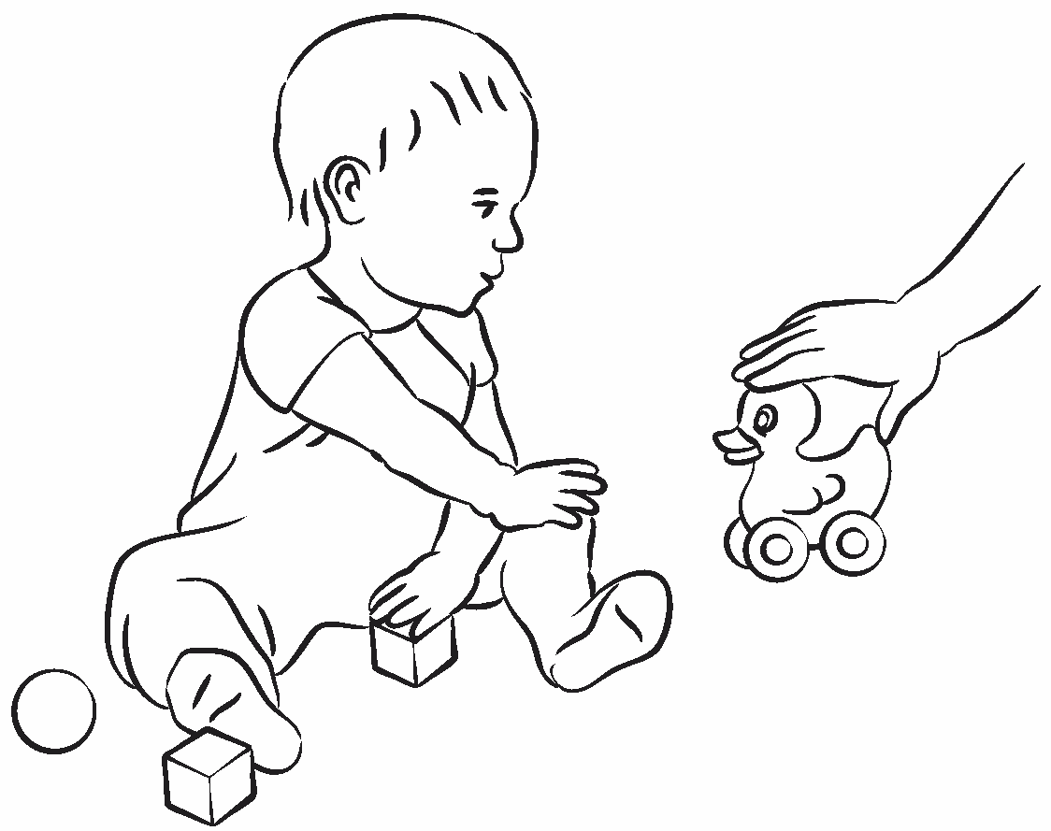
Purpose as Related to O&M:
- Develops balance
- Encourages good posture
- Promotes directed reach
- Stimulates grasping
- Strengthens trunk rotation

Sitting 6.17 (slide is a continuation picture of the activity sheet from the curriculum book)
Activities/Routines:
- Put a container of toys on each side of the child. Encourage the child to reach for toys in one container and place them in the other container.
- After diapering or dressing routines, place the child in a sitting position, place an auditory, visual, or tactual toy or desired object to encourage the child to reach in variety of directions.
- Use a defined space, with toys on the perimeter, such as a hula hoop, play pen, or inverted Resonance Board™.
- Use a variety of visual, auditory and tactual toys to keep child engaged.
- Present object on one side of child at eye level. Once child is engaged, present second object on the other side to promote trunk rotation.
Infused Skills:
- Body to body concepts
- Body to object concepts
- Body segmentation
- Environmental awareness
- Object permanence
- Orientation concepts: directional, positional, spatial
- Weight-shifting

Sitting 6.17 (slide is a continuation picture of the activity sheet from the curriculum book)
Areas of Concern:
- A child with other sensory impairments may need more physical prompting, wait time and reduced sensory stimulation
- Consult with Physical Therapist or Occupational Therapist for: hypertonia; hypotonia, other motor impairments
Stepping Forward
- Transitioning self in and out of sitting position with ease in a variety of settings and surfaces
- Scooting
- Crawling

Included on the Flashdrive
- T2S Evaluation Simple Excel.xlsx
- T2S Evaluation.xltx
- T2S Curriculum.epub
- T2S Evaluation.epub

Evaluation document includes:
- Cover page
- Reflexes
- Mobility (blue)
- Orientation (green)
- Summary by Age
- Summary Overview by Skill Level

Cover Page
The following are 4 tables depicting the cover page. It is broken down to different table due to space limitations.
Table 1 reflects written information about the student.
Table 2 reflects information collected from the first assessment. Scores from the electronic version are automatically calculated to Row 1. All the “+” or mastered items are calculated as a percentage.
Table 3 reflects information collected from the second assessment. Scores from the electronic version are automatically calculated to Row 2. All the “+” or mastered items are calculated as a percentage.
Table 4 reflects information collected from the third assessment. Scores from the electronic version are automatically calculated to Row 3. All the “+” or mastered items are calculated as a percentage. The last column reflect the total number of skills in each area.

Table 1
Texas 2 STEPS Evaluation
(Successfully Teaching Early Purposeful Skills)
STUDENT INFORMATION:
Name
COMS Evaluator: | Shay Utley
Gender | Male
Date of Birth: | 9/22/17
Age: | 28 | Months | 2 Yr 4 Mo
Visual Condition:
Medical Information
Date(s) of Evaluation: | 1/11/19 |  | 1/20/19
Age(s) at Evaluation: | 16 | Mo. | 26 | Mo. | 0 | Mo.
Administrative time per session: |  | min. |  | min. |  | min.

Table 2
 | Row 1
 | 1/0/00
 | + | - | E | N/A | % +
Head Control | 100 | 0 | 0 | 0 | 100%
Trunk, Arm, and Leg Control | 8 | 0 | 0 | 0 | 100&
Rolling | 10 | 0 | 0 | 0 | 100%
Reaching | 8 | 0 | 0 | 0 | 100%
Grasping | 4 | 0 | 0 | 0 | 100%
Sitting | 18 | 0 | 0 | 0 | 100%
Scooting | 5 | 0 | 0 | 0 | 100%
Crawling | 12 | 0 | 0 | 0 | 100%
Standing | 14 | 1 | 0 | 0 | 93%
Walking | 11 | 4 | 0 | 1 | 73%
Jumping | 1 | 3 | 1 | 0 | 11%
Climbing | 2 | 0 | 1 | 0 | 17%
Kicking | 0 | 0 | 1 | 0 | 0%
Running, Galloping, Skipping | 0 | 0 | 2 | 0 | 0%
Basic Skills | 0 | 0 | 0 | 0 | 0%
Cane Skills | 0 | 0 | 0 | 0 | 0%
Sensory | 4 | 0 | 1 | 0 | 25%
Body Awareness | 4 | 6 | 1 | 0 | 25%
Object Permanence | 7 | 1 | 0 | 0 | 44%
Cause and Effect | 2 | 0 | 1 | 0 | 13%
Environmental Awareness | 3 | 2 | 0 | 0 | 19%
Social | 4 | 2 | 0 | 0 | 25%
Language | 0 | 0 | 0 | 0 | 0%
Directional and Positional Concepts | 0 | 0 | 0 | 0 | 0%
Comparative Concepts | 0 | 0 | 0 | 0 | 0%

Table 3
 | Row 2
 | 1/0/00
 | + | - | E | N/A | % +
Head Control | 26 | 0 | 0 | 0 | 100%
Trunk, Arm, and Leg Control | 8 | 0 | 0 | 0 | 100%
Rolling | 10 | 0 | 0 | 0 | 100%
Reaching | 8 | 0 | 0 | 0 | 100%
Grasping | 4 | 0 | 0 | 0 | 100%
Sitting | 18 | 0 | 0 | 0 | 100%
Scooting | 5 | 0 | 0 | 0 | 100%
Crawling | 12 | 0 | 0 | 0 | 100%
Standing | 15 | 0 | 0 | 0 | 100%
Walking | 15 | 0 | 0 | 0 | 100%
Jumping | 6 | 0 | 0 | 0 | 67%
Climbing | 5 | 0 | 0 | 0 | 42%
Kicking | 3 | 0 | 0 | 0 | 100%
Running, Galloping, Skipping | 2 | 0 | 0 | 0 | 40%
Basic Skills | 0 | 0 | 0 | 0 | 0%
Cane Skills | 0 | 0 | 0 | 0 | 0%
Sensory | 12 | 0 | 0 | 0 | 75%
Body Awareness | 12 | 0 | 0 | 0 | 75%
Object Permanence | 7 | 0 | 0 | 0 | 44%
Cause and Effect | 2 | 0 | 0 | 0 | 13%
Environmental Awareness | 4 | 0 | 0 | 0 | 25%
Social | 5 | 0 | 0 | 0 | 31%
Language | 0 | 0 | 0 | 0 | 0%
Directional and Positional Concepts | 0 | 0 | 0 | 0 | 0%
Comparative Concepts | 0 | 0 | 0 | 0 | 0%

Table 4
 | Row 3
 | 1/0/00
 | + | - | E | N/A | % + | TOTAL
Head Control | 26 | 0 | 0 | 0 | 100% | 26
Trunk, Arm, and Leg Control | 8 | 0 | 0 | 0 | 100% | 8
Rolling | 10 | 0 | 0 | 0 | 100% | 10
Reaching | 8 | 0 | 0 | 0 | 100% | 8
Grasping | 4 | 0 | 0 | 0 | 100% | 4
Sitting | 18 | 0 | 0 | 0 | 100% | 18
Scooting | 5 | 0 | 0 | 0 | 100% | 5
Crawling | 12 | 0 | 0 | 0 | 100% | 12
Standing | 15 | 0 | 0 | 0 | 100% | 15
Walking | 15 | 0 | 0 | 0 | 100% | 16
Jumping | 6 | 0 | 0 | 0 | 67% | 9
Climbing | 5 | 0 | 0 | 0 | 42% | 12
Kicking | 3 | 0 | 0 | 0 | 100% | 3
Running, Galloping, Skipping | 2 | 0 | 0 | 0 | 40% | 5
Basic Skills | 0 | 0 | 0 | 0 | 0% | 5
Cane Skills | 0 | 0 | 0 | 0 | 0% | 6
Sensory | 12 | 0 | 0 | 0 | 75% | 16
Body Awareness | 12 | 0 | 0 | 0 | 75% | 27
Object Permanence | 7 | 0 | 0 | 0 | 44% | 9
Cause and Effect | 2 | 0 | 0 | 0 | 13% | 4
Environmental Awareness | 4 | 0 | 0 | 0 | 25% | 13
Social | 5 | 0 | 0 | 0 | 31% | 8
Language | 0 | 0 | 0 | 0 | 0% | 11
Directional and Positional Concepts | 0 | 0 | 0 | 0 | 0% | 19
Comparative Concepts | 0 | 0 | 0 | 0 | 0% | 12

Mobility
The following is a table sample of the electronic form of the evaluation tool.
Column A are ages in months. Column B is the Mobility skill. Column C is the skill number. Column D is the description of the skill. Columns E-F-G are the scoring sections. Column E is the first assessment date, column F is the second assessment date and column G is the third assessment date.

18.00-24.00 | Walking | 10.11 | When walking forward, child will stop, pivot, and change direction of travel. | + | + | +
 |  |  | Evaluation Suggestions: Observe child changing direction to avoid obstacles or to move towards a stimulus.
 |  |  | Comments:
18.00-24.00 | Walking | 10.11
18.00-24.00 | Walking | 10.12 | Child will walk backwards at least 5 steps. | – | + | +
 |  |  | Comments:
18.00-24.00 | Walking | 10.12
18.00-25.00 | Walking | 10.13 | Child will walk independently with a narrow gait and low guard. | – | + | +
 |  |  | Evaluation Suggestions: Child’s walking pattern becomes rhythmic and coordinated. Arms are not used for balance. Reciprocal arm swing may or may not be present.
 |  |  | Comments:
18.00-25.00 | Walking | 10.13
18.00-30.00 | Walking | 10.14 | Child will walk while using an adaptive mobility device (AMD) or cane as a mobility tool. (These tools are not to be used for balance.) | N/A | N/A | N/A
 |  |  | Evaluation Suggestions: Observe child in natural environment. Cane travel may be introduced at this time, if deemed beneficial.
 |  |  | Comments:
18.00-30.00 | Walking | 10.14
24.00-36.00 | Walking | 10.15 | Child will walk using a heel-toe pattern and reciprocal arm swing. | – | + | +
 |  |  | Evaluation Suggestions: Observe child walking independently in natural environment.
 |  |  | Comments:
24.00-36.00 | Walking | 10.15
24.00-36.00 | Walking | 10.16 | Child will walk on a variety of outdoor surfaces. | – | + | +
 |  |  | Evaluation Suggestions: Observe child while traveling across different surfaces outdoors such as grass, sidewalk, woodchips, etc.
 |  |  | Comments:
24.00-36.00 | Walking | 10.16
06.00-09.00 | Jumping | 11.1 | When supported in standing position, child will actively bounce. | + | + | +
 |  |  | Evaluation Suggestions: When supported by an adult or baby bouncer, child will initiate bouncing or up and down movements; feet may or may not leave the floor.
 |  |  | Comments:
06.00-09.00 | Jumping | 11.1
15.00-20.00 | Jumping | 11.2 | Child attempts to jump with both feet, with minimal support. | E | + | +
 |  |  | Evaluation Suggestions: Child will jump up and down several times in succession. Child may hold on to a table or adult’s hands for support.
 |  |  | Comments:
15.00-20.00 | Jumping | 11.2
18.00-24.00 | Jumping | 11.3 | Child will jump with support from a height of approximately 7-12 inches. | – | + | +
 |  |  | Evaluation Suggestions: Child will jump off playground equipment, stair, or other raised surface holding a hand or rail for support.
 |  |  | Comments:
18.00-24.00 | Jumping | 11.3
20.00-24.00 | Jumping | 11.4 | Child will step-jump from a height of approximately 7-12 inches, without support. | – | + | +
 |  |  | Evaluation Suggestions: Child will jump off playground equipment, stair, or other raised surface with one foot landing, then the other.
 |  |  | Comments:
20.00-24.00 | Jumping | 11.4
24.00-30.00 | Jumping | 11.5 | Child will jump in place, landing on both feet, without support. | – | + | +
 |  |  | Evaluation Suggestions: Child will jump with both feet together several times in succession maintaining balance.
 |  |  | Comments:
24.00-30.00 | Jumping | 11.5
24.00-36.00 | Jumping | 11.6 | Child will jump in a forward direction 3-5 times. |  | + | +
 |  |  | Evaluation Suggestions: Child will jump with feet together moving forward.
 |  |  | Comments:
24.00-36.00 | Jumping | 11.6

Summary By Age
Following is a sample table from the electronic version showing comparison of skills by age in months.
The spreadsheet has been broken into 2 tables on this document.
Table 1 shows columns A-H
Column A is the ages listed in months. Columns B, C, and D are the total number of skills for that age group for Reflexes, Mobility and Orientation. Column E is the total number of all skills for that age group. Column F is blank. Column G is the list of reflexes that may be present. Column H is blank.
Table 2 shows Columns A and then Columns I-Q
Columns I and J are the results of the first assessment for the total number of skills mastered for Mobility for that age group and percentage towards mastery of all skills available for that age group. Columns K and L is the same but for the Orientation skills. Column M is blank. Columns N, O, P, Q are a repetition of columns I, J, K, L. This is for the results of the second assessment.

Table 1
 | REFLEX | MOBILITY | ORIENTATION | Total |  | REFLEX
00.00-01.00 |  | 14 | 4 | 18
00.00-02.00 |  | 4 | 2 | 6
00.00-03.00 | 3 | 44 | 10 | 57 |  | 0
01.00-03.00 | 1 | 8 | 7 | 16 |  | 0
02.00-02.00 |  | 4 | 0 | 4
02.00-03.00 |  | 20 | 2 | 22
02.00-04.00 |  | 8 | 0 | 8
02.00-06.00 |  | 4 | 0 | 4
03.00-04.00 |  | 12 | 0 | 12
03.00-05.00 |  | 8 | 2 | 10
03.00-06.00 |  | 52 | 5 | 57
04.00-05.00 |  | 12 | 0 | 12
04.00-06.00 | 1 | 16 | 6 | 23 |  | 0
05.00-06.00 |  | 32 | 0 | 32
05.00-07.00 |  | 12 | 2 | 14
05.00-09.00 |  | 4 | 2 | 6
06.00-08.00 | 1 | 8 | 0 | 9 |  | 0
06.00-09.00 |  | 54 | 10 | 64
06.00-10.00 |  | 4 | 0 | 4
07.00-08.00 |  | 4 | 0 | 4
07.00-09.00 |  | 8 | 0 | 8
07.00-10.00 |  | 4 | 0 | 4
07.00-11.00 |  | 16 | 0 | 16
07.00-12.00 |  | 0 | 2 | 2
08.00-10.00 |  | 4 | 0 | 4
08.00-12.00 |  | 0 | 4 | 4
08.00-14.00 |  | 4 | 0 | 4

Table 2

 | MOBILITY | % Mobiliy | ORIENTATION | % Orientation |  | MOBILITY |  | ORIENTATION
00.00-01.00 | 4 | 28.57% | 2 | 50.00% |  | 4 | 28.57% | 2 | 50.00%
00.00-02.00 | 1 | 25.00% | 1 | 50.00% |  | 1 | 25.00% | 1 | 50.00%
00.00-03.00 | 11 | 25.00% | 5 | 50.00% |  | 11 | 25.00% | 5 | 50.00%
01.00-03.00 | 2 | 25.00% | 0 | 0.00% |  | 2 | 25.00% | 2 | 28.57%
02.00-02.00 | 1 | 25.00% |  |  |  | 1 | 25.00%
02.00-03.00 | 5 | 25.00% | 1 | 50.00% |  | 5 | 25.00% | 1 | 50.00%
02.00-04.00 | 2 | 25.00% |  |  |  | 2 | 25.00%
02.00-06.00 | 1 | 25.00% |  |  |  | 1 | 25.00%
03.00-04.00 | 3 | 25.00% |  |  |  | 3 | 25.00%
03.00-05.00 | 2 | 25.00% | 1 | 50.00% |  | 2 | 25.00% | 1 | 50.00%
03.00-06.00 | 13 | 25.00% | 1 | 20.00% |  | 13 | 25.00% | 3 | 60.00%
04.00-05.00 | 3 | 25.00% |  |  |  | 3 | 25.00%
04.00-06.00 | 4 | 25.00% | 0 | 0.00% |  | 4 | 25.00% | 2 | 33.33%
05.00-06.00 | 8 | 25.00% |  |  |  | 8 | 25.00%
05.00-07.00 | 3 | 25.00% | 1 | 50.00% |  | 3 | 25.00% | 1 | 50.00%
05.00-09.00 | 1 | 25.00% | 1 | 50.00% |  | 1 | 25.00% | 1 | 50.00%
06.00-08.00 | 2 | 25.00% |  |  |  | 2 | 25.00%
06.00-09.00 | 14 | 25.93% | 2 | 20.00% |  | 14 | 25.93% | 5 | 50.00%
06.00-10.00 | 1 | 25.00% |  |  |  | 1 | 25.00%
07.00-08.00 | 1 | 25.00% |  |  |  | 1 | 25.00%
07.00-09.00 | 2 | 25.00% |  |  |  | 2 | 25.00%
07.00-10.00 | 1 | 25.00% |  |  |  | 1 | 25.00%
07.00-11.00 | 4 | 25.00% |  |  |  | 4 | 25.00%
07.00-12.00 |  |  | 1 | 50.00% |  |  |  | 1 | 50.00%
08.00-10.00 | 1 | 25.00% |  |  |  | 1 | 25.00%
08.00-12.00 |  |  | 2 | 50.00% |  |  |  | 2 | 50.00%
08.00-14.00 | 1 | 25.00% |  |  |  | 1 | 25.00%

Summary Overview by Skill Level
This slide has been broken into two tables.
The purpose of this sheet is to visually show mastery level through colored cells. The colored cells are denoted by the * or # symbols. The cell numbers with an* depicts the first assessment date of 1/11/2019. The cell numbers with a # depicts the seconds assessment date of 11/20/2019. Skill numbers without the * or # have not been achieved or assessed.
Table 1 shows all skill areas in the Mobility section. Going across the rows are the skill numbers that correlate to the evaluation numbers for each skill in that area.
Table 2 shows all skill areas in the Orientation section. The numbers across depict each skill for that area.

Table 1

 | 1/11/2019* |  | 11/20/2019#
Reflexes and Postural Reactions
Head Control | 1.1* | 1.2* | 1.3* | 1.4* | 1.5* | 1.6* | 1.7* | 1.8* | 1.9* | 1.10* | 1.11* | 1.12* | 1.13* | 1.14* | 1.15* | 1.16* | 1.17* | 1.18* | 1.19* | 1.20* | 1.21* | 1.22* | 1.23* | 1.24* | 1.25* | 1.26*
Trunk, Arm, and Leg Control | 2.1* | 2.2* | 2.3* | 2.4* | 2.5* | 2.6* | 2.7* | 2.8*
Rolling | 3.1* | 3.2* | 3.3* | 3.4* | 3.5* | 3.6* | 3.7* | 3.8* | 3.9* | 3.10*
Reaching | 4.1* | 4.2* | 4.3* | 4.4* | 4.5* | 4.6* | 4.7* | 4.8*
Grasping | 5.1* | 5.2* | 5.3* | 5.4*
Sitting | 6.1* | 6.2* | 6.3* | 6.4* | 6.5* | 6.6* | 6.7* | 6.8* | 6.9* | 6.10* | 6.11* | 6.12* | 6.13* | 6.14* | 6.15* | 6.16* | 6.17* | 6.18*
Scooting | 7.1* | 7.2* | 7.3* | 7.4* | 7.5*
Crawling | 8.1* | 8.2* | 8.3* | 8.4* | 8.5* | 8.6* | 8.7* | 8.8* | 8.9* | 8.10* | 8.11* | 8.12*
Standing | 9.1* | 9.2* | 9.3* | 9.4* | 9.5* | 9.6* | 9.7* | 9.8* | 9.9* | 9.10* | 9.11* | 9.12* | 9.13* | 9.14# | 9.15*
Walking | 10.1* | 10.2* | 10.3* | 10.4* | 10.5* | 10.6* | 10.7* | 10.8* | 10.9* | 10.11* | 10.12 | 10.13# | 10.14 | 10.15# | 10.16#
Jumping | 11.1* | 11.2# | 11.3# | 11.4# | 11.5# | 11.6# | 12 | 12 | 12
Climbing | 12.1* | 12.2# | 12.3* | 12.4# | 12.5# | 12.6# | 13 | 13 | 13 | 12.10 | 12.11 | 12.12
Kicking | 13.1# | 13.2# | 13.3#
Running, Galloping, Skipping | 14 | 14 | 14 | 14 | 15
Basic Skills | 15 | 15 | 15 | 15 | 16

Table 2

 | 1/11/2019* |  | 11/20/2019#
Sensory | 1.1* | 1.2* | 1.3* | 1.4* | 1.5 | 1.6# | 1.7# | 1.8# | 1.9# | 1.10# | 1.11# | 1.12# | 1.13# | 1.14 | 1.2 | 1.2
Body Awareness | 2.1* | 2.2* | 2.3* | 2.4# | 2.5# | 2.6* | 2.7# | 2.8# | 2.9# | 2.10# | 2.11# | 2.12# | 2.13 | 2.14 | 2.15 | 2.16 | 2.17 | 2.18 | 2.19 | 2.20 | 2.21 | 2.22 | 2.23 | 2.24 | 2.25 | 2.26 | 2.27
Object Permanence | 3.1* | 3.2* | 3.3 | 3.4* | 3.5* | 3.6* | 3.7* | 3.8* | 3.9
Cause and Effect | 4.1* | 4.2* | 4.3* | 4.4
Environmental Awareness | 5.1* | 5.2* | 5.3* | 5.4# | 5.5 | 5.6 | 5.7 | 5.8 | 5.9 | 5.10 | 5.11 | 5.12 | 5.13
Social | 6.1* | 6.2* | 6.3* | 6.4* | 6.5# | 6.6 | 6.7 | 6.8
Language | 7.1* | 7.2* | 7.3* | 7.4# | 7.5 | 7.6# | 7.7 | 7.8 | 7.9 | 7.10 | 7.11
Directional and Positional Concepts | 8.1# | 8.2# | 8.3# | 8.4# | 8.5# | 8.6# | 8.7 | 8.8 | 8.9 | 8.10 | 8.11 | 8.12 | 8.13 | 8.14 | 8.15 | 8.16 | 8.17 | 8.18 | 8.19

Purchasing Information
- Texas 2 STEPS Curriculum and Evaluation Set (59458-TTS) can be purchased from Texas School for the Blind and Visually Impaired
- For in-depth training please contact Debra Sewell.

Authors
- Jill Brown, TVI, COMS
- Tracy Hallak, TVI, COMS
- Shay Utley, COMS
- Gema Nelson, COMS
- Marjie Wood, TVI, COMS
- Stephanie Walker, TVI, OMS
- Olga Uriegas, TVI, OMS
- Debra Sewell, TVI

