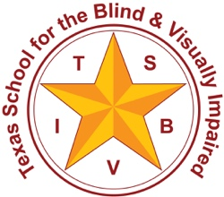Texas School for the Blind and Visually Impaired

Outreach Programs

[www.tsbvi.edu](http://www.tsbvi.edu) | 512-454-8631| 1100 W. 45th St. | Austin, TX 78756

TSBVI Outreach Coffee Hour

Learning Nemeth Code: Pre-K through 1st Grade

September 28, 2020

Presented by  
Susan A. Osterhaus

Texas School for the Blind and Visually Impaired

1100 West 45th Street

Austin, TX 78756

[susanosterhaus@tsbvi.edu](mailto:susanosterhaus@tsbvi.edu)

[www.tsbvi.edu/math](http://www.tsbvi.edu/math)

[www.tsbvi.edu/videos-webinars/mathematics](http://www.tsbvi.edu/videos-webinars/mathematics)

Agenda

* What is the Nemeth Braille Code and when should instruction begin?
* Resources for Teachers, Parents, and Paraprofessionals to Learn the Nemeth Code
* Curriculum for Pre-K through 1st Grade Students to Learn the Nemeth Code
* High Tech Translation Apps

What is Nemeth Code?

* The Nemeth Braille Code for Mathematics and Science Notation was created by Dr. Abraham Nemeth for his own use as a brilliant mathematician, and he was kind enough to share it with rest of us. At the time, it blended beautifully with the surrounding literary text: English Braille American Edition (EBAE).
* In 2012, the Braille Authority of North America (BANA) adopted Unified English Braille (UEB), and we now transcribe Nemeth Code within UEB Contexts.

BANA Nemeth Code Book  
[www.brailleauthority.org/mathscience/math-science.html](http://www.brailleauthority.org/mathscience/math-science.html)

* The Nemeth Braille Code for Mathematics and Science Notation, 1972 Revision.
* Nemeth Updates from 2007 through 2015
* In the Nemeth code rule book, the nonmathematical text that surrounds the mathematics is based on English Braille, American Edition (EBAE), which is being replaced by Unified English Braille (UEB).

Nemeth Code within UEB Contexts [www.brailleauthority.org/mathscience/math-science.html](http://www.brailleauthority.org/mathscience/math-science.html)

* The BANA Nemeth Technical Committee is in the process of updating the Code Book, but in the meantime, we have the:
* *Guidance for Transcription Using the Nemeth Code within UEB Contexts,* April 2018

National Federation of the Blind Course in Nemeth Code Transcribing  
<https://www.nfb.org/programs-services/braille-certification/mathematics-braille-transcribing>

* An Introduction to Braille Mathematics, 1978
* Errata and Addenda to An Introduction to Braille Mathematics, November 10, 2014
* An Introduction to Braille Mathematics LESSON 16, Updated July 2016
* Course Manual Revision (Provisional)
* The course manual is currently being updated to align with the use of Nemeth Code within UEB contexts. A provisional version of the revised lessons is made available here for review purposes only.

When should Nemeth code instruction begin?

Begin in Pre-School

* Braille Math Blocks from <https://unclegoose.com/product/braille-math-blocks-2/>

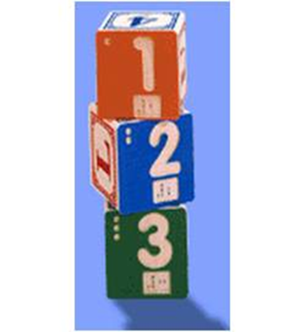

Figure Three Braille Math Blocks from www.lindenwoodinc.com numbered 1, 2, and 3 in engraved print and Nemeth code

Pre-K through 1st Grade Resources for Teachers, Parents, and Paraprofessionals

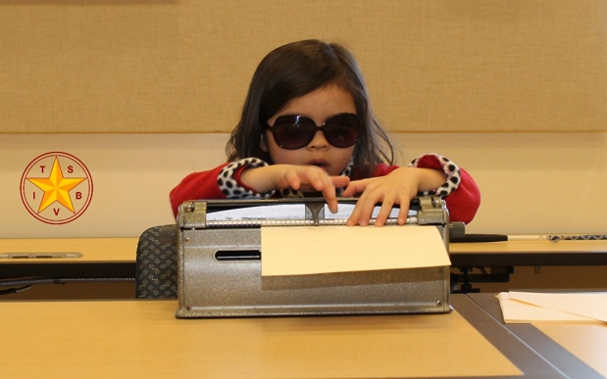

Figure Little Girl Checking Her Nemeth Code while her paper is still in the Braillewriter

When to Teach Nemeth Code Aligned with Math Standards

* Maryland’s College and Career Ready Standards for Unified English Braille and Nemeth Code: Mathematics, Maryland State Department of Education Updated 2015 <https://mdk12.msde.maryland.gov/INSTRUCTION/commoncore/Documents/MD_CCRS_UEB_Math.pdf>

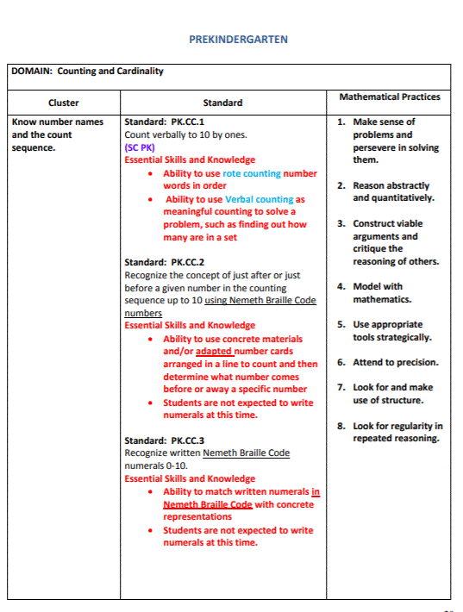

Figure Prekindergarten Cluster/Standard/Mathematical Practices Table

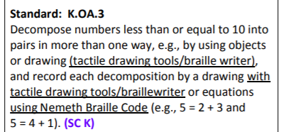

Figure Decompose numbers less than or equal to 10 into pairs in more than one way, e.g., by using objects or drawing (tactile drawing tools/braille writer), and record each decomposition by a drawing with tactile drawing tools/braillewriter or equations using Nemeth Braille Code (e.g., 5=2+3 and 5=4+1). (SC K)

Determine the unknown whole number in an addition or subtraction equation relating three whole numbers. For example, determine the unknown number that makes the question true in each of the equations 8+?=11, 5=?-3, 6+6=?.
To represent unknown symbols in Nemeth Braille ode, use:
symbol of omission for question mark
double dash for blank line
square shape indicator for box/square

Figure Determine the unknown whole number in an addition or subtraction equation relating three whole numbers. For example, determine the unknown number that makes the question true in each of the equations 8+?=11, 5=?-3, 6+6=?. To represent unknown symbols in Nemeth Braille ode, use: symbol of omission for question mark double dash for blank line square shape indicator for box/square.

Maryland’s Plan in More Detail

Nemeth at a Glance

* Tactile Skills Necessary for Math
* Early Numeracy
* Spatial Arrangements
* Comparison Signs
* Grade Level Chart
* Grade 1 Examples
* Reading Evaluation
* Writing Evaluation
* *Nemeth at a Glance: A Math Resource, Grade Level Chart, and Evaluation Tool,* February 2017
* <http://www.tsbvi.edu/store/ecom/index.php?action=ecom.pdetails&mode=nemeth>

Grade Level Chart and Reading and Writing Evaluation Snip-Its

Commonly Used Nemeth Mathematics Symbols Arranged by Grade and Course
PK - Kindergarten Symbols

Figure Commonly Used Nemeth Mathematics Symbols Arranged by Grade and Course PK - Kindergarten Symbols

Commonly Used Nemeth Mathematics Symbols Arranged by Grade and Course
Kindergarten - 1st Grade Symbols

Figure Commonly Used Nemeth Mathematics Symbols Arranged by Grade and Course Kindergarten - 1st Grade Symbols

Reading Evaluation
First Five Items

Figure Reading Evaluation First Five Items

Writing Evaluation
Items 5 - 10

Figure Writing Evaluation Items 5 - 10

APH Nemeth Tutorial

* <https://tech.aph.org/nemeth/>

APH Nemeth Tutorial
Introduction and Index
Chapter One: First Grade
1.1 The Numeric Indicator
1.2 Punctuation
1.3 Comma
1.4 Equals Sign
1.5 Signs of Comparison

Figure APH Nemeth Tutorial Introduction and Index Chapter One: First Grade 1.1 The Numeric Indicator 1.2 Punctuation 1.3 Comma 1.4 Equals Sign 1.5 Signs of Comparison

Nemeth Braille Code for Instructors and Paraeducators Online Courses

* <https://www.tsbvi.edu/course-listing#nemethdescription>

Nemeth Braille Code for Instructors and Paraeducators Online Courses
PreK/1
1 Numeric Indicator
2 Punctuation Indicator
3 English Letter Indicator
4 Math Comma and Hyphen
5 Addition Sign in Horizontal Expressions
6 Subtraction Sign in Horizontal Expressions
7 Sings of Comparison - Equal Sign
8 Tally Marks
9 Ellipsis and Long Dash
10 General Omission Symbol
11 Spatial Arrangement - Addition & Subtraction
12 Spatial Arrangement - Addition/Regroup
13 Inequality Signs in Horizontal Expressions
14 PreK/1 UEB/Nemeth Examples

Figure Nemeth Braille Code for Instructors and Paraeducators Online Courses PreK/1 1 Numeric Indicator 2 Punctuation Indicator 3 English Letter Indicator 4 Math Comma and Hyphen 5 Addition Sign in Horizontal Expressions 6 Subtraction Sign in Horizontal Express

Nemeth Curriculum for the Little Ones

* Never too young!!

1+3 = 4 in Nemeth code

Figure 1+3 = 4 in Nemeth code

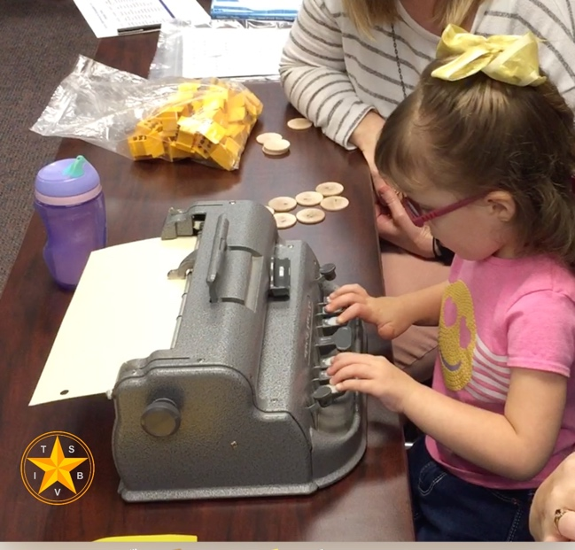

Figure Little girl brailling her Nemeth Code on a braillewriter

Nemeth Braille Code Curriculum  
<http://accessibility.pearson.com/nemeth/>

* Teaches students to read and write Nemeth Code within UEB Contexts
* Pre-K, kindergarten, first grade, and second grade materials
* Aligned with the Common Core State Standards (CCSS Initiative, 2010)
* Hands-on games and activities
* Includes teacher scripts, braille ready files for student worksheets, answer keys, data recording sheets, review activities, and assessments

Pearson Nemeth Curriculum Materials Page

Nemeth Curriculum Materials Page describes the
Nemeth Braille Code Curriculum
Nemeth Braille Focused Lessons
Nemeth Symbol Library

Pre-Kindergarten – Building a Train

Materials

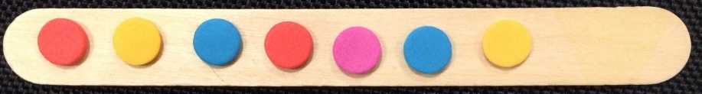

Figure Seven foam stickers have been placed in a line on a craft stick to create a train.

Flash card with the number 7 in Nemeth

Flash card with the number 7 in Nemeth. Three cells of dots 2-5 are followed by a space followed by the numeric indicator and seven followed by a space and then three more cells of dots 2-5.

Figure Flash card with the number 7 in Nemeth

* Foam stickers
* Craft sticks
* Flash cards labeled 1- 7

Steps

* Student shuffles flash cards
* Student draws a card and reads the numeral on the card
* Student uses stickers to “build” the train

If you add print numbers to the flash cards, your student can do the activity with a friend.

Kindergarten – Tens and Ones

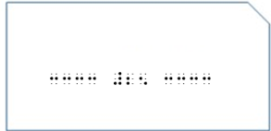

Figure Flash card with the number 25 in Nemeth

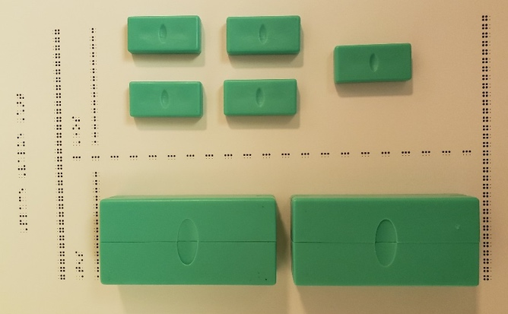

Figure Digi-Blocks on a Place Value Chart

Kindergarten – Maze

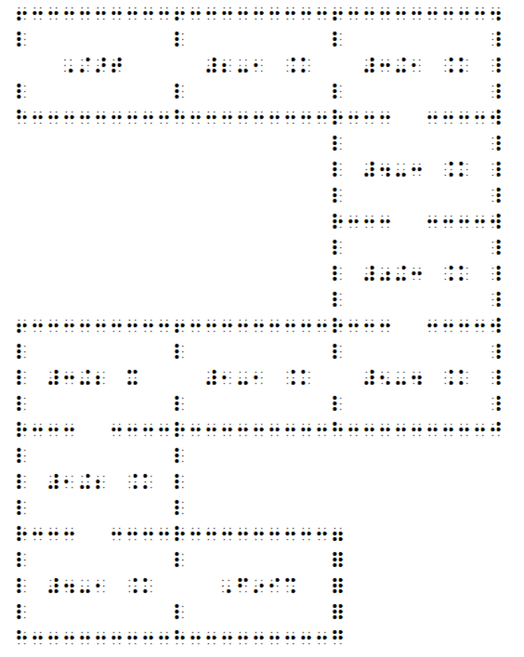

Figure Maze with math problems

Kindergarten - Rebuild a Hundreds Chart

Piccture of a hundred chart cut into 6 pieces

Figure Hundreds board activity

First Grade – Find the Path Activity and Help the Pilot Get to the Airplane!

Find the Path Activity

Find the Path Activity has four rows of addition problems. Find the sum of all the problems, and then mark each 8 or 9. Connect all the 8s and 9s and find the path to the airplane. There is space at the bottom right for the child to draw an airplane.

Figure Find the Path Activity Braille Activity

First Grade – Determine the Shape and Then Write the Missing Numbers

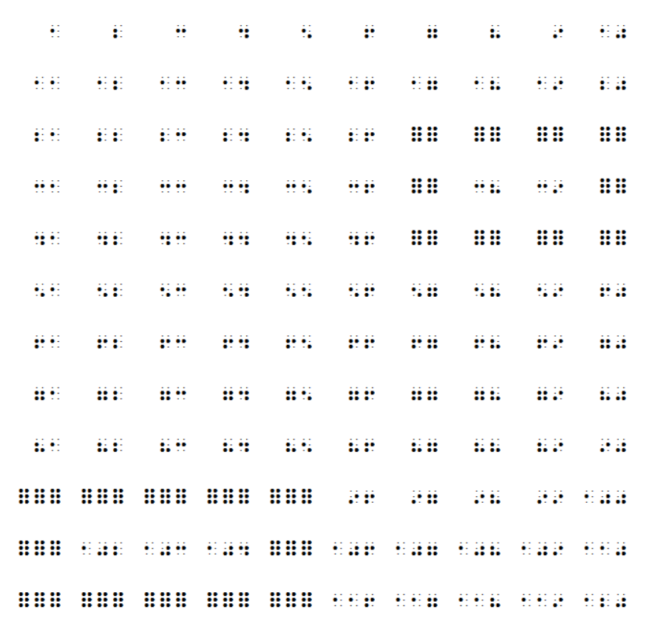

Figure 120 Chart with Missing Numbers

More Hands-on Materials and Manipulatives for Math and Science

* Templates for BINGO cards
* Template for Five Frame
* Template for Ten Frame
* Connect Four Game Cards and Problem Sets
* Roll and Race Game Cards
* Flash Cards
* Shapes Activity
* Counting to 120 Chart

Strategies for Supporting the Student in Building Math Skills

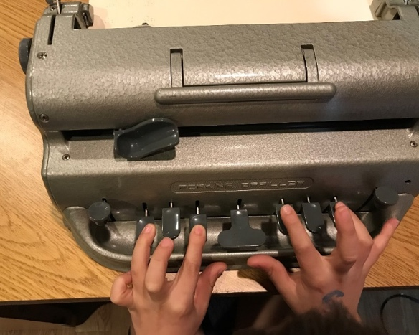

Figure A young child is brailling the equal sign.

Brailling the Equals Sign (=) .k

* Begin brailling using two fingers of the right hand.
* Then follow with two fingers of the left hand.
* Memory cues:
* Two fingers are “equal to” two fingers.
* Two dots are “equal to” two dots.

High Tech Translation Apps

Accessible Equation Editor

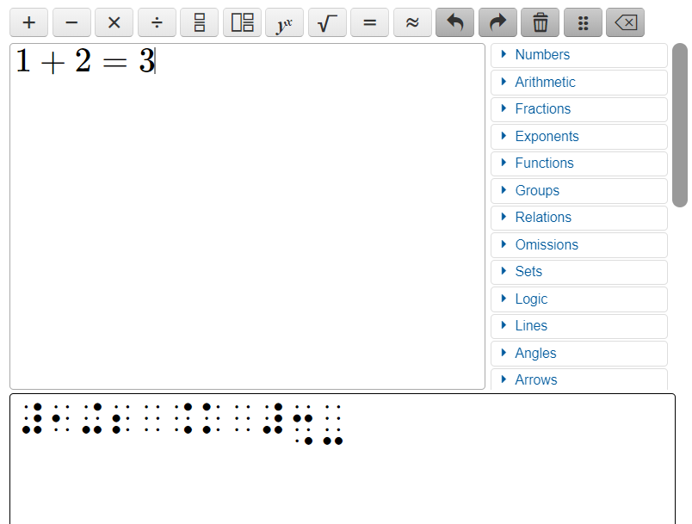

Figure Accessible Equation Editor depicting 1+2= 3 in print and Nemeth Code.

<http://accessibility.pearson.com/aee>

Desmos Braille Demo

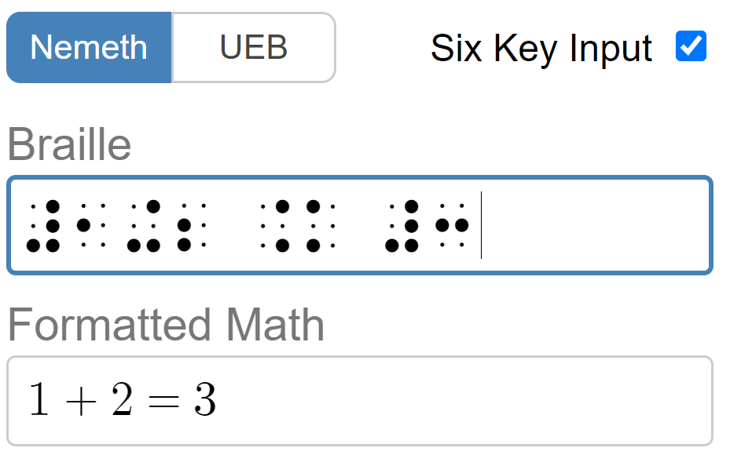

Figure Desmos Braille Demo depicting 1+2 = 3 in print and Nemeth Code.

<https://www.desmos.com/braille-demo/index.html>

Texas School for the Blind & Visually Impaired

* Thank you for your kind attention.
* Now, it’s time for questions…

# Texas School for the Blind & Visually Impaired Outreach Programs

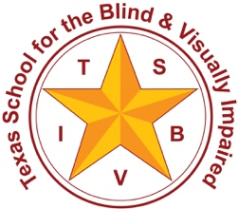

Figure : TSBVI logo

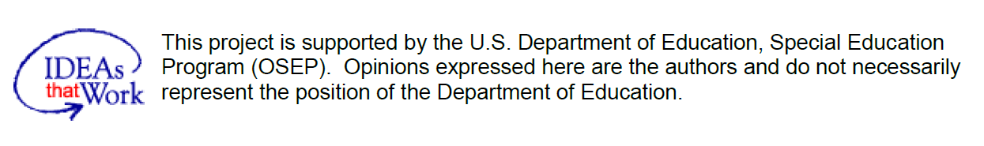

Figure : IDEAs that Work logo and OSEP disclaimer.