Texas School for the Blind and Visually Impaired
Outreach Programs
www.tsbvi.edu | 512.454.8631 | 1100 W. 45th St. | Austin, TX 78756

Coffee Hour – April 8, 2021
Collaborating with Families in the IEP Process
Presented by Lanya McKittrick, Founder, Lane of Inquiry, Deafblind Education Research and Family Support
Parent Experiences:

Deafblind Specific Parent Experiences with the Special Education System (McKittrick, 2019)
- Lack of Professional Knowledge of Deafblindness
- Parents taking on role of case manager and sharing knowledge
- Interveners
- Bringing in support – DB Projects
- Professionals misunderstanding student needs
- Parent need to push for services
- Desire for appropriate goals
  - Not enough future focus
  - Lack of understanding of communication abilities
    - “your child does not have the communication skills necessary to [do what the other kids are doing]”
  - “honors classes are not appropriate for children like yours”
- Professionals not valuing communication mode
- Student unable to communicate needs directly
- Large team of service providers
- Lack of access to other families
- Emotional impacts
- Impact on entire family
- Transitions (post-secondary and more)
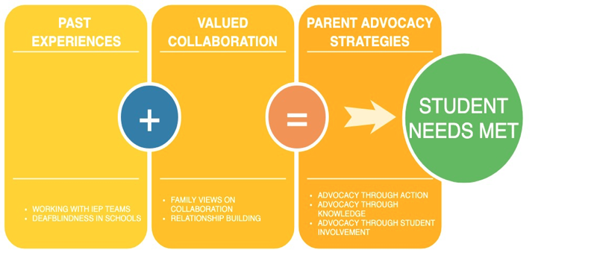

7 Principles of Effective Family-Professional Partnership (Blue-Banning et al., 2004)
- Communication
- Professional Competence
- Commitment
- Advocacy
- Equality
- Respect
- Trust

Importance of Family-Professional Partnerships in Times of Uncertainty (COVID) (McKittrick, 2021)
- Strong family-school communication made all the difference for families
- Professional commitment was a bright spot during the pandemic
- Parents are engaged and empowered
Parent reported Deafblind-specific COVID Challenges
- Accessibility
- Social emotional and disrupted routines
- Not all services were possible
- Logistics of in-person support
- Lack of support

COVID Positives/Successes
- Parents having more control
- Children meeting non-academic goals. More time for ECC.
- Some children are doing well remotely.
- Increased communication – texting, Class Dojo
- “I’ve actually enjoyed it because now I can really see what he’s capable of and what he’s not. All these things I’ve been asking for them to put in place at school, are working at home. It’s really made me a better, or more engaged parent in many ways.

What is on parent minds right now – COVID Implications
- Unique needs - a one size fits all approach won’t work.
- Requires good communication, problem solving, for an individualized approach.
- For some, in-person support is necessary but still not possible. How do we find ways to support these families?
- Students have not been able to receive some of the services and supports they need.
- Put new accommodations in place
  - Find ways to mitigate Zoom fatigue - (i.e., camera off, frequent breaks, alternative ways to show engagement, recordings, transcripts).
- Accessibility: captioning, FM system, virtual interpreter, document cameras, lighting, adjusting computer settings for font size.
- Additional teacher check ins, to make sure students have what they need for the week and check for understanding
- Self-advocacy and self-determination are more important than ever. Good time to focus on Expanded Core Curriculum.
- Social emotional impacts

What can we learn from this pandemic about collaboration?
- Relationships matter – partnership is more important than ever before.
- Collaboration Strategies
  - Prioritize communication and relationship building – individual check ins
  - Push teams to be flexible, to individualize, and to problem solve.
  - Reprioritize – consider the value of non-academic goals.
  - Practice self-care
  - Parents build up advocacy toolbox based upon new first-hand knowledge
  - “Be flexible. This year is difficult for everyone. Understand that the children are also feeling stressed. We need to work together as a team to be able to make progress for the child.”

General Collaboration Strategies
- Ensure someone who is knowledgeable about deafblindness is on the team.
- Build trusting relationships with students and their families
  - Share knowledge
  - Honestly, accountability
  - Mutual respect
- Develop communication plans with families
- Remain flexible
- Involve the student
- Acknowledge the strengths of all those involved
- Balance the time spent listening and sharing
- Follow through
- Avoid jargon
- Encourage sensitivity to all aspects of diversity
- Make sure no surprises
- Check in with families before IEP meetings
- Make sure all team members are collaborating

References
- Blue-Banning, M., Summers, J. A., Frankland, H. C., Nelson, L. L., & Beegle, G. (2004). Dimensions of Family and Professional Partnerships: Constructive Guidelines for Collaboration. Exceptional Children, 70(2), 167–184.
- Correa-Torres, S., Bowen, S., Gershwin, T. G., & McKittrick, L. (2018, April). Conflict and special education: An Investigation of the Experiences of parents of Children with Sensory Disabilities. Workshop presented at the Deaf-Blind International Network of Americas conference.
- McKittrick, Lanya Lynn. (2019). Strategies That Mothers of Children Who Are Deafblind Employ to Foster Collaboration Within Individualized Education Program Teams. Ann Arbor MI: ProQuest LLC.
- McKittrick, Lanya Lynn (2021). Importance of Family-Professional Partnership in Times of Uncertainty. Retrieved from www.laneofinquiry.org.

Thank you for joining us today!
Contact Lanya McKittrick with questions or more information.
Sign up for my newsletter.

