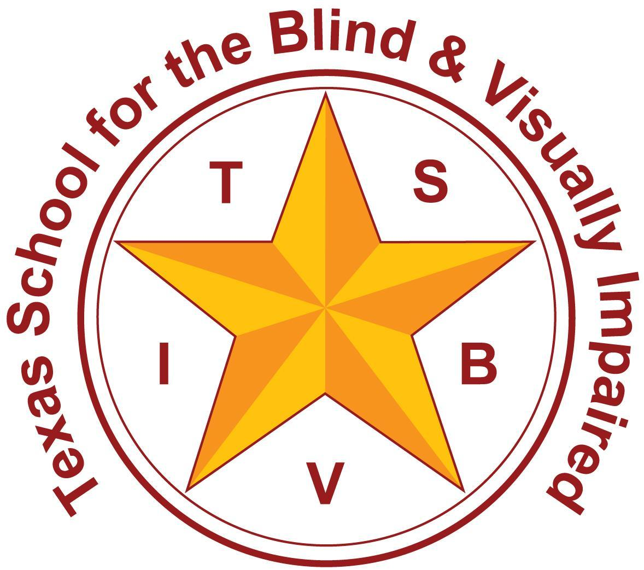
Texas School for the Blind and Visually Impaired
Outreach Programs
www.tsbvi.edu | 512-454-8631| 1100 W. 45th St. | Austin, TX 78756

Coffee Hour: Resources & Guidance For Using the CVI Range

February 27, 2023

Facilitated by

Sara Kitchen, VI Education Consultant

kitchens@tsbvi.edu

Lynne McAlister, VI Education Consultant

mcalisterl@tsbvi.edu

Where are you in your CVI Assessment Journey?
- Resources for increasing CVI knowledge
- Resources for learning about the CVI Range (C. Roman, 2017) assessment process
- Tools/Resources Used in Coaching/Collaboration
- CVI Range Collaboration Overview (building your skills, knowledge, and community)

Resources for Increasing CVI Knowledge
- Pediatric Cortical Visual Impairment Society
- Christine Roman: CVI Resources, YouTube channel
- CVI Scotland: Lessons
- Perkins CVI Now
- Diane Sheline: Strategy to See
- more resources in the handout

Resources for learning about the CVI Range assessment process
- Cortical Visual Impairment: An Approach to Assessment and Intervention Roman Lantzy, C. A. (2018). 2nd Edition. New York: American Foundation for the Blind.
- Texas School for the Blind and Visually Impaired: CVI Scenarios, Phase I, Phase II, Phase III (free, up to 12 CEUs)
- 10 week Perkins Course: The CVI Range Approach ($400, 50 CEUs)

CVI Range Collaboration (building your skills, knowledge, and community)
- Parent Interview
- Observation
- Direct Assessment
- Score Rating II
- Score Rating I
- Find the CVI Range
- Considerations for learning media
- Intervention

Tool for Data Collection

Data Collection Form which includes
- Each Characteristic (Visual Complexity broken down into 4 parts)
- A section under each characteristic to record information gleaned from:
- Parent Interview
- Observation
- Direct Assessment
- Example from Sandra Newcomb

Parent Interview

Cortical Visual Impairment: An Approach to Assessment and Intervention, Roman, 2nd Edition (AFB Press)
- Parent Interview questions (p. 56)
- Parent Interview answer guide (p. 64)
- How to do the parent interview (p. 90)

Observation

Cortical Visual Impairment: An Approach to Assessment and Intervention, Roman, 2nd Edition (AFB Press)
- Use “observation” section on p. 91-92, Roman, 2017, for ideas

Direct Assessment

Cortical Visual Impairment: An Approach to Assessment and Intervention, Roman, 2nd Edition (AFB Press)
- Procedure Guide - Ideas for Direct assessment (p. 138)
- Suggestions for Direct Assessment of CVI Characteristics (p. 93)
- Suggestions for an Assessment Kit (p. 95)

Score Rating II

Cortical Visual Impairment: An Approach to Assessment and Intervention, Roman, 2nd Edition (AFB Press)
- Description of Rating 2 (p. 103-105)
- Scoring Complexity (p. 105)
- Rating 2 Scoring Guide (p. 166)

Score Rating I

Cortical Visual Impairment: An Approach to Assessment and Intervention, Roman, 2nd Edition (AFB Press)
- See directions on bottom of first page of CVI Range Assessment
- Rating 1 Scoring Guide (p. 153)
- Directions for the “Ceiling Effect” (p. 101)

Find the CVI Range

Cortical Visual Impairment: An Approach to Assessment and Intervention, Roman, 2nd Edition (AFB Press)
- The Two CVI Range Scores (p. 106)
- If the difference between Rating I and Rating II is greater than 1.5, re-evaluate your scoring decisions.
- When in doubt, score conservatively (p. 105)

Considerations for Learning Media

Sensory Balance: Planning for Students with CVI, Roman & Tietjen, Perkins School for the Blind, 2020
- Web Tutorial from Perkins
- Forms

Intervention

Cortical Visual Impairment: An Approach to Assessment and Intervention, Roman, 2nd Edition (AFB Press)
- Sample Recommendations and Interventions for CVI (based on phase & range) (p. 231)
- Chapter 6: Program Planning & Intervention (p. 175)

Steps followed in the collaborative process
- Identify student who needs assessment
- Decide on who will be the lead
- Determine who will help process the information (TVI/COMS/OT/Parent/ESC VI Lead/TSBVI/etc.)
- Agree on a secure way to share documents and videos: we use Google Drive.
- Create a folder and share it with the participants.
- Create a data sheet (or use Newcomb’s)
- Gather information from parent using the parent interview questionnaire
- Take video clips of student using their vision in typical environments
- Meet as a team to process information from the parent interview and observation clips and record on your data sheet.
- View the descriptions of each section of the range and estimate how the child is using their vision from the data you have so far.
- Hone in on which section(s) you will spend the most time on. When in doubt, start with Range 1-2.
- Using information from the data sheet and the Rating I Scoring Guide, identify the items that you have sufficient information about and those that you do not.
- Highlight the areas on the CVI Range Rating 1 score sheet that need to be tested (not enough information yet)
- Use the Procedure Guide for CVI Range Rating I if you need help with ideas for how to test specific statements.
- Decide what materials you will bring (for guidance, use “Suggested Items for an Assessment Kit”)
- Find a location in which the environment can be controlled (lights, array, sound, etc.)
- Determine who will video and who will perform the assessment.
- Video the direct assessment and upload clips into shared folder
- Meet as a team to review the direct assessment clips.
- Record information from direct assessment onto your data collection sheet.
- Fill out the CVI Range Rating 2 based on overall knowledge using scoring guide.
- Fill out the CVI Range Rating 1 based on the data sheet and scoring guide.
- Determine the CVI Range from the number found in Rating 1 and the number found in Rating 2.
- The Range score will help you determine the child’s CVI Phase.
- Use the book for intervention suggestions (p.231) by Characteristic and Phase to help identify recommendations to increase the child’s visual functioning across the day.
- Use the data sheet information to report on each characteristic if you want to add it to your FVE.
- Use the statements from Rating 1 to determine present levels of visual performance.
- Use the statements from Rating 2 to determine accommodations.
- Sensory Balance: Planning for Students with CVI, Roman & Tietjen, Perkins School for the Blind, 2020
- Fill out the Learning Media Profile to determine what modality the student will use in daily tasks.
- You can also use the Activity Planning Form for more detailed guidance for your team.

Need Help with CVI Range?
- Contact your Regional Education Service Center.
- Use TSBVI Website for help from Outreach. Specify CVI Range Collaboration when filling out the Training Request.
- Contact Lynne or Sara if you have questions.
- kitchens@tsbvi.edu
- mcalisterl@tsbvi.edu

Resources:
- Pediatric Cortical Visual Impairment Society: Links for parents, educators, and medical professionals
- Texas Educational Service Centers. Each of the 20 Regions in Texas has an Educational Service Center that supports that Region. Each Service Center has a lead Teacher of Students with Visual Impairments that can help support families and educators of children with CVI.
- Christine Roman: CVI Resources. Christine is a leader in the field and has many resources on her page. She also has a YouTube channel that has several informative videos.
- CVI Scotland: Lessons. Very user-friendly and short basic lessons about vision and CVI.
- Perkins CVI Now. The Perkins School for the Blind offers resources and online education about CVI.
- Start Seeing CVI. A parent-run website supporting parents of children with CVI.
- Encouraging Efficient Use of Vision in Students with CVI by Diane Sheline at Strategy to See
- American Printing House for the Blind: CVI Page. This site contains many CVI resources.
- Texas School for the Blind and Visually Impaired: CVI Scenarios, Phase I, Phase II, Phase III. These are case studies of completing the CVI Range Assessment for three students with different visual capabilities. These webinars are free.
- Jeanne Gardier: Strategies for Working with Children with Cortical Visual Impairment
- Scottish Sensory Centre: Devising Strategies to Optimize Home and School Life for Children with Visual Impairment Due to Damage to the Brain

- Alan Weinstein Idaho Project for Children and Youth with Deaf-Blindness CVI Fact Sheet
- MaryAnn Demchak, Charmaine Rickard, and Marty Elquist Tips for Home or School. Cortical Visual Impairment. Nevada Dual Sensory Impairment Project.
- Perkins AAC
- CVI Range Data Collection Form

Texas School for the Blind & Visually Impaired Outreach Programs

Coffee Hour: Resources & Guidance for using the CVI Range

Thank you for joining us!

Texas School for the Blind & Visually Impaired Outreach Programs
Figure 7: TSBVI logo

Figure 8: IDEAs that Work logo and OSEP disclaimer.

