Nemeth in a Box for Middle School Students
- Susan Osterhaus, Texas School for the Blind and Visually Impaired
- Dr. Tina Herzberg, University of South Carolina Upstate
- Sara Larkin, Iowa Educational Services for the Blind and Visually Impaired

Slide 2: Overview of Project INSPIRE
- U.S. Department of Education grant funded project
- Provides:
  - Professional development for teachers of students with visual impairments
  - Extra-curricular programming supporting the use of STEM braille codes by students in both math and science.
- Years 1 – 3 Nemeth Code
- Years 4 – 5 Some Nemeth Code, but mostly UEB Technical

Slide 3: Nemeth in a Box
- The use of puzzles and hands-on learning experiences increase conceptual knowledge of mathematical concepts.
- However, little is known about the impact of students’ learning of Nemeth code and mathematical concepts using problem-based learning methods, especially in an online learning environment.

Slide 4: Data Collected
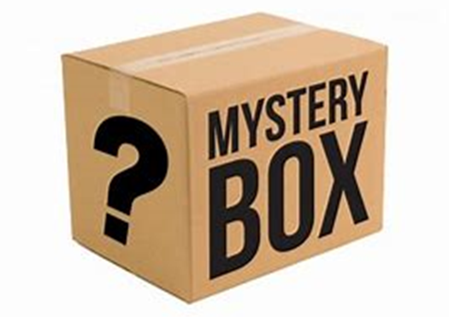
- Pre- and post-test
- Field notes
- Pre- and post teacher survey
- Pre- and post student survey

Slide 5: Targeted Symbols and Math Concepts – Lessons 1-3
- Lesson 1 – fractions, mixed numbers, less than or equal to, greater than or equal to, and not equal to
- Lesson 2 – decimal, percent, dollar sign, cent sign, and approximately equal to
- Lesson 3 – parentheses, negative sign, order of operations, and absolute value (vertical bars)

Slide 6: Targeted Symbols and Math Concepts – Lessons 4-6
- Lesson 4 – math and science-related tables, coordinate pairs, and the mathematical comma
- Lesson 5 – exponents and degrees, including the superscript indicator, baseline indicator, hollow dot
- Lesson 6 – principal square roots

Slide 7: What Is The Question from Week 1
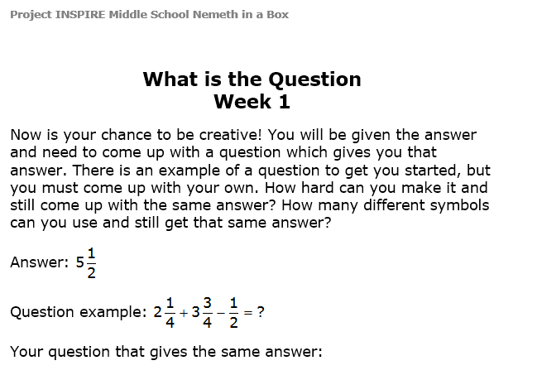

Slide 8: Which One Doesn’t Belong from Week 2
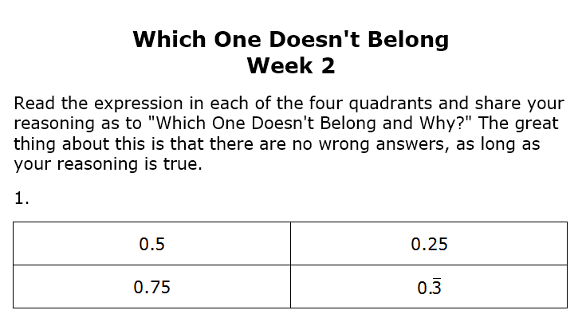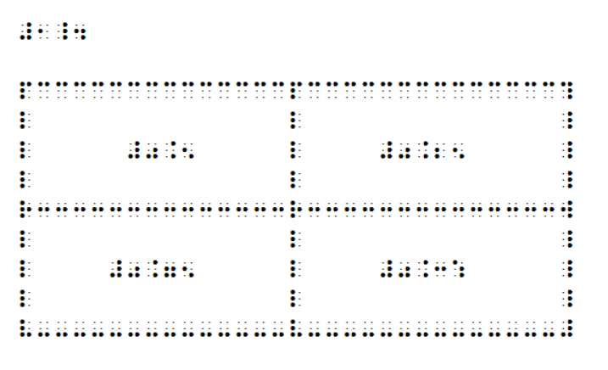

Slide 9: What is Wrong from Week 3
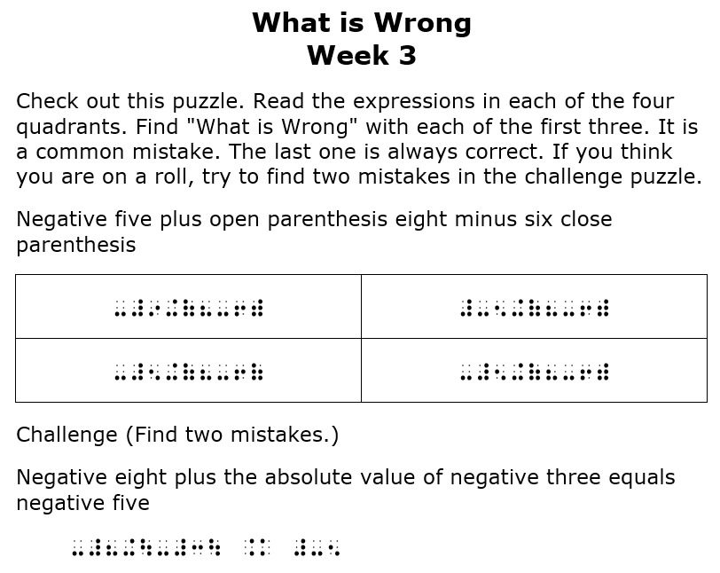

Slide 10: Boggle from Week 4
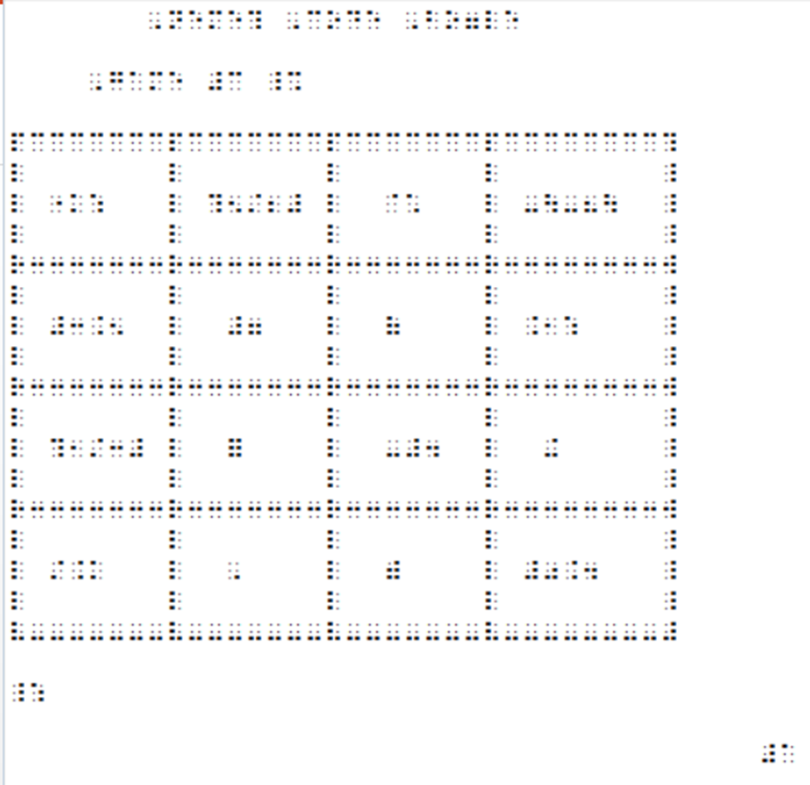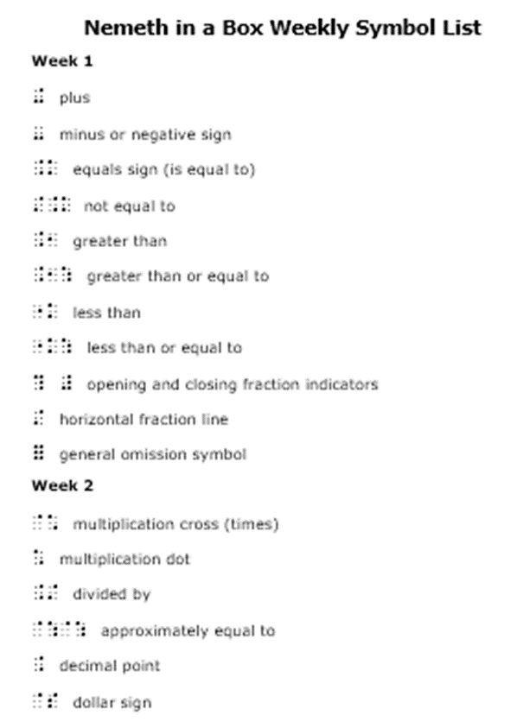

Slide 11: Maze from Week 5
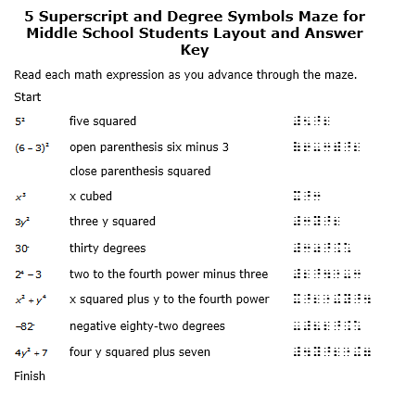

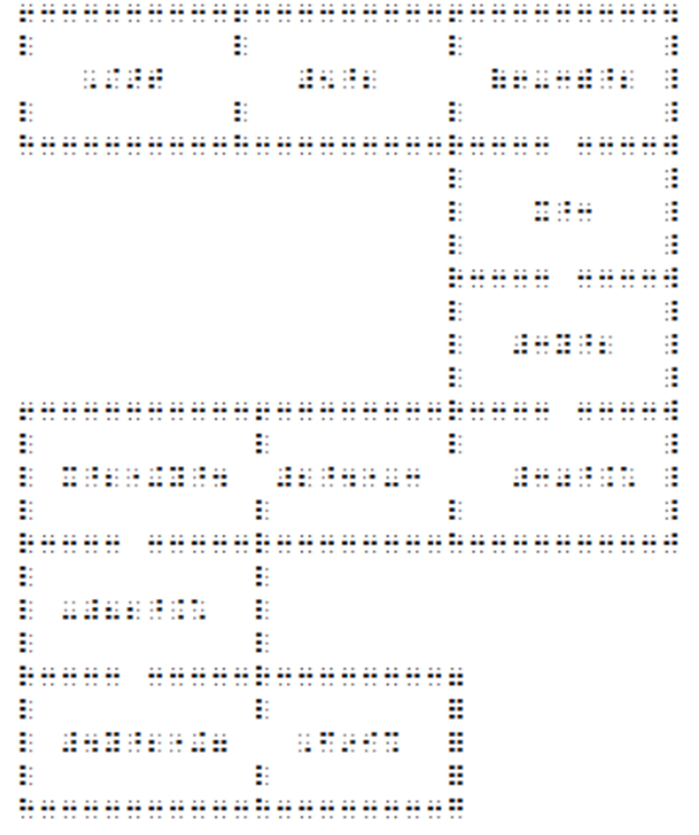

Slide 12: Bingo from Week 6
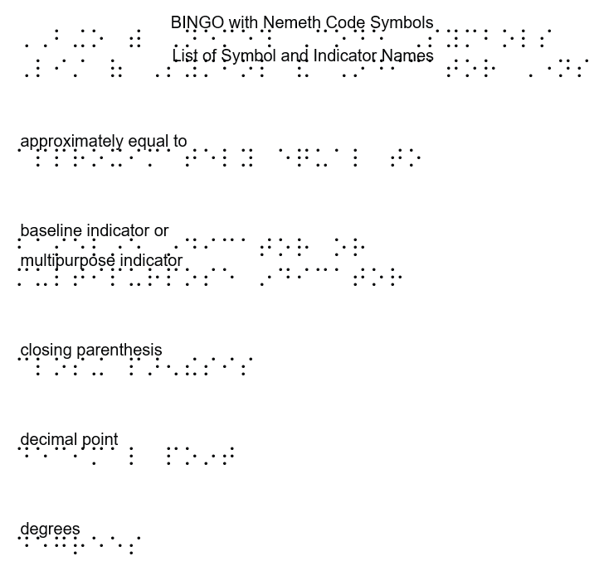
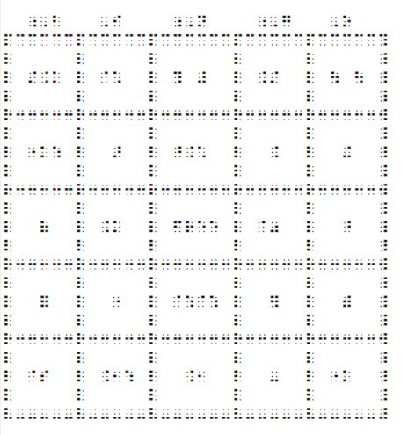

Slide 13 Jeopardy
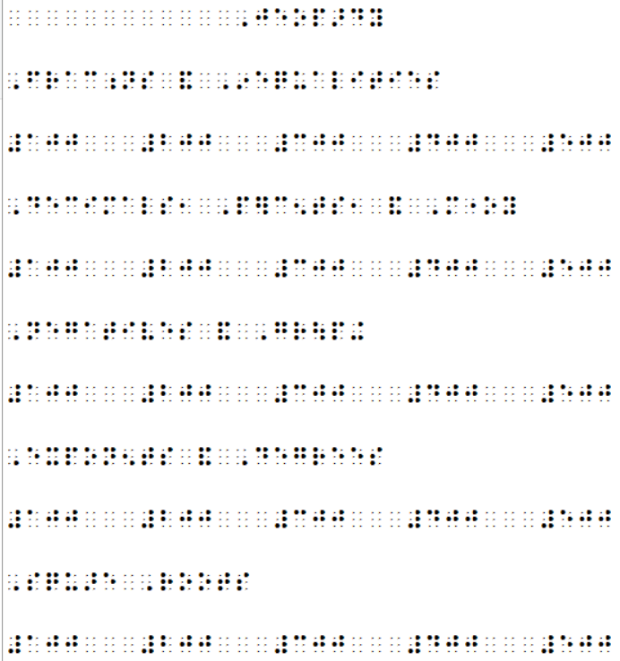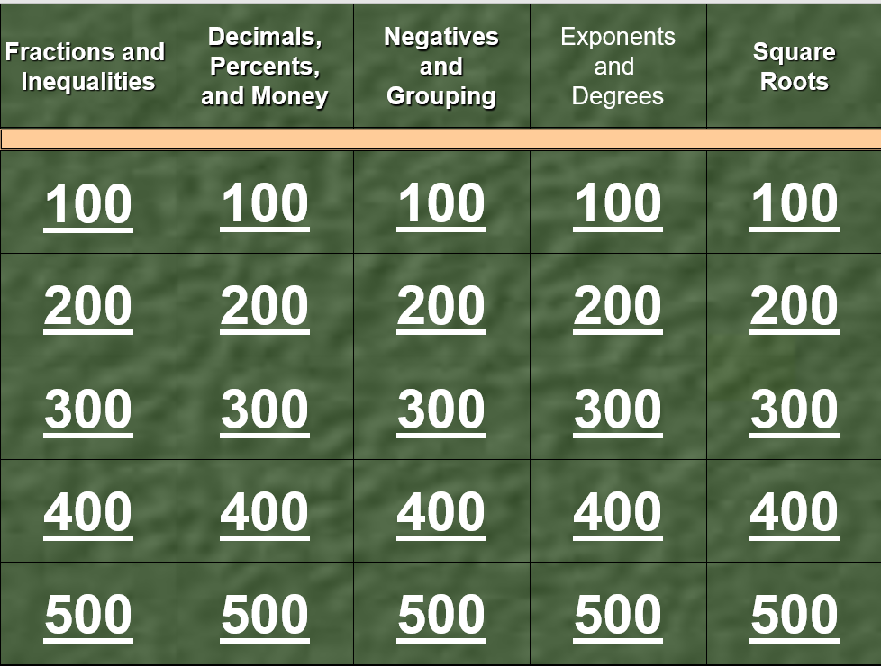

Slide 14: Spring 2021
- Twelve students successfully completed Nemeth in a Box.
- Scores for the completers on the 14-item reading pretest ranged from 0-13 with an average of 7.2.
- Scores on the reading posttest ranged from 3-14 with an average of 11.7.
- Of the 12 completers, 11 successfully demonstrated competency by scoring 75% or higher (at least 11 out of 14) on the posttest.

Slide 15: Survey Results
- All students indicated that they would like to participate in another Nemeth in a Box program or other events Project INSPIRE might offer.
- They also indicated that they would recommend the Nemeth in a Box program to other students.

Slide 16: In Their Words – What They Liked Best
- Boggle
- I liked getting to know new people and play the math games.
- Getting to know some of my blind peers from around the country
- I enjoyed most though, is the puzzle, "Which one Doesn't Belong." I enjoyed this because I got to give out my own opinion on which one I thought was different, and I also got to listen to other's opinions and choices.

Slide 17: More About What They Liked
- I really enjoyed working as a team and figuring out the problems. And the games!
- I enjoyed the “What is the Question” most. I liked connecting with other people that I can relate to the most.
- Everything
- I enjoy the fact that I learned a lot more [Nemeth] symbols while still having fun.
- The teachers and games

Slide 18: Summer 2021
- Student feedback was very positive.
- Data analysis is continuing.

Slide 19: Just in Time…
- Many students with visual impairments did not have accessible materials during COVID-19 in order to fully participate in the general education curriculum (Rosenblum et. al, 2020; Rosenblum et. al, 2021).
- Many students with visual impairments also missed opportunities to be around their same age peers (Rosenblum et. al, 2020; Rosenblum et. al, 2021).
- However, with Nemeth in the Box, students had…
  - High-quality, accessible materials
  - Expert teachers
  - Opportunities to socialize with peers
  - Learning within Expanded Core Curriculum

Slide 20: What Is Next?
- Spring and Summer 2022
  - Nemeth in a Box for middle school students
  - UEB Technical in a Box for middle school students
  - Mission INSPIRE
- Early 2023
  - Nemeth in a Box for high school students

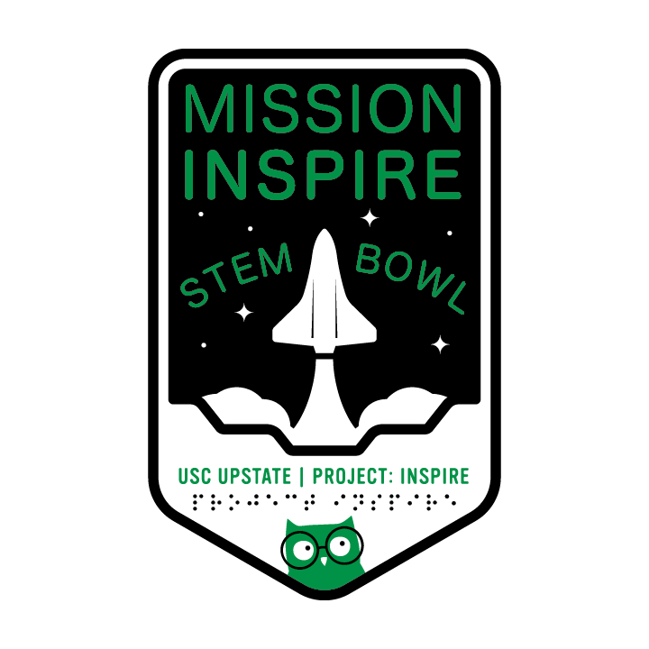

Slide 21: What about the Teachers and Paraprofessionals?
- Fall 2021 – not too late!
  - Geometry and Tactile Graphics for Students in Grades 3 to 8 [repeat from summer 2021]
  - Nemeth Code Symbols Used in the Middle Grades and Strategies for Supporting Math Learning [NEW]
- Spring/Summer 2022
  - Nemeth Code Symbols Used in the Middle Grades and Strategies for Supporting Math Learning [repeat from fall]
  - Nemeth Code Symbols Used in High School and Strategies for Supporting Math Learning [NEW]

Slide 22: Sharing Together
- Weekly “Happy Hour” sessions
- Sign up for fall courses at https://uofsc.co1.qualtrics.com/jfe/form/SV_6x2pcyohIBLfKsK
- Posting of free self-paced courses at https://www.pathstoliteracy.org/resources/project-inspire-free-self-paced-courses-increase-stem-potential-individuals-who-read
- Email list to learn about upcoming opportunities https://uofsc.co1.qualtrics.com/jfe/form/SV_8wzwsiIDiLX6mB7

Slide 23: Contact Information
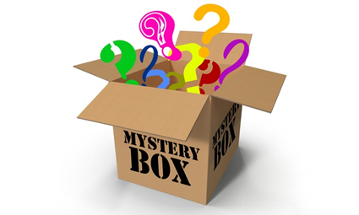
- Thank you for your kind attention.
- Now it’s time for questions.
- For more information, contact
  - Tina Herzberg at herzberg@uscupstate.edu
  - Susan Osterhaus at osterhauss@tsbvi.edu
  - Sara Larkin at sara.larkin@iaedb.org

