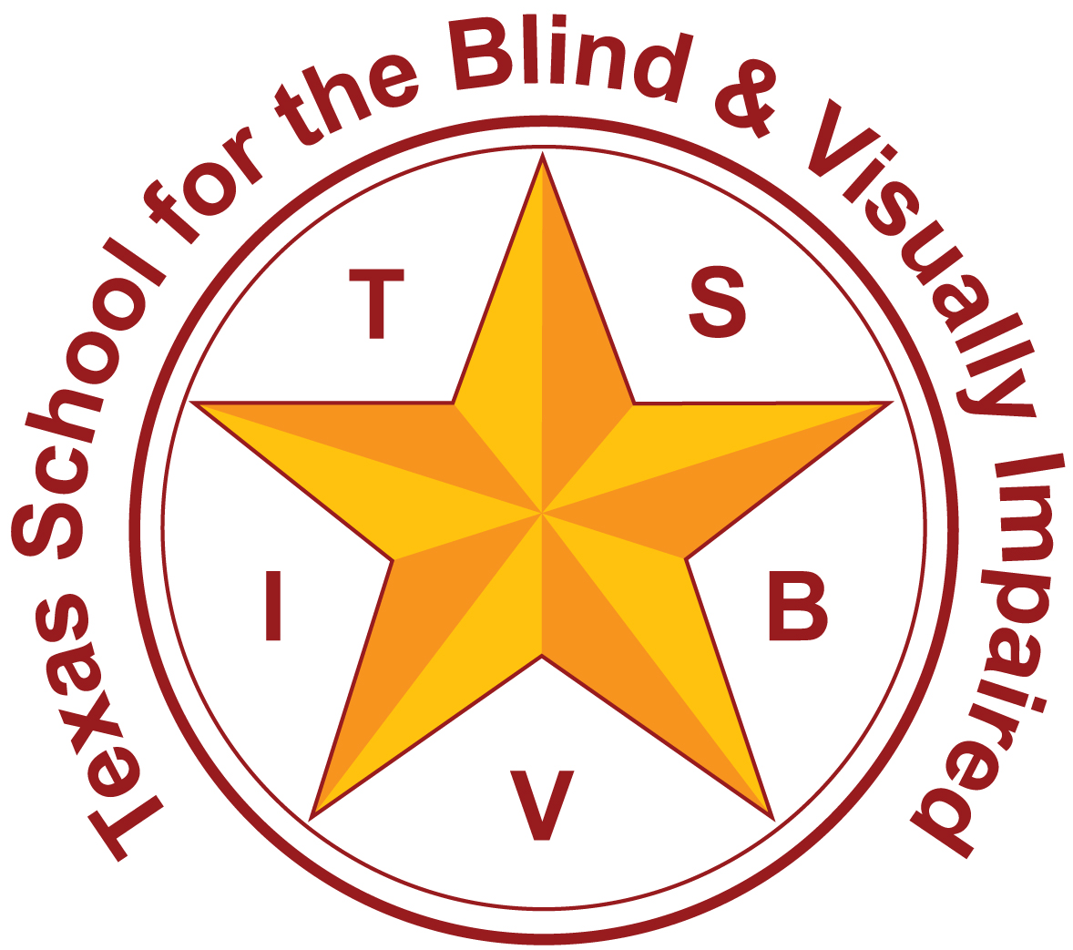
Texas School for the Blind and Visually Impaired
Outreach Programs
www.tsbvi.edu | 512-454-8631| 1100 W. 45th St. | Austin, TX 78756

Optimizing Support for Children with CVI
Part 2: CVI Clusters
Gordon Dutton &
Helen St Clair Tracy
April 26th, 2021

Facilitated by
Sara Kitchen, VI Education Consultant
kitchens@tsbvi.edu
Lynne McAlister, VI Education Consultant
mcalisterl@tsbvi.edu

Thank You! For inviting us back.

Brain Based Impairments of Vision

Central Visual Disorders of the Visual Pathways and Occipital Lobes
- Visual Acuity Impairment
- Contrast Sensitivity Impairment
- Colour Vision Impairment

Peripheral Visual Disorders of the Visual Pathways and Occipital Lobes
- Hemianopia
- Quadrantanopia
- Lower Visual Field Impairment
- Upper Visual Field Impairment
- Visual Field Constriction
- Complete Lack of Vision

Disorders of the Middle Temporal Lobe
- Dyskinetopsia
- Akinetopsia

Disorders of the Posterior Parietal Lobe
- Simultanagnostic Vision
- Optic Ataxia
- Hemi Inattention

Disorders of the Temporal Lobe
- Prosopagnosia
- Shape and Object Agnosia
- Topographic Agnosia

Brain Disorders of Visual Processing
- Palinopsia
- Visual Hallucinations

Specific Variants of Reading and Number Difficulties Related to Disordered Visual Processing
- Dyscalculia
- Acalculia
- Neurological Dyslexia
- Alexia

Brain Based Impairments of Vision
- Table with the heading brain based impairments of vision and highlighted different colours, visual acuity impairment, contrast sensitivity impairment, simultanagnostic vision, optic ataxia, dyskinetopsia, lower visual field impairment.

(From Part 1)
Different CVIs =Different Approaches
- Make it bigger
- Increase contrast
- Use optimal area in visual field
- Slow down
- Keep things in the same place
- Reduce Complexity
- One Thing at a Time (jigsaw)

Cartoon drawing of squirrel reading a book looking very confused.

Cartoon drawing in three pictures, the first of a person thinking, the second of a 'lightbulb' moment, and the third of them writing.

A black magnifying glass with the letter A in the centre.

Picture of a rainbow

Icon Meaning ‘Run’.

Raised Hand Icon.

A grey oval with a hole in the centre and the words ‘Simultanagnostic Vision’.

Oval shape with a green field and blue sky and the words ‘Visual Field’.

Table showing the different icons introduced next to the named visual impairments.
- Reduced Visual Acuity = Visual Acuity
- Reduced Contrast Sensitivity = Contrast Sensitivity
- Dyskinetopsia = Seeing Movement
- Optic Ataxia = Reaching
- Simultanagnostic Vision = Attention
- Lower Visual Field Impairment = Low Down

Icon Meaning ‘Run’ with the word ‘Movement’.

Raised Hand Icon with the word ‘Reaching’.

Table with the icons explained, next to the areas of visual impairment they relate to.

Image of the world with three children holding hands and a number of books

- Every child with CVI is different. Which CVIs they are affected by is just one part of what needs to be known about them for optimized support.

A grey oval with a hole in the centre, hand and oval of the field with the bottom slither coloured grey with the words ‘CVI Cluster 1’.

Gordon Dutton demonstrating lower visual field, by standing and raising one leg slightly, short video
CVI Cluster 1: Mild Lower Visual Field Impairment
- Trip over things low down
- Difficulties with sports with low ball (e.g. soccer, hockey)
- Dislike of down escalators
- Nervous going down stairs – needs rail

Oval of field with low slither coloured grey, oval of field with low slither coloured grey, plus a thick grey band covering the outer areas, a grey oval with a hole in the centre with the words ‘Mild Simultanagnostic Vision ‘.

Oval shape with a green field and blue sky.

Oval of field with low slither coloured grey, plus a thick grey band covering the outer areas.

Map-Attention-Recognition

Oval shape with a green field and blue sky, oval of field with low slither coloured grey, plus a thick grey band covering the outer areas with the words ‘Mild Simultanagnostic Vision’.

Oval image of dark busy street with the back of someone's head in the centre, oval image of dark busy street with the back of someone's head in the centre, and the outer area covered with a thick grey band, a grey oval with a hole in the centre with the words ‘Mild Simultanagnostic Vision’.

Oval of field with low slither coloured grey, plus a thick grey band covering the outer areas,oval image of dark busy street with the back of someone's head in the centre, and the outer area covered with a thick grey band, a grey oval with a hole in the centre with the words ‘Mild Simultanagnostic Vision’.

CVI Cluster 1:

Mild Simultanagnostic Vision
- Less attentive when tired or somewhere busy.
- Need breaks.
- May struggle keeping up in school
- Struggles socially

Chalkboard with the word 'can't' crossed out, and replaced with the word 'can' with the words ‘this type of vision’.

Oval of field with low slither coloured grey, plus a thick grey band covering the outer areas, raised hand with the words ‘CVI Cluster 1 Mild Optic Ataxia (Reaching)’.

Oval of field with low slither coloured grey, plus a thick grey band covering the outer areas, and a hand image over the grass area with the words ‘CVI Cluster 1’.

Some handwriting which is difficult to read due to words and lines overlapping.

CVI Cluster 1 Mild Optic Ataxia (Reaching)’
- May seem a bit clumsy.
- May struggle with handwriting.
- Difficulties with activities needing fine accuracy skills e.g. needlework.

CVI Cluster 1
- Trip over things low down
- Difficulties with sports with low ball (e.g. soccer, hockey)
- Dislike of down escalators
- Nervous going down stairs – needs rail
- Less attentive when tired or somewhere busy.
- Needs breaks.
- May struggle keeping up in school
- Struggles socially
- May seem a bit clumsy.
- May struggle with handwriting.
- Difficulties with activities needing fine accuracy skills e.g. needlework.

Large question mark in a red circle with the words ‘CVI Cluster 1- Support

Green toolbox with the letters CVI on the front with the words ‘CVI Toolbox’

From Dr Amanda Lueck…
- It is so important for parents to trust what they have learned from their children and to communicate this to professionals.
- I have found that it is important to wipe the slate of my preconceptions utterly clean, although this is not so easy to do.
- I have learned to watch as each child teaches me and others how he or she experiences the world.
- Each child is a universe. And each universe has its own rules, checks, and balances.

Chalkboard with the quote 'each child is a universe. And each universe has its own rules, checks and balances.'

CVI Cluster 1 – Support Suggestions
- Check tiredness, plan breaks
- Encourage friends and family to use words to express how they feel rather than rely on a fleeting facial expression.
- With handwriting, joined up writing can help, but also learning to touch type and thick wide lined paper.
- Encourage talking, learn where life is difficult

Image of the side of a head with the brain coloured blue and a number of jigsaw pieces

Logo for the CVI project, child's profile in blue

Photo of a teacher facing a class and the words 'CVI on average at least one child in every class of thirty.’

Quote box with the words 'it looks like CVI is also likely to be one of the biggest causes of learning and developmental difficulties in children too’.

Oval of grass field, with the bottom quarter coloured grey, a grey oval with a hole in the centre, a hand and an image of a person running.

Oval image of green field, with the bottom quarter coloured grey and a thick grey band covering around a quarter of the edges

Oval shape with a green field and blue sky, Oval image of green field, with the bottom quarter coloured grey and a thick grey band covering around a quarter of the edges with the words ‘CVI Cluster 2’.

Icon of ‘Run’ with the words ‘CVI Cluster 2- Difficulty seeing clearly things that are moving, especially when moving fast.

Image of a platform on an underground train station with a train passing through very fast so it can't be seen clearly with the words ‘Seeing things that move’.

CVI Cluster 2: Dyskinetopsia (Seeing Movement)
- Inconsistent vision, things sometimes seen clearly, sometimes unclear, sometimes not seen at all
- Easily confused as things appear and disappear
- Sometimes startled or frightened
- Dislikes places with lots of movement
- Feels safe in car

Oval of grass field, with the bottom quarter coloured grey with the words ‘CVI Cluster 2 Lower Visual Field Impairment’

CVI Cluster 2: Lower Visual Field Impairment
- Trip over things low down, repeatedly – does not learn / remember to avoid them
- Difficulties with sports with low ball (e.g. soccer, hockey)
- Dislike of down escalators – may become very distressed
- Nervous going down stairs – needs rail – may become very anxious
- Watches TV upside down or sat on the floor looking up
- Goes down slide head first

Image of a television with a picture of a smiling turtle

Two images of a person positioned in front of television with image on turtle. On left side the person is positioned higher up and the bottom half of the tv screen covered. On the right image the person positioned lower down and more of the TV screen available to see.

Image of child going down a slide face first with the words ‘Children with a lower visual field impairment may choose to go down a slide head first’.

The thing about lower visual field impairment:
- It is a very common CVI
- It is relatively easy to spot and measure, if you know what you are looking for
- It is quite consistent, whereas many other CVIs are very dynamic
- It is a good indicator of specific other CVIs to look for

CVI Cluster 2: Simultanagnostic Vision
- Less attentive when tired or somewhere busy.
- Need breaks, can quickly become overwhelmed, stressed and confused.
- Struggles socially, possibly leading to behavioural challenges.
- Can severely affect all aspects of learning.
- Loses things and can’t find things.
- May be a little obsessive about things not being moved

CVI Cluster 2: Optic Ataxia (Reaching)
- May seem very clumsy.
- May struggle with writing / copying / drawing.
- Difficulties with activities needing accuracy of motor skills e.g. catching a ball, tying laces.
- May line things up.
- Looming – may quickly become startled / frightened and avoid busy places

Photo of decorative hens in different colours lined up in rows with the words ‘Why line toys up, or organize them very specifically?’.

Photograph of large grey bin with man and two boys walking past with the words ‘Looming: The bin “suddenly appeared in front of me and terrified me. I screamed, jumped and almost ran away”.

Photo of child drawing with their finger in the sand with the words ‘Finger Drawing’.

Profile image of head with jigsaw pieces missing, and the matching jigsaw pieces outside the head with the words ‘One step at a time, to build memories’.

CVI Cluster 2: Dyskinetopsia (Seeing Movement)
- Inconsistent vision, things sometimes seen clearly, sometimes unclear, sometimes not seen at all
- Easily confused as things appear and disappear
- Sometimes startled or frightened
- Dislikes places with lots of movement
- Feels safe in car
- CVI Cluster 2
- Trip over things low down, repeatedly – does not learn / remember to avoid them
- Difficulties with sports with low ball (e.g. soccer, hockey)
- Dislike of down escalators – may become very distressed
- Nervous going down stairs – needs rail – may become very anxious
- Goes down slide head first
- Watches TV upside down or sat on the floor looking up
- Less attentive when tired or somewhere busy.
- Needs breaks, can quickly become overwhelmed, stressed and confused.
- Struggles socially, possibly leading to behavioural challenges.
- Can severely affect all aspects of learning.
- Loses things and can’t find things.
- May be a little obsessive about things not being moved
- CVI Cluster 2 cont.
- May seem a very clumsy.
- May struggle with writing / copying / drawing.
- Difficulties with activities needing accuracy of motor skills e.g. catching a ball, tying laces.
- May line things up.
- Looming – may quickly become startled / frightened and avoid busy places
- Inconsistent vision, things sometimes seen clearly, sometimes unclear, sometimes not seen at all
- Easily confused as things appear and disappear
- Sometimes startled or frightened
- Dislikes places with lots of movement
- Feels safe in car

Photo of two children holding hands with the words ‘Language / Communication Difficulties’.

Oval of grass field, with the bottom quarter coloured grey, a thick grey oval covering the outer edge, a hand and an image of a person running with the words ‘CVI Cluster 2’.

Oval of field with low slither coloured grey, plus a thick grey band covering the outer areas, and a hand image over the grass area with the words ‘Recap: CVI Cluster 1, CVI Cluster 2’.

Oval of grass field, with the bottom half coloured grey, a grey oval with a hole in the centre, a hand, an image of a person running, a magnifying glass with the letter A in the centre and a rainbow with the words ‘CVI Cluster 3’.

Oval image of green field, with the bottom half coloured grey and a thick grey band leaving only a small area of the field visible in the centre, a grey oval with a hole in the centre.

Image of a woman wearing thick glasses, wobbly brownish image that is difficult to recognize.

A photograph of a woman and a man, edited to simulate different levels of increasingly severe reduced visual acuity and reduced contrast sensitivity.

All four ovals described in the talk, starting with the oval grass field with blue sky, and getting more severe lower visual field impairment and a greater area covered with a grey band showing reduced visual attention.

Oval of grass field, with the bottom half coloured grey, a grey oval covering most of the picture, a hand, an image of a person running, a magnifying glass with the letter A in the centre and a rainbow, Oval of grass field, with the bottom quarter coloured grey, a thick grey oval covering the outer edge, a hand and an image of a person running, oval of field with low slither coloured grey, plus a thick grey band covering the outer areas, and a hand image over the grass area.

Images of the brain showing the locations of the occipital, parietal and temporal lobes.

Links
- CVI Project cviscotland.org/mem_portal.php?article=293
- CVI & Autism cviscotland.org/mem_portal.php?article=282
- CVI Frights cviscotland.org/documents.php?did=1&sid=40
- Amanda Lueck’s Blog cviscotland.org/news/dr-amanda-luecks-guest-blog-29-01-2018
- CVI & Non-Verbal Children cviscotland.org/documents.php?did=4&sid=344
- CVI Puzzle cviscotland.org/mem_portal.php?cat_id=74
- CVI Clusters cviscotland.org/mem_portal.php?article=257
- Lessons Level 9 The Map cviscotland.org/lessons.php?cat_id=11

Thank you for joining us!

Texas School for the Blind & Visually Impaired Outreach Programs
Figure 1: TSBVI logo
Figure 2: IDEAs that Work logo and OSEP disclaimer.

