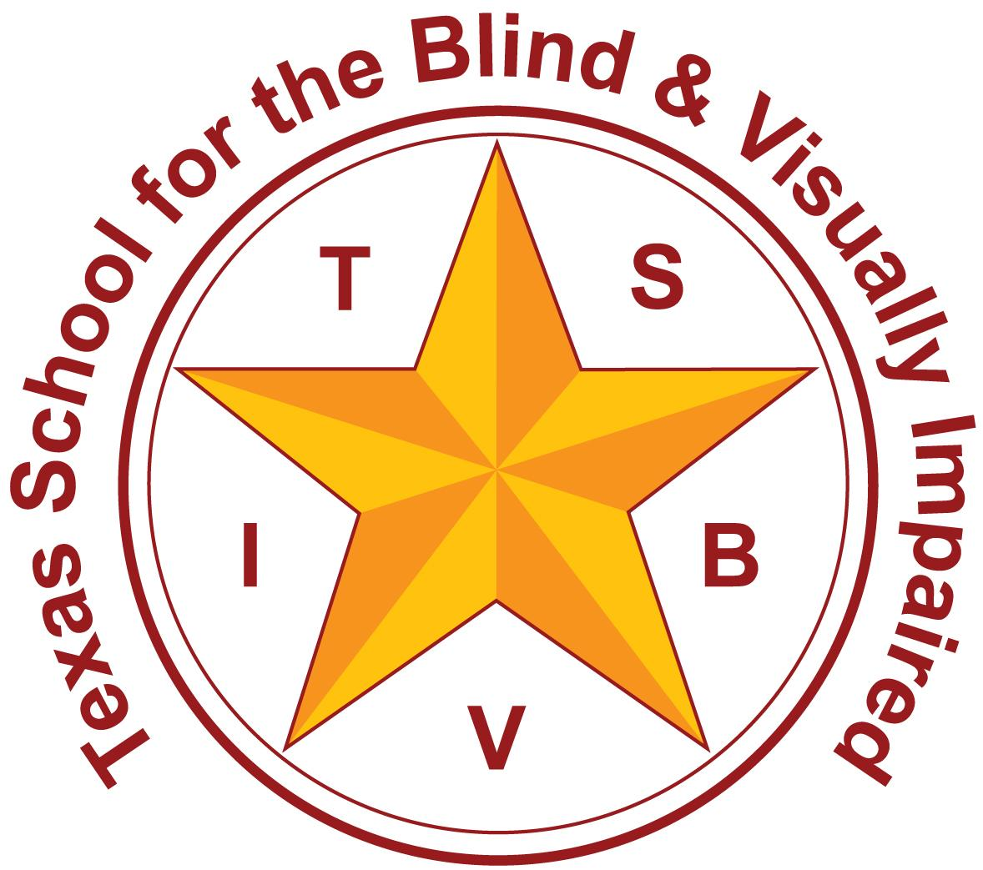
Texas School for the Blind and Visually Impaired
Outreach Programs
www.tsbvi.edu | 512-454-8631| 1100 W. 45th St. | Austin, TX 78756

Coffee Hour
Calendars In Action: A How-To Discussion

September 15, 2025
Rachel Collins, Deafblind Education Consultant

What are calendar systems and why do they matter?
Calendars:
- Provide predictability
- Build communication opportunities
- Develop understanding of time
- Provide emotional support

Where do you start?
Four things to keep in mind when creating a calendar system:

- Determine the modifications to access instruction.
- Develop a communication system for the student.
- Design a schedule.
- Determine the Time Frame.

Hierarchy of Abstraction
Moving from Concrete to Abstract:
- Object symbols - spoon
- Parts of object (not shown)
- Picture symbols (photos, drawings, etc.) - picture of divided lunch tray with food; labeled with print word cafeteria/Tactile symbols - tactile symbol for “cafeteria”
- Print/Braille - printed card “cafeteria”, braille card “cafeteria”

Communication Development
https://wvde.us/academics/special-education/communication-matrix/foundation-intervention
https://www.communicationmatrix.org/
7 Levels of Expressive Communication
- Pre-Intentional Behavior
- Intentional Behavior
- Unconventional (Pre-Symbolic) Communication
- Conventional (Pre-Symbolic) Communication
- Concrete Symbols
- Abstract Symbols
- Formal Language

Scheduled Activities = Routines!
- Structured activities with clear beginnings, middles, and ends.
- Carried out the same way with a child until they change or evolve based on the child's needs. CONSISTENT!

Symbol Guiding Questions
Symbols as they relate to daily routines:
- What events happen multiple times in the day?
  - What are the steps involved in the process?
  - Which steps does the student complete independently?
  - Actively participate in? Show anticipation for?

Symbol Guiding Questions, cont’d.
- What items are used within this routine?
  - Which of these items does the student touch/manipulate?
  - Which of these items is the student able/responsible for retrieving/putting away?

Let’s Practice!
MEAL TIME GUIDING QUESTIONS
- How does the student eat?
- What physical objects does the student have actual contact with during meal time?
- Are there multiple same items? (Is it easy to replace?)
- Is the family using something similar at home? (“Borrow” from home? Purchase similar items for school use)
- How does the student know meal time is over?

Meal Time Object Symbol Examples
- Bottle
- Cup/Lid/Straw
- Plate (partitioned or not)
- Feeding tube syringe/tubing/pouch
- Cap (or entire box or bottle) of nutritional drink
- Spoon
- Blender

Meal Time Symbol
Student 1 - picture of a Nutritional Drink carton
Student 2 - picture of a Nutribullet

Meal Time Routine Sequence - Student 1
- nutritional drink carton
- measured cup
- tubing
- cup of water
- syringe

Meal Time Routine Sequence - Student 2
- nutribullet
- food from home
- stock
- plate with lip or bowl
- spoon

Calendar System Time Frames
- Anticipation
- Daily
- Weekly
- Monthly
- Annual

Choosing the right Time Frame
Guide to Selecting Time Frames for Calendar Systems

Anticipation Calendar
Now - picture of green wicker, round basket
Finished - picture of black plastic, rectangular basket

Building in more routines… Now/Then
Picture of a 2-slot calendar box with objects in each slot, next to a white, rectangular finished box. There are objects inside the finished box of previous routines.

Building in even more routines…
Picture of a 4-slot calendar box with objects in each slot. Behind is an aluminum, rectangular finished box. There are objects inside the finished box of previous routines.

Daily Calendar EXAMPLE
With the collaboration of your sensory team, more routines have been established and the symbol guiding questions have been asked for each of the activities. You now have your entire daily schedule created with the corresponding object symbols.
Arrival = backpack on hook
- Bathroom = wipes
- Gym = sweat wristband
- Relax = squishy ball
- Lunch = blender
- Bathroom = wipes
- Social games = vibrating ball
- Snack prep = pudding box
- Bathroom = wipes
- Home = Ring doorbell button
Departure = backpack off hook

Calendars are so much more than schedules!

Calendars Are Vehicles for Conversation
“Whatever language and communicative environment surrounds [the deafblind student] must be consciously provided for (or “brought to”) him. If this is not done, the child will not develop his own natural language or communication mode.”
~ Barbara Miles (Remarkable Conversations, p.56)

Elements of a conversation:
- Mutual Respect
- Emotional Comfort
- Physical Comfort
- Topics of Mutual Interest
- Equal Participation
- Comfortable Pacing

How do you role release to the classroom staff and/or other service providers?
- Post the routines and the symbols associated with each routine for easy access.
- Take video doing the calendar conversation as well as each routine.
- Put all of this information into a shared location for the entire educational team to access.
- Have regular meetings to discuss progress or troubleshoot issues.

Don’t Forget!
- Involve families in choosing symbols/activities
- Share strategies between school and home

Resources
Blaha, Robbie. 2001. Calendars for Students with Multiple Impairments Including Deafblindness. Austin, TX: Texas School for the Blind and Visually Impaired.
Miles, B (1999). Conversation: The essence of communication. In B. Miles & M. Riggio (Eds.), Remarkable conversations: A guide to developing meaningful communication with children and young adults who are deafblind (pp. 54-75). Perkins School for the Blind.
Hagood, L. (1997). vanDijk Methods. In Communication A Guide for Teaching Students with Visual and Multiple Impairments (pp. 43–45). Texas School for the Blind and Visually Impaired.

Contact Me
Rachel Collins
collinsr@tsbvi.edu

Thank you for joining me!

