 | Texas School for the Blind and Visually Impaired  Outreach Programs  www.tsbvi.edu |512-454-8631 | 1100 W. 45th St. | Austin, Texas 78756
TETN #20436
O&M Evaluations for Everyone
September 30, 2013
2:30-4:00 PM

Presented by
Donna Lynn Glover, COMS, CY-FAIR I.S.D.
K.C. Crager, COMS, CY-FAIR I.S.D.
Amy Tange, COMS, CY-FAIR I.S.D.
Chuck Holcomb, COMS, CY-FAIR I.S.D.
Meagan Matkin, COMS, CY-FAIR I.S.D.

Developed for
Texas School for the Blind & Visually Impaired
Outreach Programs

O&M Evaluations for Everyone

Presented by COMS Staff from Cypress-Fairbanks ISD

Donna Lynn Glover, COMS, CY-FAIR I.S.D.

K.C. Crager, COMS, CY-FAIR I.S.D.

Amy Tange, COMS, CY-FAIR I.S.D.

Chuck Holcomb, COMS, CY-FAIR I.S.D.

Meagan Matkin, COMS, CY-FAIR I.S.D.

White Cane Day
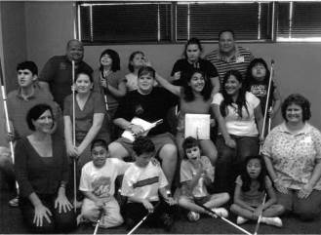

Figure 1 Cy-Fair COMS and kids on White Cane Day.

BE IT ENACTED BY THE LEGISLATURE OF THE STATE OF TEXAS:
SECTION 1. Section 30.002, Education Code, is amended by adding Subsections (c-l) and (c-2) to read as follows:
(c-l) To implement Subsection (c) (1) and to determine a child's eligibility for a school district's special education program on the basis of a visual impairment, the full individual and initial evaluation of the student required by Section 29.004 must, in accordance with commissioner rule:
(1) include an orientation and mobility evaluation conducted:
by a person who is appropriately certified as an orientation and mobility specialist, as determined under commissioner rule; and in a variety of lighting conditions and in a variety of settings, including in the student's home, school, and community and in settings unfamiliar to the student; and
(2) provide for a person who is appropriately certified as an orientation and mobility specialist to participate, as part of a multidisciplinary team, in evaluating data on which the determination of the child's eligibility is based.
(c-2) The scope of any reevaluation by a school district of a student who has been determined, after the full individual and initial evaluation, to be eligible for the district's special education program on the basis of a visual impairment shall be determined, in accordance with 34 C.F.R. Sections 300.122 and 300.303 through 300.311, by a multidisciplinary team that includes, as provided by commissioner rule, a person described by Subsection (c-1)(1)(A).
SECTION 2. (a) Not later than January 1, 2014, the commissioner of education shall adopt rules necessary to implement Sections 30.002(c-1) and (c-2), Education Code, as added by this Act.
(b) Not later than the beginning of the 2014-2015 school year, Sections 30.002(c-l) and (c-2), Education Code, as added by this Act, shall be implemented.
SECTION 3. This Act takes effect immediately if it receives a vote of two-thirds of all the members elected to each house, as provided by Section 39, Article III, Texas Constitution. If this Act does not receive the vote necessary for immediate effect, this Act takes effect September 1, 2013.
Conducted by a person who is appropriately certified as an Orientation and Mobility Specialist.

To determine a child’s eligibility for a school district’s special education program on the basis of a visual impairment, the full individual and initial evaluation must include an Orientation and Mobility
Evaluation.

In a variety of lighting conditions as well as a variety of settings, including within the students home, school, and community, and in settings unfamiliar to the student.

Provide a COMS to participate as part of a multidisciplinary team in evaluating data on which the child's eligibility is based.

The scope of any reevaluation by a school district of a student who has been determined, after the full individual and initial evaluation, to be eligible for the district’s special education program on the basis of a visual impairment shall be determined by a multidisciplinary team that includes a COMS.

Shall be implemented no later than the beginning of the 2014-2015 school year.

Senator Judith Zaffirini (D-Laredo)
Senate Bill 38

Representative Elliott Naishtat (D-Austin)
House Bill 590


Figure 2 Photo of Jackie Chan with his hands on his head and a pained expression.

Texas
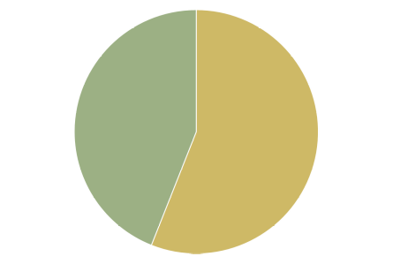

Figure 3 Graph showing percentages of students in Texas who have and have not received O&M evaluations.

56 % Received O&M evaluations in the last 3 years

44% have not

Total = 8,968 VI Students

CYFAIR
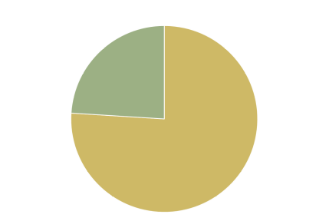

Figure 4 Graph showing percentages of students in CYFAIR who have and have not received O&M evaluations.

76% Received O&M evaluations in the last 3 years

24% Have not

146 Total VI Students

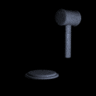
Figure 5 Photo of a gavel

CYFAIR
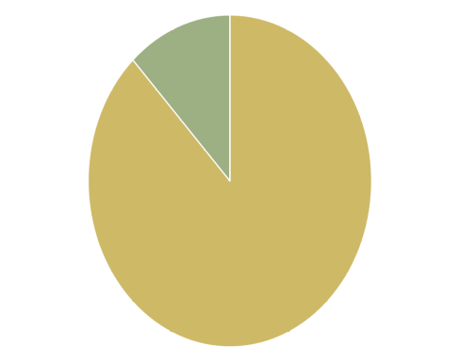

Figure 6 Graph showing percentages of students in CYFAIR who have received O&M evaluations at some point in time.

88% received an O&M evaluation at some point

12% have not

146 Total VI Students


Figure 7 Clipart showing people reviewing a plan.

Formula
Total Number of VI Students ÷ Number of COMS ÷ = Estimated Number of Evals Per Year

Cy-Fair Formula Example
146 students ÷ 4 COMS = 36.5 evals per COMS ÷ 3 years = 12.16 evals per year, per COMS ÷ 12 months = 1.013 evals per month, per COMS

TOOK CONTROL OF THE REFERAL PROCESS
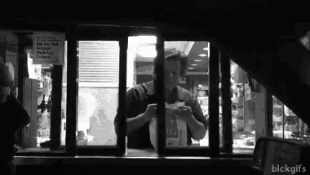
Figure 8 Waiter at the drive-in window of a McDonald's.

It is a process!!!
- 09-10 Did O&M section of F.V.E .
- 10-11 Developed a new O&M referral process
- 13-14 Developed latest and greatest O&M referral process
- January 1, 2014 Commissioners Rules
- Beginning 14-15 school year requirements of new law must be implemented

Orientation and Mobility Referral Process
- Ask for an Orientation and Mobility Evaluation at all VI intake meetings.
- If a new FVE or LMA is requested on a student who has previously received an O&M evaluation, please contact the O&M on your campus or Donna Glover to determine if an additional O&M evaluation is needed.
- Have the parent fill out and sign the Orientation and Mobility information form. Give the parent the pink copy, put the white copy in the IEP meeting.
- Send the yellow copy of the parent information form along with the most current eye report and IEP meeting to
Donna Lynn Glover, COMS
Falcon Annex
281-807-8644
donna.glover@cfisd.net

The Latest and Greatest O&M Referral Procedure

Figure 9 Photo of fireworks.

Orientation and Mobility Referral Process
- Request an O&M evaluation as part of the Full Individual initial Evaluation to determine a student’s eligibility for special education on the basis of a visual impairment.
- When considering the scope of any reevaluation for a student with a visual impairment, please contact the Certified Orientation and Mobility Specialist (COMS) on your campus or Donna Lynn Glover as part of the multidisciplinary team that determines if an additional O&M evaluation is needed.
- If an O&M evaluation is requested, have the student’s parent fill out and sign the Orientation and Mobility information form. Give the parent the pink copy and put the white copy into the IEP paperwork. Send the yellow copy of the parent information form along with the most current eye report and IEP meeting to:
Donna Lynn Glover, COMS
Falcon Annex
281-807-8644
donna.glover@cfisd.net

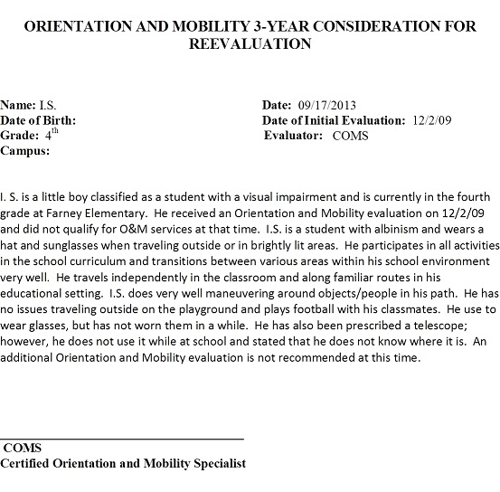
Figure 10 Example of O&M 3-year consideration for reevaluation where O&M is not recommended.

Say it in the evaluation
At this time, student A does not qualify for O&M services.
http://s22318.tsbvi.edu/surveys/TakeSurvey.asp?SurveyID=41J8l8L37l8KG


Figure 11 Photo of Mattress Mac with dollars in his hands from a Houston Press blog.


Figure 12 Phot of 4 individuals dressed in business suits from http://simplybiz.co.za/sites/simplybiz.co.za/files/styles/node_preview/public/Corportae_0.jpg representing school administrators.


Figure 13 Photo of a mom, dad, and baby from http://www.wechealthunit.org/family-health/images/113057.jpg representing parents.

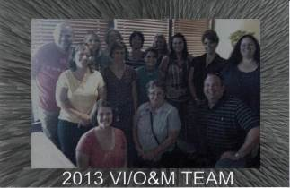
Figure 14 Photo of the Cy-Fair VI Team.

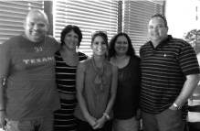
Figure 15 Photo of Cy-Fair COMS


Figure 16 Photo of Cy-Fair diagnostician.

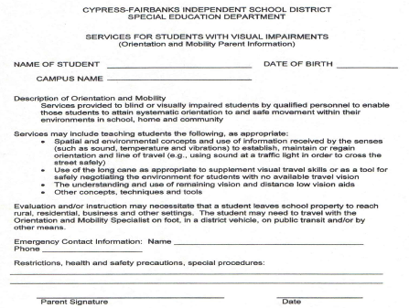
Figure 17 Example of Parent Information letter regarding O&M services.

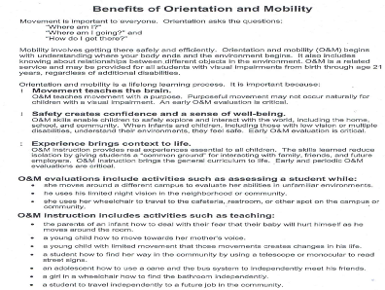
Figure 18 Photo of the information sheet "Benefits of Orientation and Mobility"

Benefits of Orientation and Mobility
- Developed by Texas School for the Blind and Visually Impaired & the Professional Preparation Advisory Group
- Edited by KC Dignan
- www.tsbvi.edu/Education/om-benefits.htm

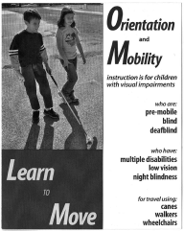
Figure 19 Photo of the Learn to Move pamphlet.

Learn to Move
- Developed by the Professional Preparation Advisory Group with the Texas School for the Blind and Visually Impaired Outreach Department
- TSBVI Outreach
- www.tsbvi.edu

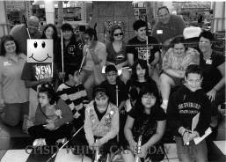
Figure 20 Photo of Cy-Fair students and COMS during White Cane Day 2010.

Bus Travel
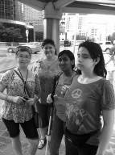
Figure 21 Donna Glover and students during bus travel exercise.

Public Transportation
- High School Age
- Non-Drivers and Restricted Drivers
- Serve in Groups
- Serve in Summer
- Include
  - Bus
  - Park n Ride
  - Light Rail
  - Taxi

Deafblind
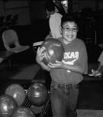
Figure 22 Photo of a young deafblind boy bowling.

Multiple Impairments
- Calendar Systems
- Destination Cards
- Routines
- Room Consistency
- Bulleted Evaluations

Low Vision
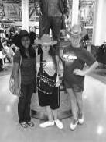
Figure 23 Three teenage girls wearing cowboy hats while on a community outing.

Distance Vision
- Telescope Training in the Community
- Prepare for Bioptic Driving
- Sign Identification

Babies

Figure 24 Photo of a baby walking on his own.

Images of O&M Evaluation Form
The next 3 slides offer photos of various parts of an O&M evaluation form used by Donna Glover.
Included information:

Student:
Date of Birth:
Evaluator:
Parents:
Address:
Phone:
- Medical History
- Cause of Visual Impairment
- Functional Vision
- Mobility Considerations
- Other
- Observations
- Recommendations
Orientation and Mobility services help children with a visual impairment attain systematic orientation to and safe movement within home, school and community environments. Based on of this evaluation conducted by a Certified Orientation and Mobility Specialist, it is determined that this child (does) (does not) need Orientation and Mobility services at this time. Changes in visual function, motor skills, age or environment many necessitate a new Orientation and Mobility evaluation to assess current needs.

Donna Lynn Glover
Certified Orientation and Mobility Specialist

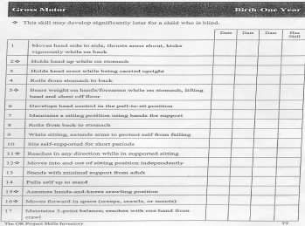
Figure 25 Photo of The Oregon Project Skills Inventory Gross Motor checklist for birth to one year.

White Cane Day 2
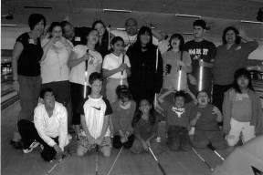
Figure 26 Photo of staff and students during White Cane Day.

We are Finding
- COMS familiar with ALL VI students
- COMS assigned to campuses with no O&M students
- Need a file on each VI student
- Need database of all VI students to include O&M eval date and reeval considerations dates

Communication is Critical
- Assure administrators of plan in place for new law
- Explain future expectations to parents
- Meet with Vis every other week
- COMS meet every week
- Give diagnostician expectations

Stay Flexible
The Commissioners rules are coming!
Is it best for kids?
Then get started!


Figure 27 Photo of a woman doing a back bend.

O&M Evals for All…Make It Work

Figure 28 Symbol for blind pedestrians.

Questions?

Texas School for the Blind & Visually Impaired
Outreach Programs

Figure 29 TSBVI logo.


Figure 30 IDEA logo and disclaimer.

