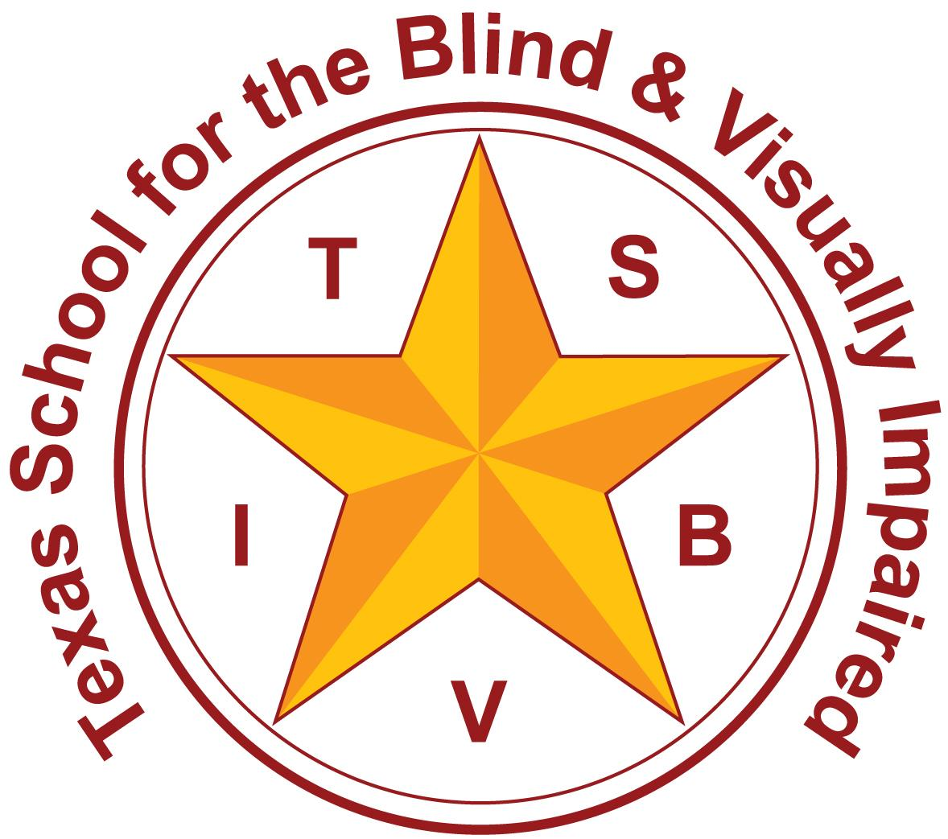
Texas School for the Blind and Visually Impaired
Outreach Programs
www.tsbvi.edu | 512-454-8631| 1100 W. 45th St. | Austin, TX 78756

Coffee Hour
The Building Blocks of Early Literacy

January 26, 2026
Kathi Garza M.Ed. TVI - Early Childhood Outreach Consultant
Emily Leeper M.Ed. TVI - Outreach Consultant

Title Slide (Slide 1)
Slide shows an image of the TSBVI logo. Slide shows a second image of a stack of alphabet blocks.
The Building Blocks of Early Literacy
Kathi Garza M.Ed. TVI - Early Childhood Outreach Consultant
Emily Leeper M.Ed. TVI - Outreach Consultant

Today’s Topics (Slide 2)
- Foundations of Literacy Development
- Print Awareness
- Quality Literacy Experiences
- Literacy Rich Environments
- Resources

Foundations of Literacy Development (Slide 3)
Slide shows an image of two girls with their backs to the camera with open story books in front of them.

Literacy Is… (Slide 4)
Slide shows four clipart drawings. From left to right, there is a face with an open mouth and talking lines, a person writing, a person reading a book, and an ear.
- Listening
- Speaking
- Reading
- Writing

Early Literacy (Slide 5)
Slide shows an image of a newborn swaddled in a blanket.
Literacy begins at birth and continues as a young child develops:
- The ability to communicate
- Sensory awareness
- Visual and/or tactual discrimination skills
- An awareness of books, print or braille, and their purpose

Emergent Literacy (Slide 6)
The continual process in a child’s life from birth until formal reading and writing begins. As a child develops knowledge and skills, they gradually “emerge” into formal literacy by:
- Developing tactual and other sensory skills
- Developing motor skills
- Forming concepts
- Learning language
- Building awareness of oral and written language

Learning to Read (Slide 7)
What does a child need to become literate; to read and write with meaning?
- Access and exposure to a wide variety of experiences
- Opportunities to explore their world
- Experiences that link words to meaning
- Knowledge about language
- Knowledge about letters and letter sounds

Print Awareness (Slide 8)
Slide shows an image of a baby laying on his tummy pointing to the page of a book with pencils drawn on it.
When read to, very young children primarily pay attention to
- the adult reading
- the images in the book.
- the squiggles on the page that represent words

Pictures Matter (Slide 9)
Slide shows an image of an adult male reading to an infant with albinism. They are both looking at the book.

Making Images Accessible (Slide 10)
- Use real objects that tie to the book topic or images
- Add textures to pages to explore
- Draw child’s attention to the pictures and encourage visual exploration
- Read books that have photographs rather than drawings.

Squiggles and Dots (Slide 11)
As children develop language, they are ready to learn that those squiggles and dots have meaning.
- Draw the child’s attention to the words or braille on the page
- Help the child to point to or touch the text
- Show that each word has meaning by pointing to or touching each word co-actively with the child

Early Writing (Slide 12)
- Model how to write co-actively using a pen and paper, computer, or braille writer
- Write a few words or a sentence dictated by the child
- Encourage exploration of writing methods and materials along with the child’s attempts to write

Have Fun! (Slide 13)
- Positively acknowledge the child’s “reading” of a familiar story
- Make stories up together (real or pretend) and allow the child to select objects, textures, or pictures that go along with the story
- Write it all down together and re-read it often

Quality Literacy Experiences (Slide 14)
Slide shows an image of a preschooler wearing a hat and sunglasses holding a cane and a butterfly on her hand.

Promoting Literacy (Slide 15)
- Reading together
- Reading aloud to your child
- Book concepts
- Playing with sounds
- Scribbling
- Pretending to read and write
- Generating lists together
- Community outings
- Cooking together
- Sensory play
- Chores
- Activity Routines

Integrating Language with Experiences (Slide 16)
Slide shows clipart of a baby in a bathtub with bubbles and a rubber duck.
Daily activities offer opportunities to combine language with sensory awareness and development of basic concepts. As you go through an activity, give your baby time to use all his senses and pair language with what he is experiencing.

Shared Language (Slide 17)
- Share your child’s focus: Your child will more easily learn language that is related to his needs and interests.
- Watch to see where his attention is placed and provide language about what he is attending to at that moment.
- All of our senses are involved in communication.

Strategies & Activities (Slide 23)
Find an activity you can share with the family
- PreK Guidelines
- Activities and Resource Guide - Perkins
- Oregon Project activities
- Elementary Concepts - TSBVI
- Preschool and other early educational references - Carolina; Little Texans, Big Futures
- Laptime and Lullabies - APH

From Experiences to Literacy (Slide 18)
Slide shows an image of a child petting a horse, a graphic of a drawing of a horse, and a text box with the word “horse” written inside.

Literacy Rich Environments (Slide 19)
Slide shows an image of an infant sitting on a blanket next to a bookshelf with several board books strewn about around him.

Considerations (Slide 20)
- Real objects
- Items to explore visually and tactually
- Places to share interactions
- Access to functional print, braille, pictures
- Repeat and novel experiences
- Consistent routines
- Opportunities to notice others reading and writing

Things to Do (Slide 21)
Slide shows an image of an adult female sitting on a couch with an infant with white hair. They are each reading a book.
- Labeling toy bins or cabinets
- Pointing out print or describing print signs in stores
- Use simple calendars or “to-do lists”
- Make books with photos/objects of favorite events or people
- Encourage participation in chores or daily routines

Activity Idea (Slide 22)
Slide shows an image of a piece of picture frame matting with a piece of sheet laminate attached to it. On the laminate are items from nature, and the matting is being held by a student.

Resources (Slide 23)

Slide shows an image of a young toddler sitting on top of a black lab in front of a coffee table with books spread around her.

Where to Find Activities (Slide 24)
- PreK Guidelines
- Activities and Resource Guide - Perkins
- Oregon Project activities
- Elementary Concepts - TSBVI
- Preschool and other early educational references - Carolina; Little Texans, Big Futures
- Laptime and Lullabies - APH
- Teaching Life Differently - Perkins

Resources for Braille Reading & Writing (Slides 25 & 26)
Evaluation:
- Early Tactile Learning Profile - (TSBVI)
- Assessment of Braille Literacy Skills - ABLS (ESC4)
- Oregon Project - (Jackson ESD)
- EVALS Pre-Braille Checklist - (TSBVI)
- Essential Tools of the Trade - (TSBVI)
- Braille Readiness Grid
Instructional strategies:
- Building on Patterns
- Beginning with Braille
- Oregon Project
- Fine Motor Activities Handout
- Lots of Dots
- Braille FUNdamentals
- Essential Elements in Early Intervention
- Laptime & Lullabies
- Reading Connections

Don’t Forget About These Websites (Slide 27)
- Active Learning Space
- Strategy to See
- Paths to Literacy
- NCDB - Literacy for Children with Combined Hearing and Vision Loss
- Reading Rockets
- Zero to Three
- CELL – Center for Early Literacy Learning

Contact Us (Slide 44)
Slide shows an image of the TSBVI Logo
- Kathi Garza M.Ed. TVI garzak@tsbvi.edu
- Emily Leeper M.Ed. TVI leepere@tsbvi.edu

