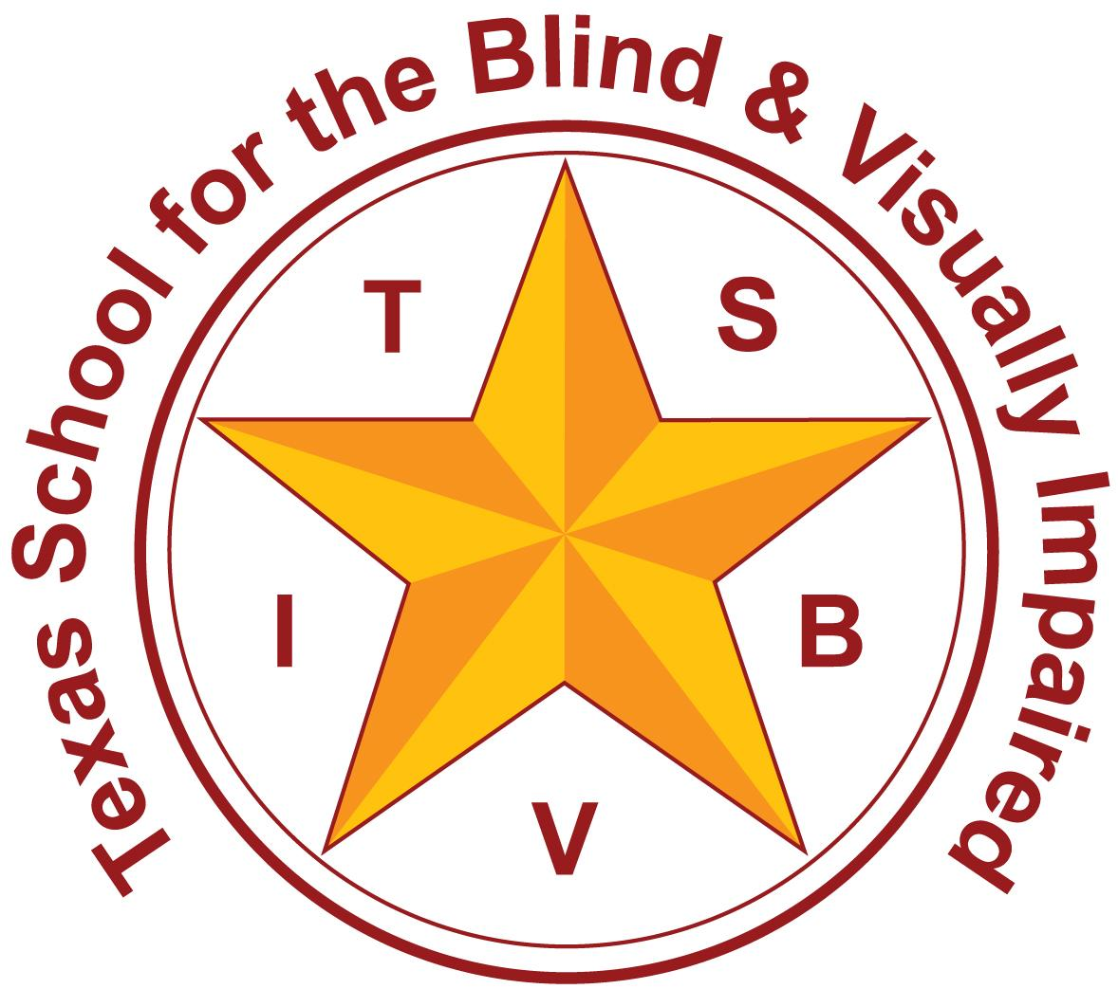
Texas School for the Blind and Visually Impaired
Outreach Programs
www.tsbvi.edu | 512-454-8631| 1100 W. 45th St. | Austin, TX 78756

Taking the Angst Out of Literacy Media Decisions
Spoiler Alert: It’s Not Either/Or

Presenter Contact
Chrissy Cowan M.Ed, TVI – (512) 206-9367
Kathi Garza M.Ed, TVI – (512) 206-9112

Support for Multiple Literacy Formats
- Classically, the LMA process guides the TVI towards visual or tactile media driving the car while auditory comprehension takes the back seat.
- We’re suggesting a shift in thinking to consider multiple literacy formats.
- Anyone must have the skill to read print and/or braille, but they also must have the skill to access and comprehend auditory media.

Skills Needed to Read Fluidly
- Phonemic Awareness
- Phonics
- Fluency
- Vocabulary
- Comprehension

Notes

This session is not specifically about learning to read, but we want to provide a background. These skills apply to both braille and print.

- Phonemic Awareness – the understanding that words are created from small units of sound in language called phonemes. The ability to hear and manipulate those units within words. (bug vs beg, dug vs dog)
- Phonics – the connection between sounds and letter symbols. One can look at those words and connect the sounds to print.
- Fluency – the ability to read with speed, accuracy, and expression
- Vocabulary – the words we know orally and within written texts
- Comprehension – understanding what text is all about.

Listening Skills Related to Literacy
- Discriminative listening – develops very early and is the most basic form of listening that does not involve understanding the meaning of words and/or phrases, but merely the different sounds that are produced
- Comprehensive listening – understanding the message that is being communicated
  - Informational listening – listening to learn
  - Critical listening – listening to evaluate and analyze

Listening Skills Related to Literacy (continued)
- The ability to listen to audio materials such as books, the internet, radio, and television
- Listening to a screen reader while using the computer
- Listening to audible literature on digital players, computers, electronic notetakers, and Personal Digital Assistants (PDA: ex. smartphone)
- Regular exposure and understanding of print and braille formats.
Listening to audible materials does not replace print and/or braille literacy skills.

IDEA and Literacy Media
Office of Special Education Program (OSEP) Letter, June 19, 2013:
- Braille instruction must be provided unless the IEP determines it is not appropriate for a particular child.
- This determination is based on a “thorough and rigorous” evaluation that includes
  - notation of a range of multiple learning modalities including auditory, tactile, and visual
  - a data based media assessment
  - a functional vision evaluation

“Thorough and Rigorous” Evaluations Include
- Learning/sensory channels
- Learning media
- Selection of the appropriate primary literacy media (braille, print, tactile symbols)
- Selection of appropriate literacy tools/assistive technology
- Access to the general ed curriculum (compensatory skills)
- Performance with auditory/listening skills
- Performance with braille/tactile symbols
- Performance with print (size, speed, stamina)

Notes
IDEA and the OSEP letter doesn’t tell someone to do an LMA specifically, but in Texas, we use this evaluation, and it meets the “thorough and rigorous” definition of the OSEP letter.

Initial Selection of Literacy Media
- Based on observation and data collection with varied
  - Materials (puzzles, pictures, drawings, print, board games, toys)
  - Lighting conditions
  - Times of day to account for visual fatigue
- Based on the etiology, this decision can look different
- Let’s see for ourselves!
  - Video of Merrick
  - Video of Madelyn

Print/Braille Characteristics

Characteristics of print reader
- Efficient completion of tasks at near distances
- Interested in pictures; identifies pictures/detail
- Uses print that is not too large
- Relatively stable eye condition
- Steady progress in learning to use vision with print

Characteristics of braille reader
- Preference for tactual exploration
- Uses tactual sense to identify small objects
- Unstable eye condition/poor prognosis
- Reduced central field
- Reading print is laborious/unappealing and preferred print size is very large

Consideration for Primary Media Choices

Print
- It’s the “norm”
- Increased access
- Size can be manipulated
- Cumbersome if too large
- Instruction happens in the classroom with peers
- Stamina should be monitored
- May require specialized instruction

Braille
- Requires specialized instruction
- Instruction requires frequent sessions
- Must be taught by a certified TVI
- Includes separate codes for math and literary learning
- Alleviates visual fatigue
- Not readily available

Notes
It’s important that TVIs devote time to teaching print concepts regarding complex print formats (charts, graphs, maps) and print quality, style, and contrast

Monitoring Progress
- Set a timeframe for instruction in your media choice(s)
- Ensure direct service is frequent and consistent
- Check in with classroom teacher about progress
- Report progress at regular intervals
- Make adjustments as needed
- Consider the child’s preference in media decisions

What if the student doesn’t appear to be picking up reading?
- Is it the media?
- Is it a reading disability?
- Kids with VI are not immune to dyslexia or other reading difficulties.
- Is it a lack of appropriate instruction?
- TVI should collaborate with the classroom teacher and enlist support from assessment personnel and a reading specialist.

Pulling it All Together
- Creating a Customized Literacy Access Plan
- Developed as a result of the LMA
- Lists tools and strategies for reading and writing
- Organized by class and/or task
- Sample plans and template located in the resources folder

Notes
We define this CLAP as a fairly detailed, one-page support document that lists how the student will access reading and writing tasks within different settings or specific classes. This is specific to your child.

Customized Literacy Access Plan - Preschool
Student:
Grade Level:
Acuity:
Date:

Tools and materials for ________

Reading | Writing
 | 14.
 | 15.
 | 16.
 | 17.
 | 18.

ACTIVITY/LOCATION | TOOLS & MATERIALS
Group circle time
Learning station
Play center
Reading instruction
Personal desk/table

Definitions

Group Circle Time: groups of children sit in chairs or on a rug around the teacher as s/he reads a story, teaches a lesson, etc.

Learning Station: areas of the classroom where materials are arranged to teach a concept. Can consist of individual tables with science materials, cubbies with books, word wall, calendar, etc.

Play Center: areas of the classroom where materials are arranged for pretend play. Can consist of kitchen/food objects, dress-up items, Legos and other building toys, toy cars, etc.

Customized Literacy Access Plan
Student:
Grade Level:
Acuity:
Date:

Tools and materials for __________

Reading | Writing
 | 14.
 | 15.
 | 16.
 | 17.
 | 18.

_________’s classes with possible access tools and materials

SUBJECT | PRINT BOOKS | HANDOUTS | SMART  BOARD | WHITE  BOARD | HOMEWORK

Definitions of Literacy Tools

Sample Customized Literacy Access Plan - Madison
Student: Madison
Grade Level: Pre-K (4 years old)
Acuity: 20/250
Date: 6/6/2020

Tools and materials for Madison

Reading | Writing
- Commercial story books | 14. Pencil
- Personal copy of book | - Black marking pen (e.g., Flair)
- Stand magnifier for pictures & worksheets | 16. Unlined paper & bold lined paper
- MP3 player (smart phone w/ earbuds) | 17. iPad w/ stylus
- iPad | 18. Smart Brailler (APH)
- 2x or 4x monocular | 19. Regular crayons
- Bookshare w/ Read2Go app
- Slant board for desk
- Dual media story books
- Worksheets with clean print, larger font, & clear pictures
- Experience books w/ dual media
- Clip board
- Work/play tray

ACTIVITY/LOCATION | TOOLS & MATERIALS
Group circle time | 2, 3, 6, 10, 12
Learning station | 1, 3, 10, 13, 14, 15, 16, 19
Play center | 13
Reading instruction | 1, 2, 3, 4, 5, 7, 8, 9, 10, 11, 12, 15, 18
Personal desk/table | 2, 3, 4, 5, 6, 8, 9, 10, 12, 14, 15, 16, 17, 18, 19

Definitions

Group Circle Time: groups of children sit in chairs or on a rug around the teacher as s/he reads a story, teaches a lesson, etc.

Learning Station: areas of the classroom where materials are arranged to teach a concept. Can consist of individual tables with science materials, cubbies with books, word wall, calendar, etc.

Play Center: areas of the classroom where materials are arranged for pretend play. Can consist of kitchen/food objects, dress-up items, Legos and other building toys, toy cars, etc.

Bookshare: accessible online library

Read2Go: accessible eBook reader app that lets you read Bookshare books on an Apple device

Customized Literacy Access Plan - Jason
Student: Jason
Grade Level: 7th
Acuity: 20/100
Date: 6/6/2020

Tools and materials for Jason

Reading | Writing
- Regular print books/materials | 14. Pencil
- Enlarged print (regular print w/ magnifier) | 15. Black Sharpie pen
- MP3 player (smart phone w/ earbuds) | 16. Regular-lined paper
- iPad with internet | 17. Chromebook/laptop
- Line marker (APH) | 18. iPad
- 6x monocular
- Google Drive
- Bookshare w/ Read2Go app
- Chromebook or laptop
- Google Classroom
- Join.Me app
- Zoom app
- Calculator w/ iPad & Voiceover

Jason’s classes with possible access tools and materials

SUBJECT | PRINT BOOKS | HANDOUTS | SMART  BOARD | WHITE  BOARD | HOMEWORK
English | 1, 2, 3, 8 | 1, 2, 4, 7, 9, 10, 11, 14/15, 16 | 4, 6, 11 | 6 | 1-4, 7-10, 12, 14-17, 20
Algebra | 2, 5, 9, 10, 13 | 3, 4, 7, 10, 11, 13, 14/15, 16 | 4, 6, 11 | 6 | 1-5, 7-10, 12, 13, 14-17, 20
Science | 1-5, 8 | 3, 4, 7, 10, 11, 14/15, 16 | 4, 6, 11 | 6 | 1-5, 7-10, 13, 14-17, 20
Social Studies | 1-5, 8 | 3, 4, 7, 10, 11, 14/15, 16 | 4, 6, 11 | 6 | 1-5, 7-10, 13, 14-17, 20
Other:

Definitions

Google Drive - free cloud-based storage service that enables users to store and access files online.

Google Classroom - free collaboration tool for teachers and students. Teachers can create an online classroom, invite students to the class then create and distribute assignments.

Chromebook - laptop or tablet running the Linux-based Chrome OS as its operating system. Primarily used to perform a variety of tasks using the Google Chrome browser, with most applications and data residing in the cloud rather than on the machine itself.

Join.Me App - web-based collaboration software application for screen-sharing and online meetings.

Zoom App - cloud-based video communications app that allows you to set up virtual video and audio conferencing, webinars, live chats, screen-sharing, and other collaborative capabilities.

Bookshare: accessible online library

Read2Go: accessible eBook reader app that lets you read Bookshare books on an Apple device

Customized Literacy Access Plan - Javier
Student: Javier
Grade Level: 3rd
Acuity: 20/400
Date: 6/30/2020

Tools and materials for Javier

Reading | Writing
- Regular print books/materials | 15. Pencil
- Enlarged print (regular print w/ magnifier) | 16. Black Sharpie pen
- MP3 player (smart phone w/ earbuds) | 17. Regular-lined paper
- iPad with internet | 18. Chromebook/laptop
- Line marker (APH) | 19. iPad
- 6x-8x monocular | 20. Perkins brailler
- Google Drive
- Bookshare w/ Read2Go app
- Chromebook or laptop
- Google Classroom
- Join.Me app
- Zoom app
- Calculator w/ iPad & voiceover
- Books/handouts in braille

Javier’s Classes with possible access tools and materials

SUBJECT | BOOKS | HANDOUTS | SMART  BOARD | WHITE BOARD | HOME  WORK
English | 1, 2, 3, 4, 7, 8, 9, 10,14 | 1, 2, 4, 7, 10, 11, 14 | 4, 6, 11 | 6 | 1, 2, 3, 4, 5, 7, 8, 9, 10, 12, 14, 15/16, 17, 20
Math | 1, 2, 4, 5, 9, 10, 13, 14 | 3, 4, 7, 10, 11, 14 | 4, 6, 11 | 6 | 1, 2, 3, 4, 5, 7, 8, 9, 10, 12, 13, 14, 15/16, 17, 20
Science | 1, 2, 4, 5, 9, 10, 13, 14 | 3, 4, 7, 10, 11, 14 | 4, 6, 11 | 6 | 1, 2, 3, 4, 5, 7, 8, 9, 10, 12, 13, 14, 15/16, 17, 20
Social Studies | 1-5, 7-9, 14 | 3, 4, 7, 10, 11, 14 | 4, 6, 11 | 6 | 1, 2, 3, 4, 5, 7, 8, 9, 10, 12, 14, 15/16, 17, 20

Definitions

Google Drive - free cloud-based storage service that enables users to store and access files online.

Google Classroom - free collaboration tool for teachers and students. Teachers can create an online classroom, invite students to the class then create and distribute assignments.

Chromebook - laptop or tablet running the Linux-based Chrome OS as its operating system. Primarily used to perform a variety of tasks using the Google Chrome browser, with most applications and data residing in the cloud rather than on the machine itself.

Join.Me App - web-based collaboration software application for screen-sharing and online meetings.

Zoom App - cloud-based video communications app that allows you to set up virtual video and audio conferencing, webinars, live chats, screen-sharing, and other collaborative capabilities.

Bookshare: accessible online library

Read2Go: accessible eBook reader app that lets you read Bookshare books on an Apple device

