Texas School for the Blind and Visually Impaired
Outreach Programs
www.tsbvi.edu | 512-454-8631| 1100 W. 45th St. | Austin, TX 78756

Coffee Hour - March 18, 2021
Western Region Early Intervention Conference
Using an Active Learning Approach with Infants and Toddlers

Presented by
Charlotte Cushman and Kate Hurst, Education Consultants, TSBVI Outreach

The Active Learning Space
- Collaborative site
- Explain basic principles of Active Learning
- Resources to help others learn how to use this approach

What Is Active Learning?

- Had 4 blind siblings – she was the 2nd of 7 children in her family and she cared for blind younger brother from the time she was age 7
- Trained as a teacher, later got her doctorate in developmental psychology
- Spent years developing and doing research on Active Learning and the equipment she developed

Why this approach?
This approach specifically targets learners who are developmentally birth-48 months no matter their chronological age
Relies on research that shows how all humans develop in the earliest stages of learning – that is they learn through doing
Michigan State University, Movement Can Increase Learning in Children

Major Characteristics
Simply Psychology website about these two stages of learning: (Piaget's 4 Stages of Cognitive Development: Background and Key Concepts of Piaget's Theory, Saul McLeod, updated December 07, 2020)

Sensorimotor (0-2)
  - learns about the world through senses and through their actions
  - cognitive abilities develop: object permanence; self-recognition; deferred imitation; representational play
  - emergence of capacity to represent the world mentally
  - (8 months) understand the permanence of objects

Preoperational Stage (2-7)
  - ability to internally represent world through language, mental imagery
  - think about things symbolically
  - perception dominated by how world looks, not how it is - not yet capable of logical (problem solving) thought
  - demonstrate animism – think non-living objects have life and feelings like a person’s

ZeroToThree.org
- Physical Development: I learn about my body and grow strong by moving.
- Intellectual Development: I move, I learn.
- Communication: Watch me, and you will know how I feel and what I think.
- Building Strong Relationships: I move with you, I know you, I feel close to you.
- Self-confidence: I can do it!

Center on the Developing Child Harvard University

Children with Significant Disabilities
- Often have extended stays in hospital, negative experiences
- Have physical challenges making movement difficult
- Visual and hearing impairments reduce access to the world (distance senses)
- Experience high stress
- Need more time to process and move
- Lack opportunities to repeat movements
- May be delayed in bonding

Principles
- Overview of Active Learning
- Philosophy of Approach
- What is Play?
- Pathways to Learning
- How Special Needs Children Spend Their Day
- Dynamic Learning Circle
- Social and Emotional Development
- Key Points of Active Learning
- Five Phases of Educational Treatment

Jack and Cindy – Phase 1 Offering
- What is Cindy doing?
- What specific skills does Jack demonstrate?
- Does his behavior and emotional state seem to change from the begin to the end of the video?

Phase 1 Offering
- Make no demands
- If the child leaves or moves away from you let them go and wait for them to return
- Accept any movement or way of interacting with object

Purpose:
- to promote trust between the learner and the adult
- to observe the learner's reactions
- to identify what the learner likes/dislikes
- to establish an understanding of the learner's emotional level
- to introduce self-activity

Developmentally Appropriate Activity

What Goes Wrong?
- Do you see children who are significantly developmentally delayed display similar behaviors?
- How do you think these behaviors might change over time if the adult persists?

Phase 2 Imitation
What does the teacher do in this video that indicates she is following his lead?
- Imitate the child’s activity
- Offer new action of your own, see if child will imitate you
- If not, return to imitating child
- Evaluate if the what you offered was at too high developmentally for the child to imitate and make adjustments

Purpose:
- to increase the learner's interest in activities nearby
- to increase the learner's ability to initiate
- to increase the learner's belief in him/herself
- to introduce activities and movements not yet performed by the learner

Phase 3 Interaction
What interests the child in this activity?
Is he comfortable interacting with the adult?
Did the adult demonstrate good interaction skills?

Phase 3 Interaction
- Provide every opportunity for child to familiarize himself with activity and participate & complete movement – but make no demands or praise.
- Model activity as close to the learner’s hands as child will allow, use a hand under -hand
- If the child withdraws or turns away, you may have proceeded too quickly to the stage of interaction, and should return to the stage of imitation or even offering.

Purposes to help child:
- learn dependency on another or several other people
- initiate interactions
- the child's development of self-identity
- A basis for social development

Phase 4 Sharing the Work
Purposes:
- to increase the learner’s experience of success
- to involve the learner in new social relationships
- to increase the learner's interest in acquiring new abilities
Note: learner must be 24 months or older developmentally

Phase 5 Consequences
Purposes are:
- to help learner to endure meeting demands
- to help the learner endure changes in life
- to help the learner feel self-confident
- to establish a sense of responsibility
Note: learner must be 24 months or older developmentally

5 Phases of Educational Treatment
- Offering
- Imitation
- Interaction
- Sharing the Work
- Consequences

Key Points of Active Learning
- Active Participation – Independent and interactive play
- Opportunities to Repeat – activities and skills
- Developmentally Appropriate
- Reinforcing to the Individual
- Limited Distractions

Implementing Active Learning Principles
Active Learning is MORE than a piece of equipment! It’s an approach.
Video.

Guides
- Getting Started Guide: 5-page document to walk you through the steps to implement an Active Learning approach
- Active Learning Materials and Planning Sheet
- Equipment Overview Quick Guide

Things You Should Buy
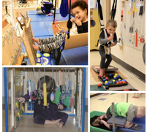
- Little Room
- Support Bench
- Hopsa Dress
- Essef Board

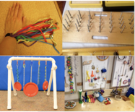
Things You Can Make
- Resonance Board
- Position Boards
- Activity Walls
- Mobiles
- Elastic Board
- Vests, belts, gloves
- Pegboard books

Resonance Board

- Birch plywood with raised wood trim, typically 4'x4', 4'x6' or 4'x8'
- Amplify feedback of any movement during independent, interactive play through vibration
- Learn about orienting and placing things within a defined space
- Use as stand-alone or with Little Room, Essef Board, Support Bench
- Can make or buy

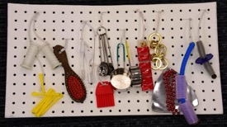
Position Boards

- Promote increased fine motor development from a level of scratching, to a level of grasping and increase skills for manipulation of objects
- Learn the position of objects and materials
- May be positioned on a wall or modified to place on a tray or as freestanding device.

Echo Bucket
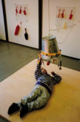
- Metal bucket suspended upside down above child.
- Holes have been made around the rim and objects are tied with elastic.
- Designed to encourage vocalization.

Activity Wall
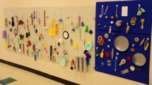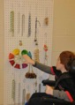

Mobiles
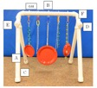

Tabletop Mobiles
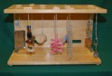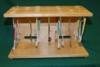

Elastic Board
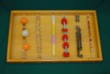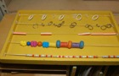

Vests and Gloves
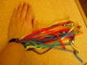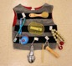

Belts
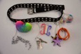
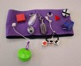

Pegboard Books
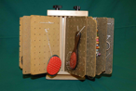

Pegboard Books (CVI)

Comparables
Video

Home Hacks
What does this look like if you don’t have the money to purchase these?
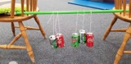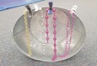

Other Ideas to Try at Home
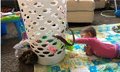

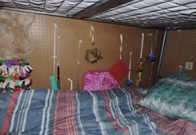
Adaptations for the Home Environment

- Activity wall by this child’s bed encourages him to stay in bed longer and play independently
- A position board or activity wall could also be placed in the living room or other communal area.
- Designate a cupboard or drawer in the kitchen for the child to explore independently while the family is preparing meals.

Materials
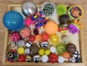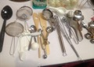
- Use a wide variety of materials in multiple quantities
- Attractive objects
- Learner’s preferences
- Learner’s skill level
- The number of objects
- What an object is made of
- What the object can do

Resources for more information
- Active Learning Space
- Forms
- Newsletter
- Modules
- Webinars
- Lilli Nielsen’s Books

Questions?
Charlotte Cushman
Kate Hurst

