Texas School for the Blind and Visually Impaired
Outreach Programs
www.tsbvi.edu | 512-454-8631| 1100 W. 45th St. | Austin, TX 78756

TSBVI Outreach Coffee Hour

Early Intervention 101: A Virtual Reality

October 5, 2020

Presented by:
Parent Infant Program for the Blind and Visually Impaired
Utah Schools for the Deaf and the Blind (PIPBVI)

MEET OUR TEAM
- Karen--Legal Stuff
- Margaret--Building a Rapport Virtually
- Nana--Research Stuff
- Pam--Virtual Assessment & Instructional Planning
- Jamie--Conducting a Virtual Home Visit

LET’S GET OUR DUCKS IN A ROW!
Figure 1 Children relaxing on blankets at a park
WHY WOULD YOU GIVE VISION SERVICES TO A BABY?!?!
- Attachment is profoundly affected by Vision
- Vision affects every developmental domain
- Vision is the primary motivating sense until about 18 months old
- Vision is the doorway to learning about our environment and appropriate behavior

LEGAL STUFF: IDEA PART C

Comparing Part C and Part B

Part C
- Referral to Eligibility is 45 Calendar Days
- Procedural Safeguards

Part B
- Eligibility shall be determined within 60 days of consent
- Procedural Safeguards

Comparing Part C and Part B

IFSP
- Current levels of function
- Outcomes
- Natural environments
- 6 month review
- Lead Agency: Health Dept.

IEP
- PLAAFP
- Goals
- Least Restrictive Environment
- Annual Review
- SEA: State Office of Education

PARENTS DRIVE THE BUS—REALLY
Figure 2 Cartoon drawing of a school bus filled with children
Comparing Part C and Part B

Part C
- Providers are grantees:
- Private corporations
- Private providers
- School districts
- Universities
- Health Dept
- NO FAPE IN PART C!

Part B
- Local Education Agency: School Districts
- Free Appropriate Public Education

What the Research Says: A Brief Look

Virtual Visit Service Delivery Model
- The use of telecommunications technology to deliver services from a distance.
- Connecting families with service providers:
- Videoconference: Zoom, Google Meet, FaceTime, WhatsApp
- Telephone: phone calls, text messages, email

The Research
- A lot of research in other disciplines, but much less in the field of early intervention visual impairment.
- What the research says:
- Promotes best practices in early intervention: coaching
- Increases parent engagement in visits and empowers them

Benefits and Cautions

Benefits
- Provides quality family-centered practices / EI services.
- Allows continuation of services.
- Increases in frequency of services / visits.
- Reduces travel.

Cautions
- Not meant to replace in-person home visits, but is a great compliment. Consider a hybrid approach.
- Need for more research in the field of BVI.
- Could cause equity issues. Not all families may be able to access services through this service delivery model.
- HIPPA and FERPA compliance issues.

Important to be aware of requirements or guidance, locally and nationally.

Building a Rapport
“People don’t care how much you know, until they know how much you care.” -- Teddy Roosevelt

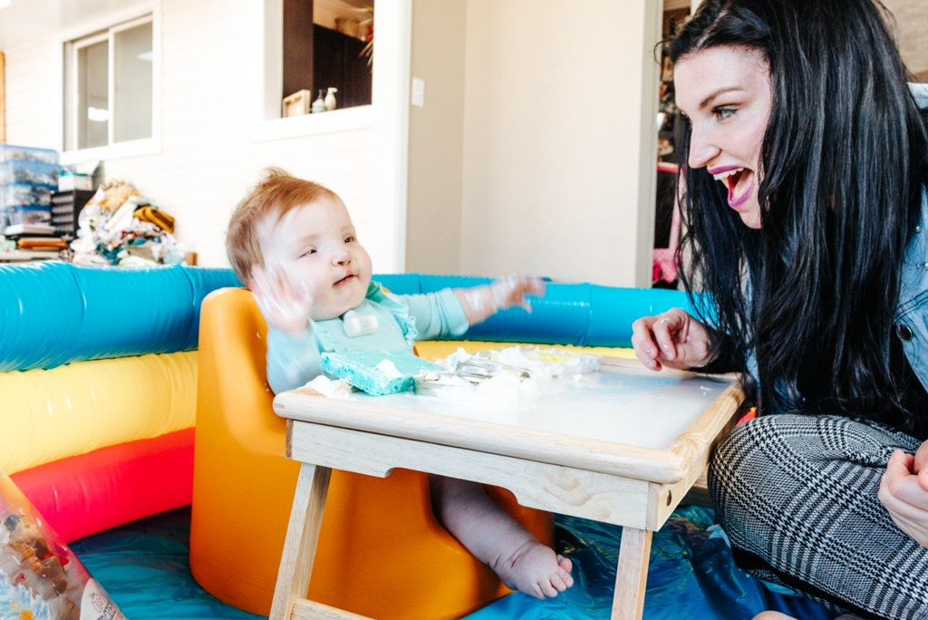
Figure 3 A woman and baby playing at a table

Gather Information Ahead of Time
- Identify the source of referral and glean important information:
- Was child in the NICU? How Long
- Medical diagnosis?
- Vision diagnosis?
- Family circumstances?

Making Contact
- Consider texting to ask permission to call
- Call the family to introduce yourself and set up your first meeting

Initial Visit
- When possible meet with both parents
- Remind them where the referral came from and the vision concerns you’re aware of
- Discover their concerns about vision and overall development
- Take time to get to know the family
- Ask simple, direct questions
- Explore their support network

Initial visit, cont’d
- Ask about medical care and concerns
- After assessment, share your concerns and explain how your services can help
- Refrain from using Special Ed acronyms or jargon
- Point out their child’s strengths
- Always include siblings
- Express Enthusiasm

Keep in mind
- It takes time to build trust with parents
- Listen with empathy
- Medical issues are often the top priority
- Rescheduling is ok
- Caring for a fragile baby is overwhelming
- Be sensitive to parents’ needs
- Sleep deprivation
- Financial needs etc.

Ya Done Good!
- Validate their experience of having a child with special needs
- Praise them for the great work they do
- Point out specifics on how their care is helping baby progress

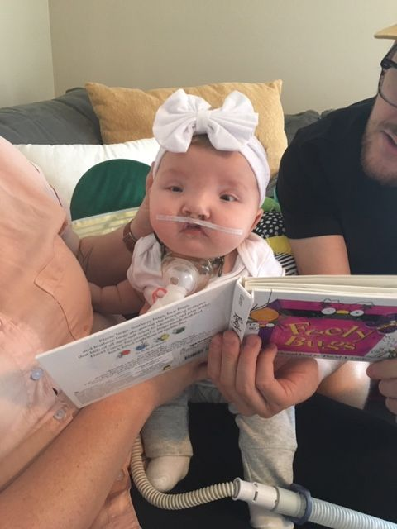
Figure 4 Two adults showing a book to a toddler

Virtual Assessment and Instructional Planning: A Brief Look

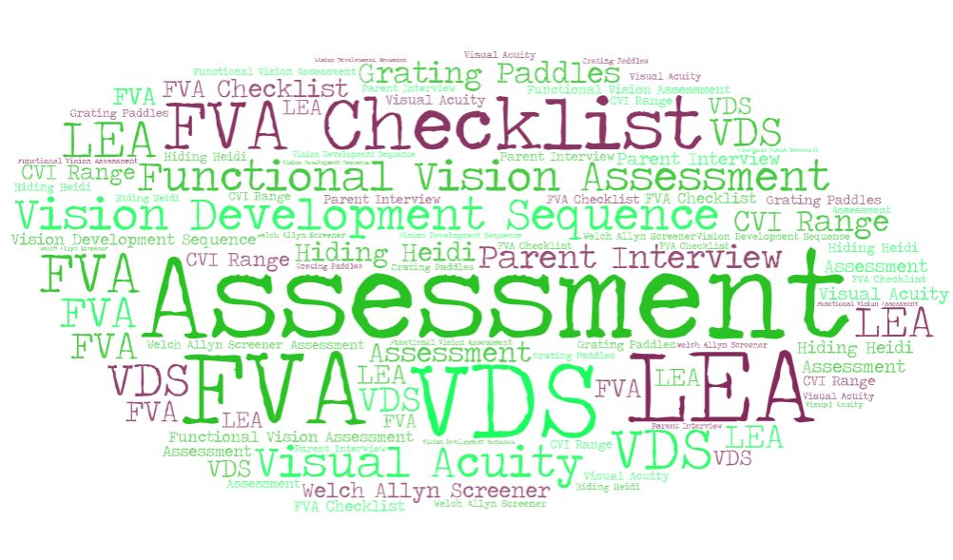
Figure 5 Word cloud

Virtual Assessment
3 ways to qualify a child for vision services:
- Assessments
- Medical diagnosis for vision
- Informed Clinical Opinion

Need consent from the parent to hold visits and complete assessments online.
Send Prior Notice for testing and to add vision services to IFSP.

Figure 6 Small chalkboard showing the word "Assessment"

Prep for assessment visit
- Research info about child (EI files, medical records)
- Info from initial contact

Meeting place:
- Outdoors at park or in the yard
- Online
- Send a copy of assessment or checklist to parent if they would like to see what visual behaviors you are looking for

Figure 7 A path and building at a park

Figure 8 Cartoon of a laptop in an online meeting

Assessment Information
- Parent concerns
- how child is using or not using their vision,
- unusual visual behaviors,
- early visual milestones
- eye report (is there a medical dx.?)
- Observe child’s visual behaviors (on screen)
- Share observations with parent. “I see….” “Did you see….?”
- Vision Development Sequence (VDS)
- Functional Vision Assessment (FVA) or Checklist
- Grating Acuity Test using LEA paddles.

Testing Materials
- Use the family’s toys.
- Parents are usually more than willing to help.
- Drop materials off for testing for the parent to use during the next online visit.

Videos
- Have parent make a video (or two) and send them to you to review.
- You may not have medical records for vision. Assessments may be on age level BUT… something is going on with how they are using their vision (ICO).
- Err on the side of caution, possibly pick up child and serve short term

Instructional Planning
- Goals are based on family concerns and needs
- Routines-based intervention
- Determine intensity of services (1x, 2x, 3x/month)

Resources for instructional materials
- Use family toys
- Modify if needed
- Deliver, email, or mail to family needed items including materials to be printed if family can’t print at home.
- Bring in needed equipment (ie. switches, braille, books)
- Dollar store has things that work too
- Collaborate with IFSP team (online visits together).
- Invite colleague to online home visit to help brainstorm strategies.

Conducting a Virtual Home Visit

Before the Visit
- When should I send the zoom invite?
- What if the family no-shows?
- Are co-visits a good idea?

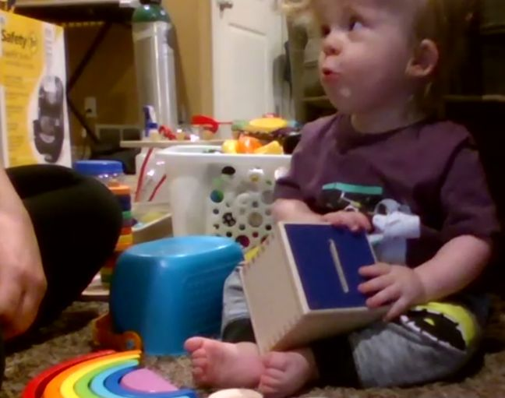
Figure 9 Toddler on the floor playing with toys

The Opening
- Ask the family for an update
- Health, jobs, life in general
- Follow-up from last visit
- Review what you worked on and ask about follow-through
- Ask the family about their priorities for the visit
- What would you like to work on today?
- Any routines that aren’t going well?

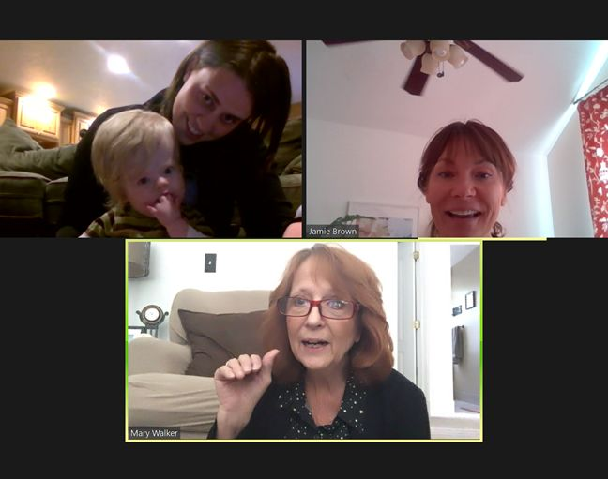
Figure 10 Teachers and a mother with her child in an online meeting

The Goals
- Ask the family to get things that will make the visit successful
- No pressure to have everything ready for the visit, instead make that a part of the visit.
- Do you have the shape sorter we used last week? I can wait while you get it.
- Do you think we could use a pan from the kitchen for banging?
- Make adjustments as needed
- Camera changes, position, etc
- Be flexible

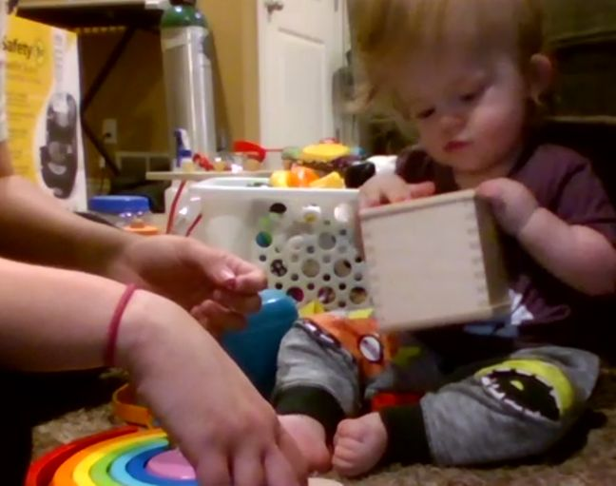
Figure 11 Toddler on the floor playing with toys

The Goals
- Parent-child focused
- Orient the camera so you can see but the parent and child are interacting
- Try not to distract when the parent has the child’s attention
- Give feedback when there’s a break in the interaction
- IFSP goal addressed
- •Remind the family of their priorities and let them know we can work on them virtually!
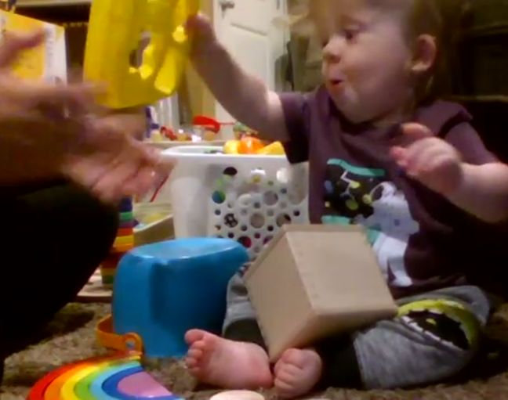
Figure 12 Toddler on the floor playing with toys

The Goals
- Use what’s in the home
- It looks like he could use a little support under his arms, do you have a pillow that we could use?
- What does he like to look at?
- He really seems to be looking at the pumpkins can we put those down on his eye level?
- Consider things that can be dropped off at the home if needed
- Mylar to stuff in the pillow
- Switch toy

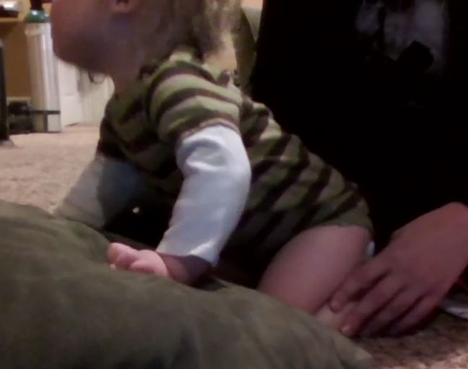
Figure 13 Toddler leaning on pillow

The Closing
- Review what you did during the visit
- Talk about what the family will work on
- Make a plan if you’re dropping things off at the home
- Confirm next visit and talk about what you will work on so the family can be prepared

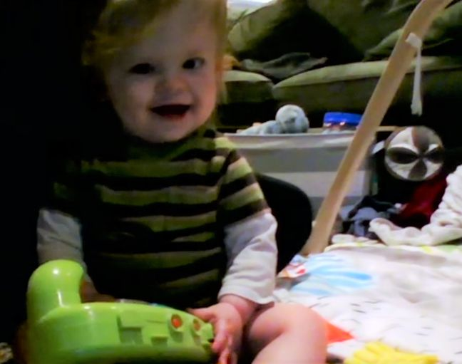
Figure 14 Toddler smiling at camera holding a green toy

YOU CAN CONTACT US:
- karenbo@usdb.org
- nanap@usdb.org
- margaretc@usdb.org
- pamelac@usdb.org
- jamieb@usdb.org

Credits
- Special thanks to all the people who made and released these awesome resources for free:
- Presentation template by SlidesCarnival
- Photographs by Unsplash

Additional Resources
- http://www.eiexcellence.org/resources/suggested-reading/
- https://leader.pubs.asha.org/doi/10.1044/leader.FTR1.23102018.46
- https://www.ncbi.nlm.nih.gov/pmc/articles/PMC7020349/#:~:text=Parent%20coaching%20in%20early%20childhood,activities%20%5B6%E2%80%938%5D
- https://veipd.org/main/pdf/guidance_fac_reflect.pdf
- https://ectacenter.org/~calls/2017/learninglab-supporting.asp

THANK YOU!

