Texas School for the Blind and Visually Impaired
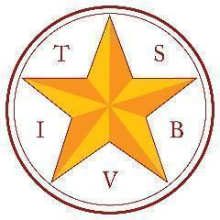
Outreach Programs
www.tsbvi.edu | 512-454-8631| 1100 W. 45th St. | Austin, Texas 78756

Coffee Hour: Communication & Complex Learners: Before the Device

September 22, 2025
Facilitated by
Sara Kitchen, VI Education Consultant, TSBVI Outreach, kitchens@tsbvi.edu

Lynne McAlister, VI Education Consultant, TSBVI Outreach, mcalisterl@tsbvi.edu

What is Communication?
- Why do we communicate?
- How do we communicate?
- What do we communicate about?

Why do we communicate?
- Reject
- Request
- Socialize/Play
- Give/Receive Info=

How do we communicate?
- Static: things that stay put
- Dynamic: things that go away

Type some examples of static and dynamic communication in the chat!

What do we communicate about?
- Concepts: things we know.
- Things we don’t know…
- Favored Topics!

Seven Levels of Communication (Rowland, 2004)
- Preintentional behavior; spontaneous movement that reflects a child’s general state (e.g., hungry, wet, sleepy).
- Intentional behavior; no intent to communicate (e.g., pushing away an empty cup).
- Unconventional communication; used intentionally to express needs, unique to the child, not symbolic (e.g., vocalizations, facial expressions).
- Conventional communication used intentionally, but still not symbolic (e.g., waving, pushing away).
- Use of concrete symbols - symbols physically resemble what they represent in a way that is obvious to the child (e.g., a shoelace to represent a shoe).
- Use of single, abstract symbols (e.g., a sign, a Braille word, a spoken word).
- Language - combining 2+ abstract symbols of any type according to grammatical rules.
Adapted from C. Rowland., 2004, Communication matrix: Especially for parents (Portland, OR: Design to Learn Projects).

Progression of Communication (Communication Matrix)
- Non-intentional Communication
- Intentional Communication
- Symbolic communication

What is non-intentional communication?

BEHAVIOR that is INTERPRETED BY CAREGIVER
- Pre-intentional: reflexive behavior indicates child’s internal state.
- Intentional: child controls own behavior but is unaware they can affect others.

Strategies for non-intentional communicators
- Observe
- Co-Regulate
- Offer
- Imitate
- Commenting/labeling learner’s actions & emotions
- Responding consistently as if communication is intentional
- Use consistent routines
- Is this when we introduce a communication device?
- What might some outcomes be?

Intentional Behavior vs. Intentional Communication
- Child orients to communication partner. Eg., looks toward, reaches toward, faces communication partner, waits for a response
- Orientating to another person is foundational - true communication is between people.
- Interaction rather than reaction.

Moving from intentional behavior to intentional communication
- Continue to offer, imitate & co-regulate
- Serve & Return
- Build communication into routines
  - Reinstatement (First Things First)
  - Use consistent objects, actions & language (communication, Hagood, p. 99)
  - Opportunities for repetition
- Introduce anticipation calendar (Blaha)

Serve & Return
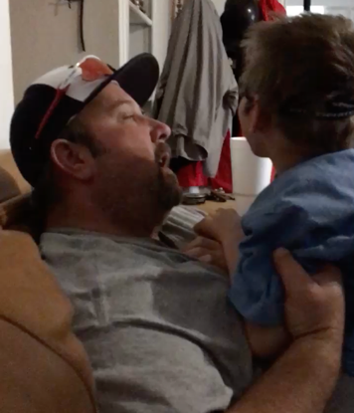

Intentional Communication

Still presymbolic = what is going on here and now
- Unconventional Communication
  - Is effective but not generally socially acceptable.
  - Eg., tugging at someone, whining, jumping up and down, etc.
- Conventional Communication
  - Learned through experience and modeling from others
  - Eg., pointing, nodding/shaking head, waving hello/goodbye, tapping someone on the shoulder

Moving from unconventional to conventional communication

Expand communication routines:
- Use concrete materials to communicate desires
  - I want _____ (hand an object to a person, perform a specific action, look toward desired object)
  - I don’t want ____ (push object away, place in container or finished basket)
  - I prefer____, not ____ (choice board) (p. 207, Communication, Hagood)
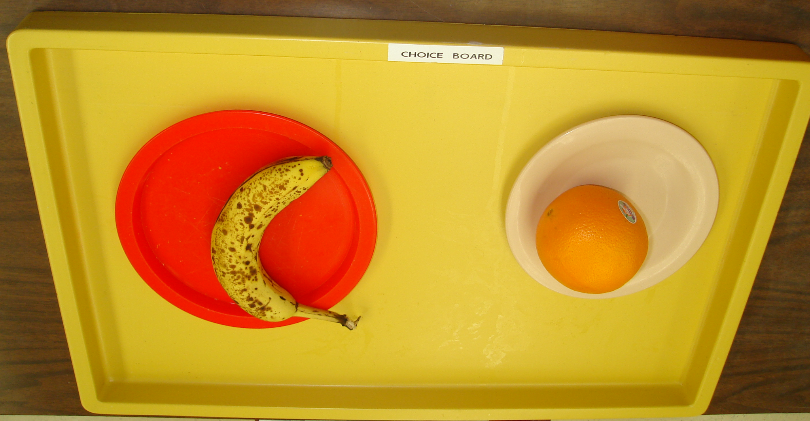
- Play turn-taking games
- Model and practice ways to initiate
- Introduce “yours” and “mine”
- Calendar conversations are longer
- Experience boxes: actions on objects, turn-taking, etc.

Symbolic Communication
- Concrete symbols look, feel move like, make sounds like what they represent. Eg., the container that the frozen juice comes from or the top of the juice container glued to a piece of cardboard.
- Abstract Symbols don’t look, feel, sound like, move like or smell like what they represent. Eg., drawing or photograph, written or spoken word.
- Child shows they understand a symbol by labeling, handing it to another person, performing the next step of a routine, etc.
- Devices may be considered once child has demonstrated that they understand:
  - The symbol represents an activity.
  - Communication involves a recipient of the message.

Calendar Conversation
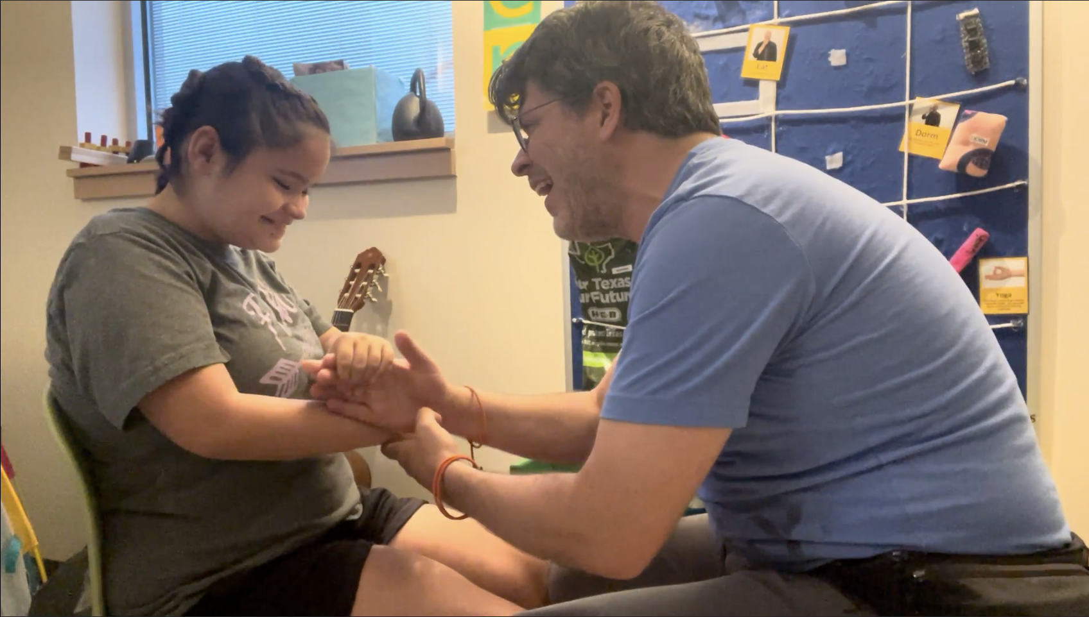

AT Assessment questions: (EMC3)
- Do you know what the individual likes? (list)
- Do you know the individuals Communication Methods (list)
- Do you know the symbol system that best matches the individual’s ability? (list)
- Is the individual consistently and predictably satisfied with the consequences when choice is presented in association with a symbol?
- List symbols and activities for which associations have been documented and list intelligible and appropriate motor patterns.
Adapted from p. 263 , Korsten, et. al., 2007, Every Move Counts, Clicks and Chats, EMC Inc.

Questions? Comments?

Thank you for joining us!

Resources
- Co-regulation Strategies from zerotothree.org
- Five Phases of Education Treatment from activelearningspace.org
- Conversations without Language by Linda Hagood
- Serve & Return Experiences from Harvard University Center for the Developing Child
- Design to Learn Products:
  - Communication Matrix
  - First Things First
  - Tangible Symbol Systems
- Every Move Counts Clicks and Chats by Jane Korsten et. al.
- TSBVI Curriculum Products:
  - Communication: A Resource Guide for Teachers of Students with Visual and Multiple Impairments by Linda Hagood
  - Calendars for Students with Multiple Impairments Including Deafblindness by Robbie Blaha (print or electronic option)
- Topical Coffee Hour Archives
  - Coffee Hours on bonding & attachment
  - Coffee Hours on Touch and Tactile Interaction
  - Complex Learners: Setting Up for a Successful School Year
  - Calendar Systems and Routines - What are they and how do we use them?

