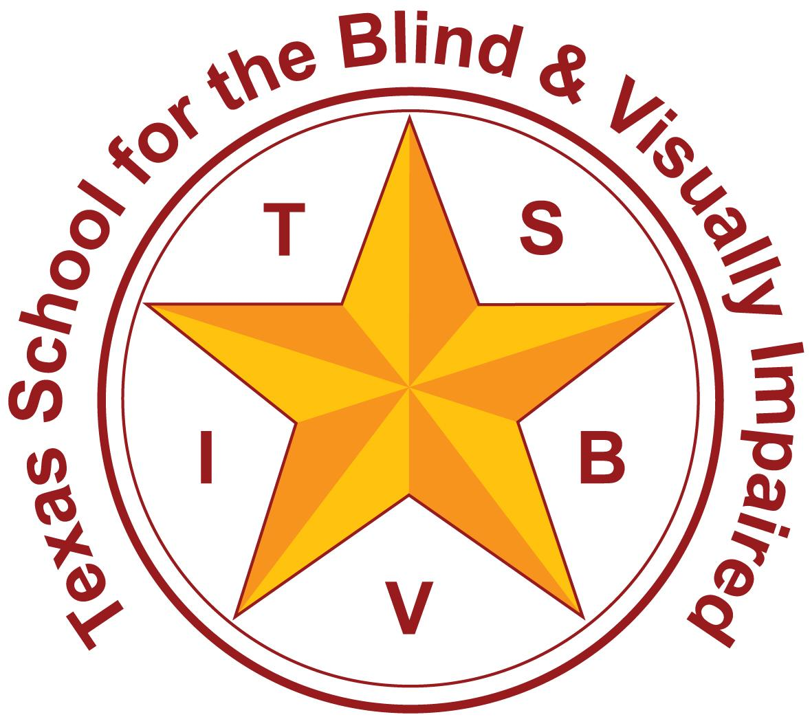
Texas School for the Blind and Visually Impaired
Outreach Programs
www.tsbvi.edu | 512-454-8631| 1100 W. 45th St. | Austin, TX 78756

Coffee Hour
Learning with LEGO

May 18, 2026
Courtney Forman, Statewide Mentor Coordinator, TSBVI Outreach
Kathi Garza, Early Childhood Consultant, TSBVI Outreach

Title Slide (Slide 1)
Slide shows a graphic of the TSBVI logo in maroon and gold.
Learning with LEGO
Courtney Forman M.Ed. TVI
Kathi Garza M.Ed. TVI
Coffee Hour - May 2026

Today’s Topics (Slide 2)
Slide shows an image of a young toddler with albinism building with large LEGO blocks.
- Curriculum Connections
- Building up the ECC
- Accessing LEGO

Curriculum Connections (Slide 3)
Slide shows an image of a giant LEGO sculpture of a woman wearing sunglasses, holding a white cane, and walking with a dog guide.

LEGO in Math (Slide 4)
Slide shows an image of several LEGO BrailleBricks numbers and operation signs on a gray lego plate.
- Number sense
- Comparing numbers
- Patterns
- Graphing
- Measurement
- Fractions

Number Sense (Slide 5)
Slide shows 3 images. The left image shows a child placing the corresponding number of LEGO bricks on sheets of paper with large print numbers written on them. The middle image shows a page with addition and subtraction problems represented using LEGO bricks. The right image shows a page with multiplication and division problems represented using LEGO bricks.

Comparing Numbers (Slide 6)
Slide shows 3 images using Mega Blocks to represent greater than, less than, and equal to number problems.

Patterns (Slide 7)
Slide shows 2 images. The first image shows Mega Blocks used to create an AB and an AAB pattern. The second image shows a child creating their own pattern of colors using Mega Blocks.

Graphing (Slide 8)
Slide shows 2 images. The left image is of a 5x10 table and a bowl of LEGO bricks. The y axis has different LEGO bricks to be graphed. The right image is of the partially completed 5x10 table where LEGO bricks have been placed in the cells along the x axis corresponding to the LEGO on the y axis.

Measurement (Slide 9)
Slide shows 2 images. The first image shows 10 LEGO bricks stacked up next to a toilet paper tube. The second image shows 9 LEGO bricks lined up next to a sparkly pen.

Fractions (Slide 10)
Slide shows 2 images. The left image contains two 4x12 LEGO plates with bricks depicting fractions. One includes bricks of 8, 4, 2, and 1 stud(s), and the other includes bricks of 6, 3, 2, and 1 stud(s). The right picture shows LEGO bricks lined up next to one another. The bricks include one 2x16, two 2x8, four 2x2, eight 1x2, and sixteen 1x1.

LEGO in Literacy (Slide 11)
Slide shows two images of LEGO BrailleBricks spread out on a gray LEGO plate.
- Braille Bricks
- Letter identification
- Building words

Letters and Words (Slide 12)
Slide shows 3 images. The outermost images show LEGO BrailleBricks used to make six CVC words. The middle image shows LEGO tiles and 1x1 circular bricks used to make braille letters to create the “and” word family with land, hand, sand, and band.

LEGO in Science (Slide 13)
Slide shows an image of one of the LEGO Education Science kits with instruction books.
- Sorting activities
- Creative constructing
- Engineering & design
- LEGO Education
- LEGO Smart Play

No Title (Slide 14)
Slide shows 5 images. The first image is of a preschooler sorting LEGO Duplo bricks by color onto corresponding colored sheets of paper. The second image shows a child building with Duplo bricks at a lego table. The third image shows a child at a dining table with a large pile of LEGO bricks in front of him, along with some creations he’s made. The fourth image shows bags with sorted LEGO bricks used to make a catapult. The fifth image shows a student holding LEGO bricks up close to his eyes while he lines them up and presses them together.

LEGO Education (Slide 15)
Slide shows 2 screenshots from the LEGO Education site. The first screenshot shows the title of a lesson plan called Beach House Builder. The second screenshot shows extension activity menus from the website.
- I can explain how water can change the land.
- I can use a model to show a solution to the problem of water eroding land.
- I can compare solutions and describe how they are similar and different.

LEGO Smart Play (Slide 16)
Slide shows 3 screenshots from the Smart Play website. Each image shows a different type of Smart Play Brick. Each image contains text indicated below.

SMART Bricks: Reacts to your every move! Full of cool tech that reacts to twists, taps, and more! It senses SMART tags and SMART minifigures to bring play to life.

SMART Tags: Keeps the fun going (and going)! They tell the SMART brick what object to behave and sound like. A car? A helicopter? Even a toilet!

SMART Minifigures: Bring stories to life! SMART Bricks play unique sounds, moods, and reactions for every SMART minifigure they encounter.

Building up the ECC (Slide 17)
Slide shows an image of a giant LEGO sculpture of a woman with glasses and a waitressing outfit on. She’s carrying trays of pizza, salad, and drinks while wearing rollerskates.

Building Concepts in O&M (Slide 18)
Slide shows 4 images. The first image shows a map of a classroom built with LEGO bricks. The second image shows a representation of a simple route from the classroom to the cafeteria using LEGO bricks. The third image shows a map of an intersection with bus stops and crosswalk poles. The last image shows a broken LEGO set on a counter.
- Making maps
- Positional concepts

Stacking up Sensory Skills (Slide 19)
Slide shows 3 images. The first image shows plastic bottles with LEGO bricks inside to be used as sensory bottles. The second image shows a LEGO fidget spinner and bags of parts to create one. The third image shows a student exploring the pieces to create a LEGO fidget spinner.
- Tactile discrimination
- Listening skills

Tactile Discrimination (Slide 20)
Slide shows 5 images of groups of LEGO bricks. In each image, one LEGO brick is not like the others. The groups range in complexity to develop skills.

Recreation and Leisure (Slide 21)
Slide shows 3 images. The first image is of a child laying on his stomach surrounded by LEGO bricks as he builds. The second image is a collage of images of the LEGO Starry Night set at different stages of completion. The third image is of a child shopping for a LEGO set.

Creating Career Concepts (Slide 22)
Slide shows 3 images. The first image shows a big dog laying upside down in his bed surrounded by a pile of Mega Blocks. The second image is of a child tapping a credit card to purchase a LEGO set at the store. The third image shows a play room floor with LEGO bricks dumped all over it.
- Funding your LEGO addiction!
- Organization & cleanup
- Job duties

A Little LEGO Self-D (Slide 23)
Slide shows 3 images. The first image is of a child smiling proudly with his Star Wars LEGO build. The second image shows an adult’s hand holding 3 custom designed LEGO Flowers. The third image shows a child holding up his excavator.

Accessing LEGO (Slide 24)
Slide shows an image of a giant LEGO sculpture of a person using a wheelchair and holding a magnifying glass.
- Magnification
- Sorting pieces
- Work trays
- Lego 4+

Tools and Strategies (Slide 25)
Slide shows 3 images. The first image is of a divided plate with LEGO bricks sorted into the different dividers by color. The second image shows a student using a work tray to contain LEGO bricks used for a lesson. The third image shows a child using a cell phone to zoom in on the instructions for a build.

LEGO 4+ (Slide 26)
Slide shows two images of the front and back of a LEGO 4+ Toy Story set. The front of the box gives basic details while the back of the box shows the adaptations included for young builders.

LEGO Builder App (Slide 27)
Slide shows an image of an adult with albinism using the LEGO builder app to build several small plants. Slide shows 3 screenshots from within the app displaying how directions are digital and images can be moved around or made larger.

Questions or A-Ha Moments? (Slide 28)
Slide shows an image of a large LEGO sculpture of a scientist with goggles on and a bottle of brightly colored potion in one hand.
Courtney Forman - formanc@tsbvi.edu
Kathi Garza - garzak@tsbvi.edu

Resources
- LEGO Braille Bricks
- LEGO Braille Bricks APH
- LEGO Education
- LEGO Smart Play System
- Ways to Use LEGO in the Classroom Article
- LEGO Fidget Spinner
- LEGO Catapult

