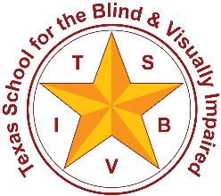 | Texas School for the Blind & Visually Impaired  Outreach Programs  www.tsbvi.edu | 512-454-8631 | 1100 W. 45th St. | Austin, TX 78756

Coffee Hour
Active Learning Equipment: The Little Room
November 19, 2020
12PM

Presented by
Patty Obrzut, M.S., O.T.R., Asst. Director
Penrickton Center for Blind Children

Facilitated by
Charlotte Cushman and Kate Hurst, Education Consultants, TSBVI Outreach

Developed for
Texas School for the Blind & Visually Impaired
Outreach Programs

Aligning an Active Learning Approach with General Education
Active Learning activities can be aligned with state standards.
- Can Active Learning Be Used for General Education Instruction?
- Resources Related to Aligning Goals to the Standard Curriculum
- Sample Goal Alignment and Lesson Plans (Word or PDF)
Let us know if you would like more information about this. If we get enough requests we can focus on this in a future Coffee Hour.

Questions about The Little Room
- Should I buy a Little Room or make my own?
- How do we configure a Little Room?
- Matching goals to objects
- Selecting objects to hang in a Little Room:
  - How many items?
  - How should they be positioned?
  - How often should objects in the Little Room be changed?
- What are some special considerations about the Little Room?
- Using the side panels - could this be changed to reflect topic of the week?

Determining the Configuration of the Little Room
Active Learning Space
Configuration Guide (Word or PDF)

Questions about The Little Room con’t
- Who should be using a Little Room?
- How do I place a child in a Little Room?
- How long should a child stay in a Little Room?
- What if a child cries in a Little Room? When should a child be taken out?
- How will I know when a child should move on from a Little Room?
  - Little Room itself is designed to get more difficult (magnetic board, hole)
- Should I interact with a child who is a Little Room?
- What about children with CVI in Little Room?
- Do I need to use Elastic / Tubing to hang items?
- What if you don’t have a Little Room? Home Hacks!
- Is a Resonance Board necessary?
- What if I’m using one Little Room for several different children with different goals?

Active Learning Equipment: The Little Room
Explore what’s on the Active Learning Space site!
- The Little Room
- Little Room Configurations
- Putting a Child in a Little Room
- Reaching and Spatial Organization
- Observation forms for Little Rooms
- Videos of Children in Little Rooms
- Points to Consider When Choosing Materials
- Loop Turner, Tubing, Elastic
- Home Hacks

Questions?
Charlotte Cushman
Kate Hurst
Patty Obrzut

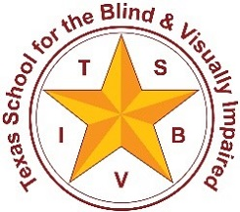
Figure 1: TSBVI Logo

This project is supported by the U. S. Department of Education, Office of Special Education Programs (OSEP). Opinions expressed herein are those of the authors and do no necessarily represent the position of the U. S. Department of Education.
Figure 2: IDEAs that Work logo and OSEP disclaimer

