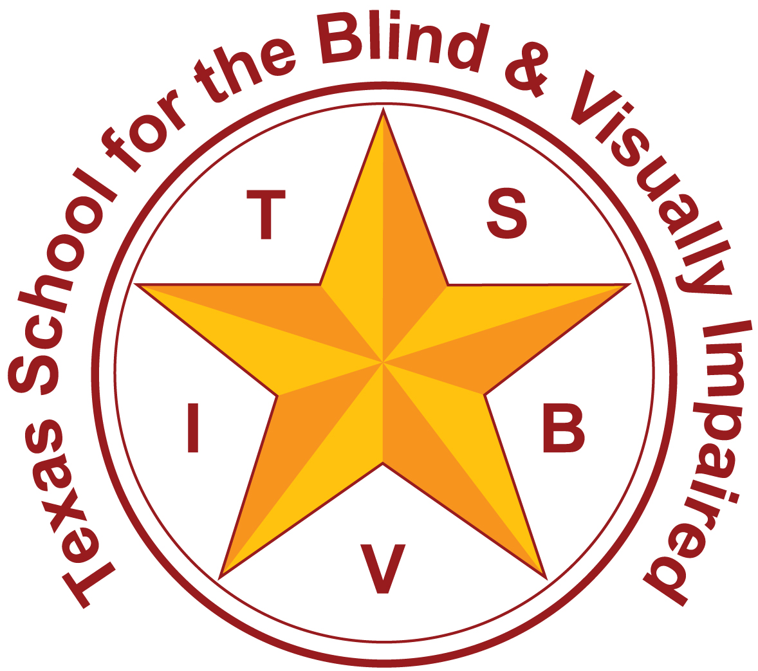
Texas School for the Blind and Visually Impaired
Outreach Programs
www.tsbvi.edu | 512-454-8631| 1100 W. 45th St. | Austin, TX 78756

Introduction to Cortical Visual Impairment:
CVI Web Exercise

Presented by
Sara Kitchen & Lynne McAlister
kitchens@tsbvi.edu, mcalisterl@tsbvi.edu

Developed for
Texas School for the Blind & Visually Impaired
Outreach Programs

Introduction to Cortical/Cerebral Visual Impairment (CVI)
Note: videos open in a new window so you can listen to the video and read the handout at the same time.

Definition and Incidence
- Definition of cortical visual impairment
- New field of research
- Fastest growing visual impairment diagnosis

The Problem with Medical Diagnosis
- Eye report frequently doesn’t say “CVI”
- Best information may come from neurological
- Test like MRI is not necessarily useful in diagnosing CVI

Look for “red flags”
- Asphyxia-damage depends on severity & duration. Some causes: placenta previa, prolapsed cord, delivery complications.
- Hypoxic Ischemic Encephalopathy-too little oxygen (hypoxia), too little blood flow (ischemia), irritation of the brain (encephalopathy). Results from asphyxia. Seizures common.
- Cerebral Vascular Accident-(stroke) blood capillaries in the brain rupture, damage depends on extent of bleed, more common in full term male infants, mostly affects left side of brain, seizures common.
- Intraventricular Hemorrhage-occurs in premature infants w/in 1st 48 hours. Severity grades I-IV.
- Periventricular Leukomalacia (PVL)-something, such as trauma, occurs and oxygen does not get to the distant areas of brain. These die and become filled w/ fluid (sometimes called cysts in the brain). Can cause CP, developmental delays.
- Infection-viral and bacterial (TORCH)=toxoplasmosis, rubella cytomegalovirus, herpes/HIV. Also meningitis.

Throughout this web exercise, please refer to:
Cortical Visual Impairment: An Approach to Assessment and Intervention, by Christine Roman-Lantzy, ©2007, AFB Press.

The Brain from Top to Bottom
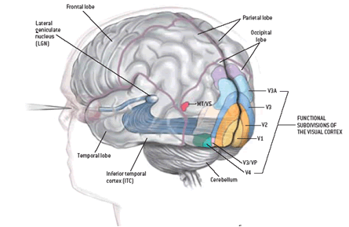
Figure 1 Image of the brain including the functional subdivisions of the visual cortex, cerebellum, inferior temporal cortex (ITC), temporal lobe, lateral geniculate nucleus (LGN), frontal lobe, parietal lobe, and occipital lobe. (from McGill University)

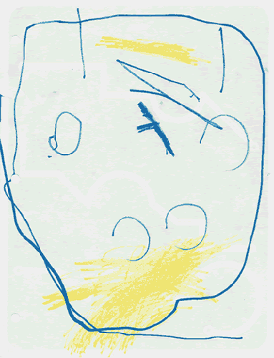
Figure 2. Drawing by an 8 –year-old child with CVI. The eyes and hair are on the bottom of the drawing and the mouth is at the top.

Unique Characteristics of CVI

- Color: strong reaction/preferential response to a particular color, typically red or yellow. Color receptors are diffused through brain & almost all children have some color vision. Need their favorite color as a visual anchor.
- Movement: Stimulates the “aware” system, gets the visual system activated. Movement w/out sound is generally easier to visually process.
- Movement plus reflective qualities provide an invasive, difficult to ignore effect on the visual system.
- Child may exhibit better than expected navigational skills.
- Latency: delayed response to presentation of object. Can vary according to time of day, state of alertness, degree of stress, and neurological stability. Decrease in latency equals increase in visual behavior.
- Visual Field Preferences: objects are more easily seen in certain parts of the visual field.
- Especially in periphery, where movement is better detected by the retina.
- Mixed field preferences: May use one eye for a field preference, and the other for verification.
- Complexity: most interfering of all characteristics.
- Target/object-some objects are too complex, and there is no place for child to anchor his vision and so vision shuts down: faces are very complex.
- Array-what’s behind the object can cause problems even with preferred objects. This is responsible for the misconception that vision is variable. Actually, vision is constant, but background interferes with vision functioning.
- Sensory environment-unable to process with more than one sense at a time; will defer to auditory over vision. Be careful where you place auditory stimuli. Limit talking while doing vision work.
- Abnormal Reaction to Light-Photophobia/Light Gazing/Non-Purposeful Gaze-prominent in early stages.
- Distance Viewing-As object gets farther away, complexity increases. Makes child appear nearsighted.
- Visual Reflexive Responses-absent, intermittent, or delayed blink reflex. Blink to threat; blink when you touch the bridge of the nose.
- Visual Novelty-strong response to familiar objects. Appear to ignore novel items.
- Visual Motor-look and touch may happen as separate events.

Resolution of Characteristics
- Best chance for resolution is within first 3 years, but the possibility for resolution continues to exist into adulthood.
- Characteristics will not resolve without structured intervention
- Phase I: Building visual behavior
- Phase II: Integrating vision with function
- Phase III: Resolution of all CVI characteristics
"When a child with CVI needs to control his head, use his vision, and perform fine motor tasks, the effort can be compared to a neurologically intact adult learning to knit while walking a tightrope." http://www.tsbvi.edu/seehear/fall98/cortical.htm

Introduction to Christine Roman-Lantzy’s Assessment

Assessment Framework
- Interview
- Observation
- Direct evaluation of student

Reliability
The Reliability of the CVI Range: A Functional Vision Assessment for Children with Cortical Visual Impairment, by Sandra Newcomb, Journal of Visual Impairment & Blindness, October 2010, © 2010 AFB.

Parent Interview/Teacher Interview
- Information on medical background
- Eye report
- What does child like to look at
- What are your concerns
- Child’s favorite color
- When is child most visually alert
- Does child look directly into faces
- Does child notice things that move more than things that are stable
- Does child seem to look “through” rather than at objects

Observation of Vision
- In living and learning environments
- Quiet and noisy times
- Near and distance
- Familiar and unfamiliar objects
- Cluttered and simple backgrounds
- Interest in objects of specific color (color preference)
- Movement
- Light gazing
- Preferential viewing

Direct Evaluation
- Evaluate range of visual functioning
- Evaluate presence and degree of individual CVI characteristics
- May need several sessions to test

Forms
- Parent Interview questions are on page 34 of book.
- Answer Guide to Parent Interview – page 41, appendix 4a.
- Rating 1– Across CVI Characteristics Method – Figure 5.2, page 57
- Rating 1 – CVI Scoring Guide – page 97, appendix 5a.
- Rating 2 – Within CVI Characteristic Method/CVI Resolution Chart – Figure 5.6, page 75
- Essential Forms are listed beginning page 186

Texas School for the Blind & Visually Impaired
Outreach Programs
Figure 3 TSBVI logo.

Figure 4 IDEAs that Work logo and OSEP disclaimer.

